Balagokulam
Now in Norristown-King of Prussia

a weekly fun / learning experience for both kids and parents Build Personality & Character The Right Way

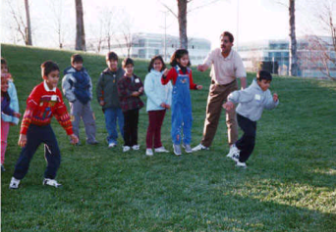
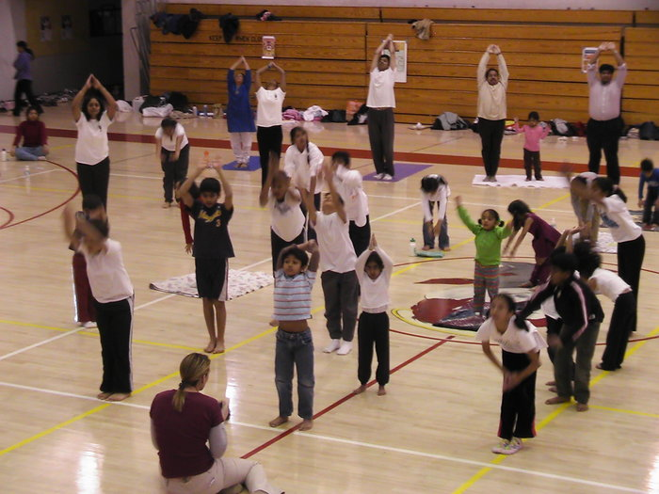

Activities

* Games * Yoga *
No Admission Fee
Your Kids
Today
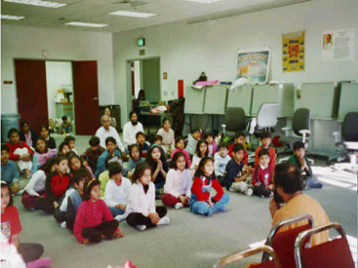
* Suryanamaskar *
* Stories * Languages *
* Bhajans * Shlokas *
* Arts and Crafts *

Every Sunday 4.00 to 5.30 PM
Karate Center
(in the complex of Genuardi's)

2808 Audubon Village Drive, Audubon, PA 19403

Age: 5yrs and above. Come and Njoy with other kids and families!

Email: hss.Philly@gmail.com or call 610 265 4959 / 860 997 3959

