www.balagokulam.org
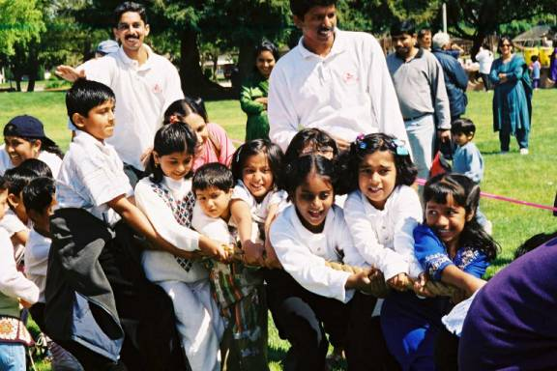
Let positive, strong, helpful thought enter into their brains from very childhood.
- Swami Vivekananda

- One place for entire family
- Once a week for one and half hour
- NO ADMISSION FEE

Activities for Children:
- Stories about Great Heroes, Cutlure and Hinduism.
- Fun filled games to inculcate team spirit and leadership qualities.
- Practice of slokas and bhajans, Yoga and Suryanamaskar, Ekatmata stotram.
- Above all a homely and loving environment where discipline and Hindu ethos are taught in a playful manner.
- Occasional Group hiking and Hindu Heritage Camps.
- Festivals like Ganesh pooja by children, Skits by children (depicting values and lives great perosnalities, Ramayana, Mahabharata, history)
- Participate in the Balagokulam Magazine OF, FOR and BY KIDS

And also HSS Shaka for Youth and Adults:
- Yoga, (Yogasanas, Pranayama), Suryanamaskars practice, exercise.
- Fun filled games for youth and adults.
- Discussions, Talks and Dialogues on Hinduism, Cultural and Social issues/topics of Hindus in USA. Occasional Family Camps to know more about Hindu Home, Hindu Family and Hindu Dharma.
Visit www.balagokulam.org/centers.php for center location

