

Hindu Heritage Camp

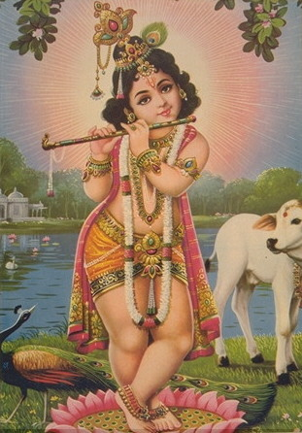

Name: ____________

Hindu Swayamsevak Sangh, USA

http://www.balagokulam.org
Email: balagokulam@hssworld.org


Dear Campers and Parents,
Welcome to Hindu Heritage Camp! During this camp, you will be introduced to a whole new world—a world where Hinduism is not a religion, but more of a way of life; where learning is not an command, but an experience; where fun is not an option, but will become a necessity; and where a smile upon your faces is not a sign to us, but a satisfaction.

Many of you may be new to this new concept of a Hindu Heritage Camp. Hinduism, as you might know, is our religion. But here, at balagokulam, it’s a way of life. Hinduism is just how we do things, not what we are controlled by. What Hinduism does is tell us what’s right and what’s wrong and give us a path upon which to base our lives on. In more simple words, don’t think of Hinduism as a religion, but more of an idea that we all share. The next word, Heritage, basically means tradition. Your heritage would be what your family did in the past, like where they lived, what kind of lives they led, and, overall, their history. It is important to know about heritage, because one day your family’s heritage will be remembered as your heritage as well. The last word, camp, basically means one thing to us here shikshaks, fun! Our job during your camp is to make sure to learn something, to have fun, and to bring a smile to all of your faces. Those three words put together form the name of this place: Hindu Heritage Camp. Don’t set your boundaries here, Hindu Heritage Camp is not only about these three words. It’s about everything you want to make it about, revolving again on that way of life, Hinduism.

You might of noticed two words above that you do not know the meaning to. The first one is balagokulam, which is a place we gather every weekend for an hour or so playing games, saying shlokas, and much more. The other word is shikshaks. Shikshaks are us, what you can refer to as teachers, but more likely we’re your friends. We’re here for you, and to make sure that you get the most out of this camp. We’ve planned this year’s Hindu Heritage Camps. We hope to enhance the camp with more exuberant activities.

Each and every camp is planned differently, with many activities. We won’t reveal those to you just yet, as they’ll remain a surprise. So, from us here, we would just like to wish all you campers a happy camp with many exciting things, and for the parents, we hope your child enjoys the camp just as much as we do conducting it.

Sincerely,
The shikshaks

Greetings

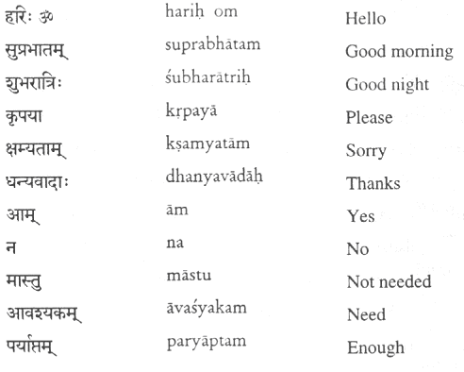

Words of Wisdom

Swayameva mrigendratha
We achieve through our own efforts

Karmanyeva adhikaraste maa phaleshu kadaachana
Our responsibility is in our actions, not to worry about their results.

Udhyamenahisidhyanti karyaani na manorathaihi
Effort alone creates results, not day-dreaming.

Na jaatu kaamaha kaamaanaam upabhogena shaamyati
By fulfilling those desires in us, those desires don't go away

Shivobhutva shivam yajet
The real pooja of Shiva is in becoming like Shiva.

Uthishta jagratha praapyavaraan nibodhata
Arise! Awake! Stop not till the goal is reached!

Aano badra kratavo yantu vishvataha
Let noble thoughts come from all places.

BADE CHALO

bade chalo bade chalo maa ke laadalo
maa ke laadalo maa ke laadalo |
vedon kaa gaan ho, giitaa kaa maan ho
bhagavaa nishaan ho maa ke laadalo
bade chalo bade chalo maa ke laadalo ||
dharma ki dhuri liye umang se chalo
umang se chalo, maa ke laadalo
niraashaa nishaa mite, prabhaat kii ushaa phate
kalanka kaalimaa kate, maa ke laadalo
bade chalo bade chalo maa ke laadalo ||
atyaachaar andhakaar chiirate chalo
chiirate chalo maa ke laadalo
shaanta karma viir bano, jnaanii gambhiir bano
keshav sama dhiir bano, maa ke laadalo
bade chalo bade chalo maa ke laadalo ||
samaaj se bhoga vaad metane chalo
metane chalo maa ke laadalo
sangh kaa ninaad ho, ek dhyeya vaad ho
akhanda puNya bhuumi ho, maa ke laadalo
bade chalo bade chalo maa ke laadalo ||

Who is the creator of Pentium chip (needs no introduction as 90% of the today’s computers run on it)? : Vinod Dahm
Who is the founder and creator of Hotmail (Hotmail is world’s No.1 web based email program)? :Sabeer Bhatia

India never invaded any country in her last 1000 years of history.

Ayurveda is the earliest school of medicine known to humans.

India invented the Number system. Aryabhatta invented ‘zero.’

The world’s first University was established in Takshila in 700BC. More than 10,500 students from all over the world studied more than 60 subjects. The University of Nalanda built in the 4th century BC was one of the greatest achievements of ancient India in the field of education.
The earliest reservoir and dam for irrigation was built in Saurashtra.
Chess was invented in India.
Sushruta is the father of surgery. 2600 years ago he and health scientists of his time conducted surgeries like caesareans, cataract, fractures and urinary stones. Usage of anaesthesia was well known in ancient India.
When many cultures in the world were only nomadic forest dwellers over 5000 years ago, Indians established Harappan culture in Sindhu Valley (Indus Valley Civilisation).
The place value system, the decimal system was developed in India in 100 BC.

Quotes About India
We owe a lot to the Indians, who taught us how to count, without
which no worthwhile scientific discovery could have been made.
Albert Einstein.
India is the cradle of the human race, the birthplace of human
speech, the mother of history, the grandmother of legend and the
great grand mother of tradition.
Mark Twain.
ALL OF THE ABOVE IS JUST THE TIP OF THE ICEBERG

Indian Languages

Language | How are you? | I am fine.
Sanskrit | Katham Asti? | Utthamam
Hindi | Aap kaise hai? | Teek hu
Telugu | Yela Unnaru? | Baagunnau
Gujrati | Kem cho? | Majama
Tamil | Yeppadi Irkel? | Nanna Irke
Punjabi | Aur kee halchal hai? | Changa
Odiya | ApaNa Kemiti Achanti? | Mu Bhala achi
Malayalam | Engane Undu? | Sukham thanne
Bangala | Kemon ashe? | Bhalo ashe
Tulu | Encha ulla? | Yana edde ulle
Marathi | Tume kasha aahath? | Me Teek ahe
Konkani | Tume Kasshi Asti? | Hava Bare Assa
Kannada | Heygideera? | Chennagideeni
Sindhi | Kia yan ahya? | Ma teek ahyan
Rajastani | Kayian cho? | Me teek cho
Hariyanvi | Aur ke halchal hai? | Me Teek Thak
Bhojpuri | Kaiise Baani ? | Bahut Achha
Chattisgadi | Aap Man Kaise Ho? | San Bane Bane

Story of Sant Jnaneswar

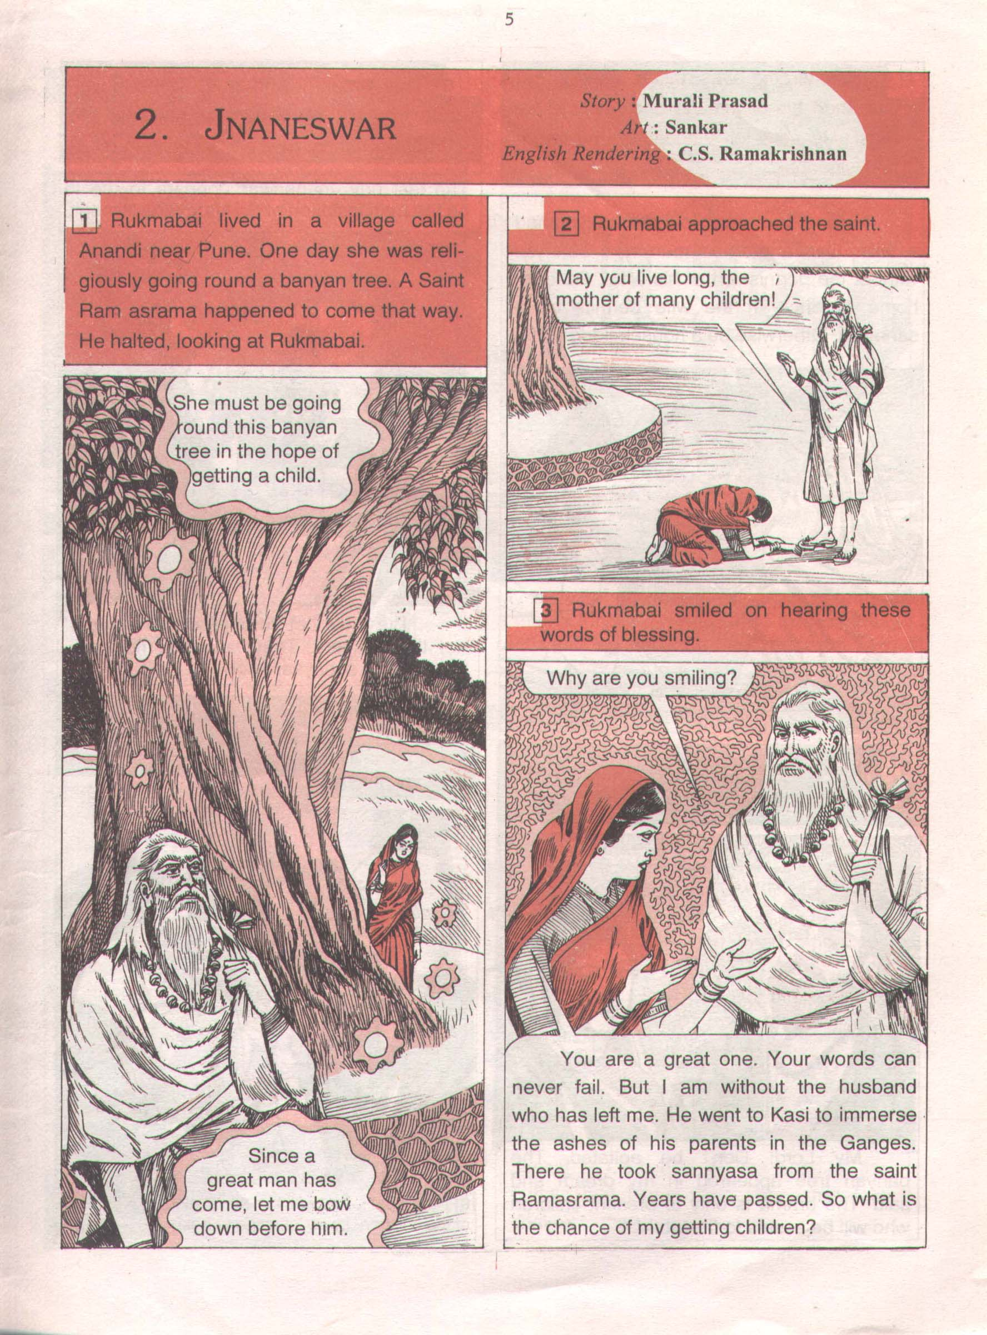

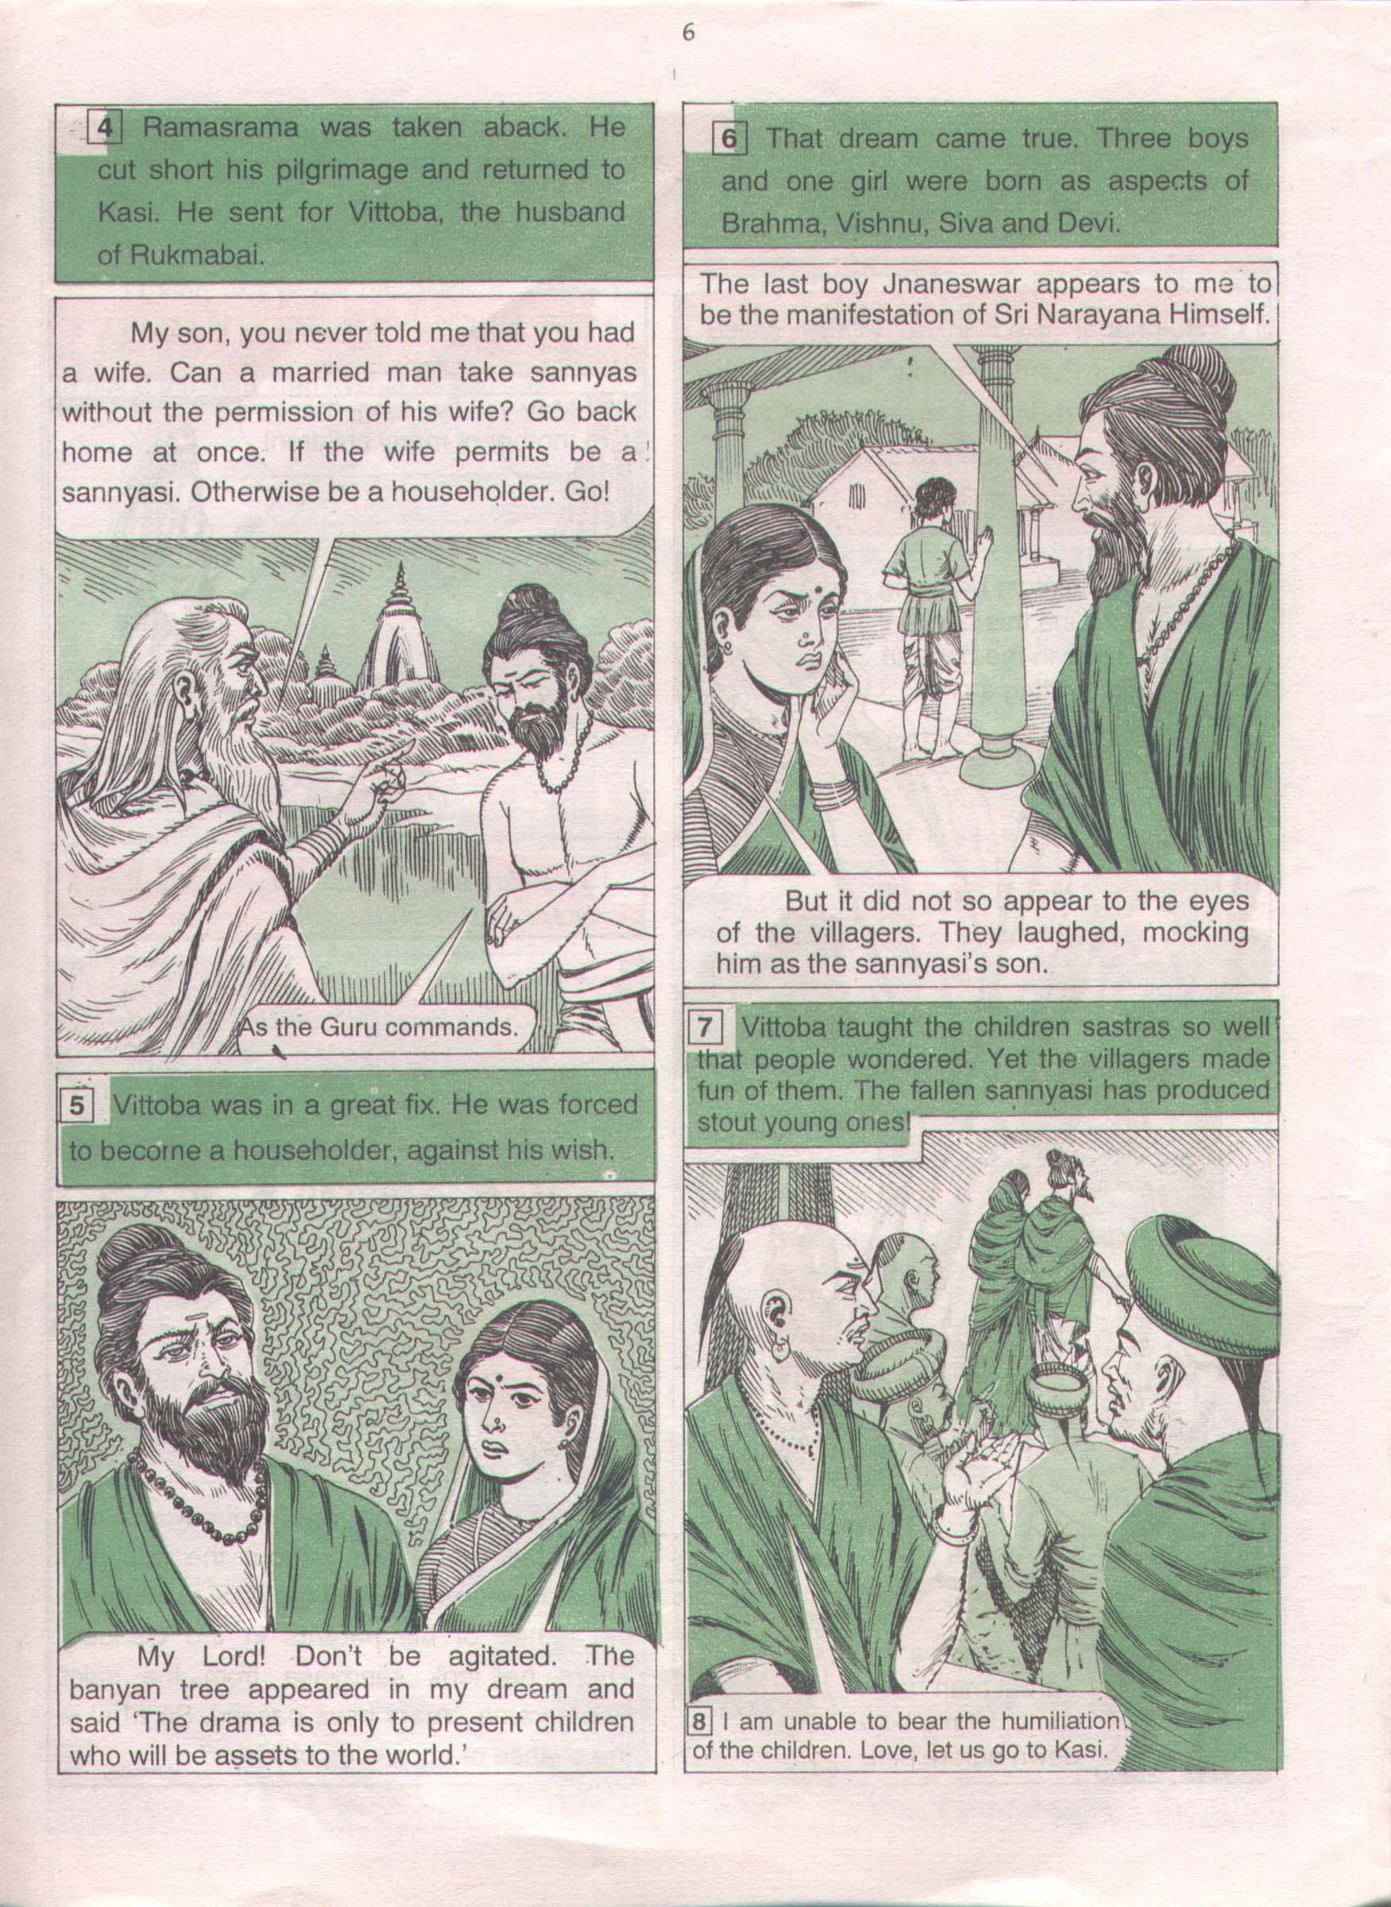

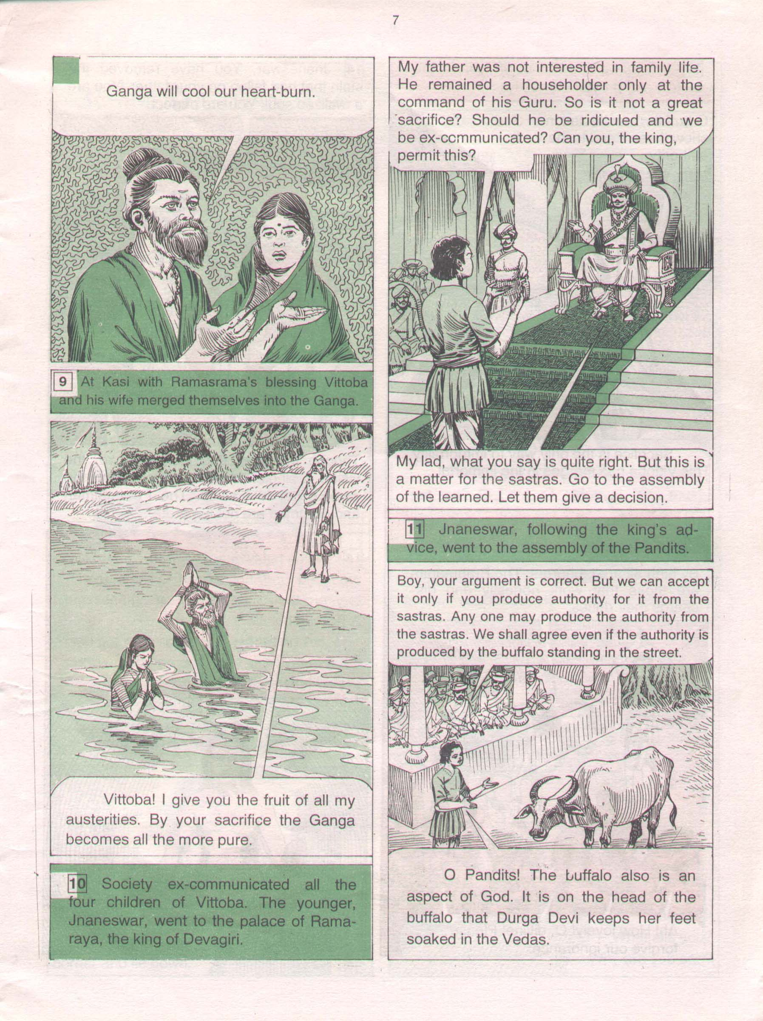

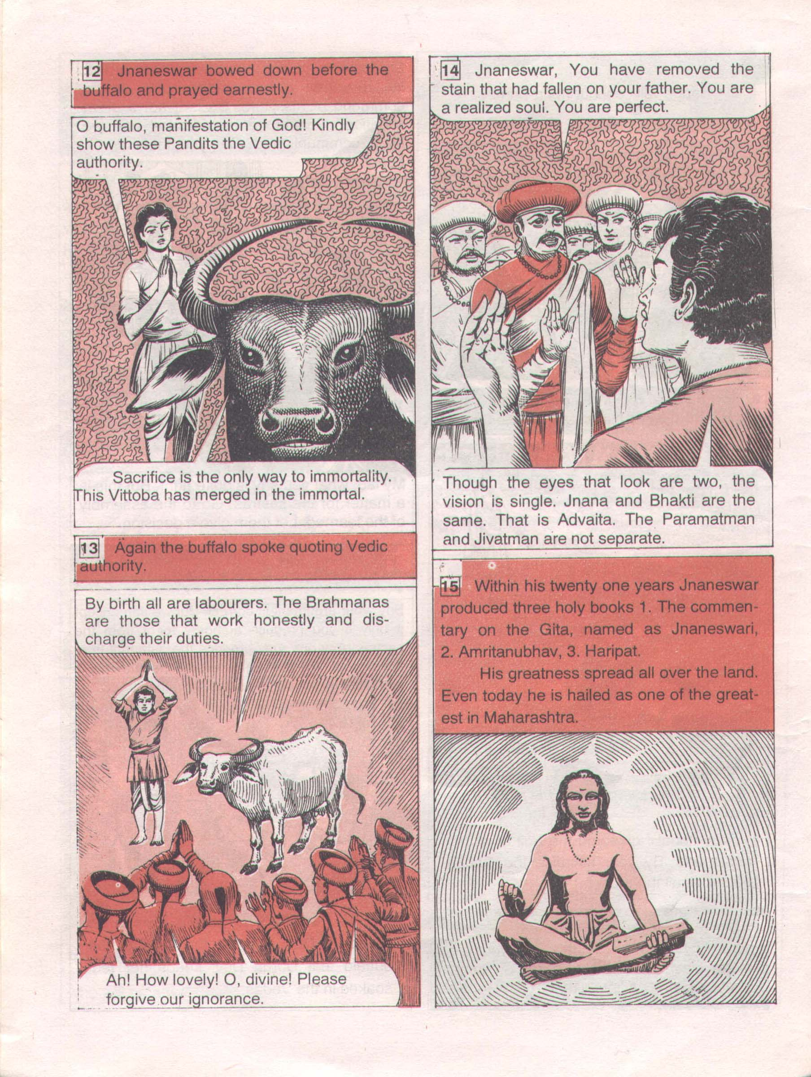

Bhajans

Come Here My Dear

Come here my dear Krishna kanayee
Mene tere liye hrideye undar building banayee
(repeat)

For you my Dear Krishna kanayee
Mene tere liye hrideye undar building banayee
(come here)

Makhan misre doda dahi khoba milaye (X2)
mene tere liye hrideye undar building banayee
(Come here)

Too much delay too much delay tum ne lagaee(X2)
Mene tere liyee hrideye undar building banayee

Come here my dear Krishna kanayee
Mene tere liye hrideye undar building banayee

Rama Ho Rama

Rama ho Rama re, bhul mat jaana

Ye tere Ayodhya chhoda ke,

Dudh laaya dahi laaya tere liye (x2)

Tuj ko khilaaunga vaapas na jaaunga

Ye tere Ayodhya chhoda ke-e-e-eRama ho

Phul laaya phal laaya tere liye (x2)

Tuj ko chadhhaunga vaapas na jaaunga

Ye tere Ayodhya chhoda ke-e-e-eRama ho

Eeth laaya pathar laaya tere liye (x2)

Mandir banaaunga vaapas na jaaunga

Ye tere Ayodhya chhoda ke-e-e-eRama ho

\
\
PUZZLE PAGE

~UNSCRAMBLE JAMBLE-FREEDOM FIGHTERS~
DIRECTIONS: Unscramble the following names of Indian Freedom Fighters

1.) AAAKSVRR _ _ _ _ _ _ _ _ 7.) HBSSUA OBES _ _ _ _ _ _ _ _ _ _

2.) DHGAIN _ _ _ _ _ 8.) AABGTH GINHS _ _ _ _ _ _ _ _ _ _ _

3.) LBA LKAIT _ _ _ _ _ _ _ _ 9.) AARDRS TLEPA _ _ _ _ _ _ _ _ _ _ _

4.) GAEORT _ _ _ _ _ _ 10.) NIVABO EAVB _ _ _ _ _ _ _ _ _ _

5.) IAAARDVN SHHOG _ _ _ _ _ _ _ _ _ _ _ _ _

6.) HDRAAHKSCANRE DAAZ _ _ _ _ _ _ _ _ _ _ _ _ _ _ _ _ _

  ~Word Search-Great Children~
  DIRECTIONS: Find the following words which may appear horizontally, vertically, or diagonally
  O | I | E | A | F | D | D | V | J | W | E | R | R | A | Q
  R | D | O | B | T | H | R | J | I | G | A | K | N | A | N
  A | R | E | H | A | R | L | A | D | P | A | A | Y | J | J
  N | A | K | I | H | U | K | J | P | S | N | E | H | N | H
  I | N | A | M | M | V | H | A | S | B | D | A | J | A | A
  D | I | L | A | A | A | Y | K | H | N | I | V | Y | S | N
  U | D | A | N | R | Y | D | N | A | L | K | Y | D | H | S
  R | U | V | Y | A | K | H | K | A | A | I | A | H | R | I
  G | R | Y | U | A | S | R | Y | V | K | R | H | R | A | K
  A | G | A | D | A | A | A | Y | A | R | A | X | U | V | I
  V | A | N | C | M | P | R | A | H | L | A | D | A | A | R
  A | B | A | L | A | K | R | I | S | H | N | A | D | N | A
  T | Y | N | A | C | H | I | K | E | T | A | K | F | A | N
  I | T | M | L | A | X | S | A | R | N | C | H | G | X | I
  R | I | K | H | U | D | I | R | A | M | B | O | S | E | Q
  Word List
  PRAHLADA
  DHRUVA
  BALAKRISHNA
  MARKANDEYA
  NACHIKETA
  RANI DURGAVATI
  JHANSI KI RANI
  EKALAVYA
  SHRAVANA
  ASHTAVAKRA
  ABHIMANYU
  AYYAPPA
  DOCTOR JI
  JNANESHWAR
  KHUDIRAM BOSE

Sarva Mangala Maangalyaam  Deveem Sarvaartha Saadhikaam  Sharanyaam Sarva Bhootanaam  Namaamo Bhoomi Mataram  Sachchidaanada Roopaaya  Vishwa Mangala Hetave  Vishwa Dharmaika Moolaaya  Namostu Paramaatmane  Vishwa Dharma Vikaasartham  Prabho Sanghatitaa Vayam  Shubhaam Aashisham Asmabhayam  Dehi Tat Paripoortaye  Ajayyam Aatma Saamarthyam  Susheelam Loka Poojitam  Gyanam Cha Dehi Vishwesha  Dhyeya Maarga Prakaashakam  SamutKarshostuno Nityam  Nishreyasa Samanvitah  Tatsaadhakam Sphuratwantah  Suveera Vratamujwalam  Vishwa Dharma Prakaashena  Vishwa Shaanti Pravartake  Hindu Sanghatanaa Kaarye  Dhyeya Nishthaa Sthiraastunah  Sangha Shaktir Vijetreeyam  Krutvaasmad Dharma Rakshanam  Paramam Vaibhavam Praaptum  Samarthaastu Tavaashisha  Tvadiiye Punya Kaaryesmin  Vishwa KalyaaNa Saadhake  Tyaaga Seva Vratasyaayam  Kaayome Patatu Prabho  || Vishwa Dharma Ki Jay || | The most sacred of all that is auspicious  The means to achieve all that one aspires  The safe refuge of all living beings  O Goodness Mother Earth, We salute thee.  You are the cause for the Universe good,  The embodiment of the Truth Wisdom, and Bliss  The Unique origin of Universal Righteousness,  Our Salutations to You, O God, Supreme.  Together we have come organized, O Lord,  The purpose being flourishing of Universal Dharma,  We seek Your blessings, the divine grace,  Bestow on us to accomplish the aim.  Possession of valor, unconquerable ever  Conduct, character renowned world over  Bestow the wisdom that brightens, O God  Paving the way to realize the goal.  Endowed with prosperity, exaltation, perpetual,  May there be affluence bestowed on us;  inspired are we to practice,  the radiant, worthy, valiant, vow.  With enlightenment from the Universal Dharma,  in propagating peace through out the world  in the task of achieving Hindu unity worldwide,  May our aim and deep faith remain resolute.  With the triumphant power of the organization,  by safeguarding our own Dharma, the righteousness,  May we be blessed to be competent  To attain the glory supreme, sublime.  In pursuit of the welfare of the mankind,  which indeed is thy holy cause and  inspired by the noble virtues of service and sacrifice,  let my being, O Bhagawan!, be offered at your feet.  || Victory to Universal Dharma ||



Name | Phone Number | Email Address

