Hindu Heritage Camp

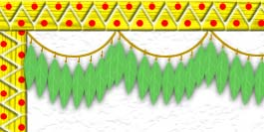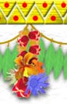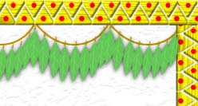

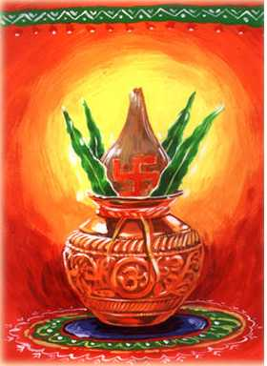

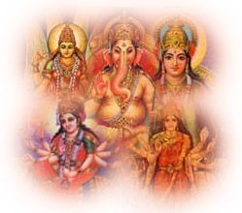

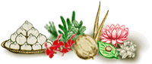

INDEX

Our Festivals
FESTIVAL | MONTH | PAGE
Makara Sankranti | January | 3
Shiva Ratri | February | 4
Yugadi | March | 5
Ram Navami | April | 6
Raksha Bandhan | August | 7
Ganesha Chaturthi | September | 8
Janmashtami | September | 10
Vijay Dashami | October | 13
Deepaavali | November | 14

Shloka | 16 to 20
Soorya Namaskar | 21, 22
YogAsan | 23 to 25
Geet "Hon'ge kAm yAb" | 26

Makara Sankranti
(Usually on January 14th or 15th)
In Samskritam language, 'Kranti' means change and 'Sankranti' means good change.

It is celebrated on this day because of the positive change in the nature at this time. The Sun enters the sign of Makara or Capricorn. From this day, the duration of day increases and that of night decreases. Light symbolizes knowledge, and brighter aspects in our lives and darkness represent ignorance and duller aspects. Thus 'Sankranti' signifies this positive change of increasing the good qualities in us and decreasing the negative ones.

This also marks the celebration of harvesting season. This happy occasion is termed as Pongal in southern Bharat and as Khichadi in northern Bharat - both of them being names of delicacies specially prepared on that day!
In many parts of Bharat there is a tradition of special art called Rangoli, which is drawn during this festival season. This art is done in front of the house with the Rice flour and colors.

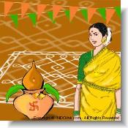
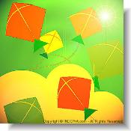
Flying Kites is seen during this festival. Kite flying competetions are held on this occassion.
In many areas of Bharat, there is a tradition of exchanging til-gul the sesame seed and jaggery. The til, brimming with fragrant and delicious oil, stands for friendship and bonding and jaggery for the sweetness of speech and behavior. People exchange til-gul and wish that every one speak sweet words.

The biggest Mela - religious fair - on the face of the earth is held once in twelve years at Prayaag, the holy confluence of rivers Ganga, Yamuna and the invisible Saraswati.
In short, Makara Sankramana embodies the ardent prayer of every Hindu heart :

Asato maa sadgamaya
Tamaso maa jyotirgamaya
Mrityoormaa amritam gamaya
Lead me, O Bhagawan, from untruth to Truth, from darkness to Light and from death to Immortality.

Shiva Ratri

Ratri means night. Shiva-Ratri means the night devoted to Bhagwan Shiva. On this day, Hindus fast the whole day and spend all the time during day and night in singing bhajans to Bhagawan Shiva.

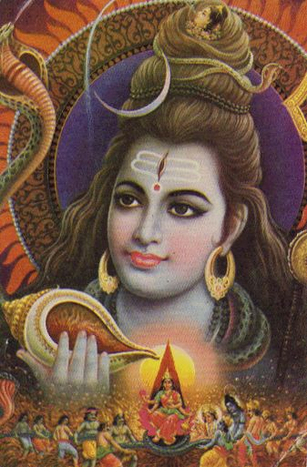
River Ganga on His head is said to be jnana Ganga, the flow of knowledge from teacher to disciple.

On Shiva's head is the crescent moon and it represents the nectar of life.

The Snake Garland: This image of Lord Shiva shows that he is fearless.

Ashes (vibhuti) on his body shows that our bodies are already dead, inert matter, which will turn to ashes one day. We should therefore rise above our identification with the body even while we are living. As long as our identification with body remains one can never become the master of situations.

Three-Eyed One
Lord Shiva is trilochana, the three-eyed One. Third eye between the eye-brows, is the eye of wisdom. The other two eyes represent love and justice.

Lord Shiva is also called nilakantha (Blue-Necked One). In ages past, when milky ocean was being churned by the gods and demons in order to get the nectar of immortality, the celestial snake, Vasuki, who was being used as the churning rope, began to vomit a fatal poison. None of the gods and daemons wanted it. In desperation they went to Lord Shiva and He took the poison and drank it. However he did not swallow the poison entirely, but kept it in his throat, which turned His neck blue. Only great and wise men will be able to swallow all the poison in life. He did not become poisonous or bitter himself. As he held it in his neck, it became an ornament for him.



Yugaadi
(The first day of chaitra, the first month in lunar calendar)

The first day of the year according to the national calendar of Bharat, is significant both for its historical import and for the advent of bountiful nature. The day falls in the beginning of spring - Vasanta Ritu - When the Goddess of Nature gets bedecked as a divine bride.

This is celebrated as new year. There is the air of freshness in the nature as this is the spring season. In some parts of Bharat, the tender leaves of neem mixed with jaggery and offered to God as naivedya and then distributed as prasaada. The neem, extremely bitter in taste, and jaggery sweet and delicious, signify the two conflicting aspects of human life – joy and sorrow, success and failure, ecstasy and agony. This tells us that we should remain calm and balanced during success and failure, joy and sorrow and take everything as the gift of God. This in fact is the essence of yoga.

Historically, the day recalls the inspiring occasion when the kings Shalivahana and Vikramaditya defeated the invading barbaric forces of Shakas from Central Asia during the 1st century A.D. The founding of new Eras in the names of Vikrama and Shalivahana signifies the supreme importance accorded to them in the Hindu history and tradition for safeguarding the nation's freedom and sovereignty. As such, the continuing tradition of the two Eras has helped to keep aglow the spirit of national freedom in the nation's mind.
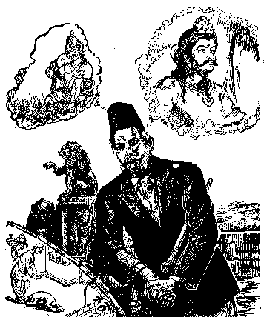
As a happy and meaningful coincidence, the great founder of the Rashtriya Swayamsevak Sangh ( RSS ) Dr. Keshav Baliram Hedgewar, was also born on this very day of Yugaadi of 1889.

Baisaakhi, which follows Yugaadi, is the first day of the Hindu Solar Year ( 2nd week of April ). In Punjab and certain other northern parts, it is an occasion for unbounded religious fervor and mass participation in festivities.

Sri Rama Navami
CHAITRA SHUKLA NAVAMI
The ninth day of the bright half of Chaitra

This is the holy day when Sri Rama was born.
" Wherever four Hindus live, Rama and Sita will be there " - said Swami Vivekananda, one of the pioneers of modern Hindu renaissance. The reverse is also equally true - wherever Rama and Sita live, the people there will remain and live as Hindus.

Every hill and rivulet of Bharat bears the imprint of the holy feet of Rama and Sita. Sri Rama reigns supreme to this day in the hearts of our people, cutting across all barriers of province, language, caste or sect. In many northern parts of Bharat mutual greetings take the form of Jay Ramjee Ki and Ram -Ram.

Sri Rama has become so much identified with all the good and great qualities.
Sri Rama's story, Ramayana, has been sung and re-sung in all the languages and dialects of the world. The tradition of writing epics centering round the saga of Rama's achievements started by Valmiki in Samskritam and was continued by Tulsidas in Hindi, by Kamban in Tamil, by Ramanujan in Malayalm, by Krittivasa in Bengali and Madhav Kambali in Assamia and in fact, in almost every Bharatiya language. The influence of Ramayana can be seen in many eastern countries like Indonesia and Bali.

Sri Rama represents the ideal in every aspect. He is ideal son, ideal brother, ideal husband and ideal king.

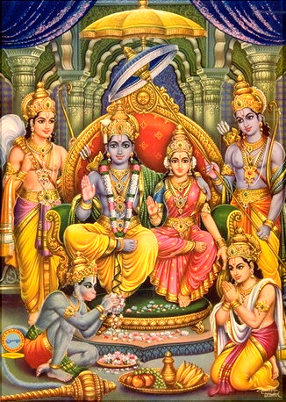

Rakshaa Bandhan

Full Moon Day in the month of Shraavana

The Rakshaa Bandhan is a celebration of the abiding and chaste bond of love between the brother and the sister.

The delicate cord tied by the sister to the brother on this day pulsates with this sublime sentiment. History and legends of Bharat abound in touching episodes of ladies seeking protection from far-off, unacquainted heroes, though the Raakhi. A story is told of Alexander's wife approaching his mighty Hindu adversary Pururava and tying Raakhi on his hand, seeking assurance from him for saving the life of her husband on the battlefield. And the great Hindu king, in the true traditional Kshatriya style, responded; and as the legend goes, just as he raised his hand to deliver a mortal blow to Alexander, he saw the Raakhi on his own hand and restrained from striking.

The sister-brother relationship highlighted by the Raakhi goes far beyond the mere personal protection of a female from a male. It also implies the basic element of an amicable and harmonious social life where all members of the society look upon themselves as brothers and sisters and as children of one common motherland.

In Sangh, we tie Raakhi to the sacred Bhagavaa Dhwaj and that symbolizes our commitment to protect each other and also the society and our Dharma.

In Maha Bharata, when Lord Krishna kills Shishupaala with his Sudershan Chakra, his finger gets wounded, seeing this Draupadi tears a piece of cloth from her saari and ties on the wound. And after quite sometime, when Draupadi was insulted by the Kauravas Lord Krishna rescues her by showering saaris.

Ganesh Chaturthi

Ganesha is the god of wisdom and prosperity and is invoked before the beginning of any auspicious work by the Hindus. He is the son of Shiva and Parvati, brother of Kartikeya and the general of the gods.

The story of creation of Ganesh is a very fascinating one.
A long long time ago when Lord Shiva, was away fighting for the gods, the lady of the house, goddess Parvathi was alone at home. On one occasion, she needed someone to guard the house when she was going for a bath. Unable to think of an alternative, she used her powers to create a son, Ganesh. She instructed Ganesh to keep strict vigil on the entrance to the house and not to allow anyone into the house. Ganesh agreed and stayed on the strictest of strict vigils.

In the meantime Lord Shiva returned happy after a glorious victory for the gods, only to be stopped at the entrance by Ganesh. Ganesh, acting on Parvathi's orders verbatim, did not allow Shiva to enter the house. Lord Shiva was enraged beyond control and in a fit of rage slashed the head of Ganesh. In the meantime Paravti came out from her bath and was aghast at the scene. She was very very angry at her lordship for what had happened and explained him the situation.

Lord Shiva wanted to make it up to Parvathi very badly and agreed to put life back into Ganesha by putting the head of the first sleeping living creature that came in sight which was sleeping with its head to the north. He sent his soldiers to go in search of the creature. The first creature which came in sight was an elephant. So Lord Shiva re-created his son with the head of the elephant. Hence the trunk of Lord Ganesha.

Parvathi was still not totally happy with the deal and wanted more. Then Shiva granted Ganesha a boon that before beginning of any undertaking or task people would worship Lord Ganesh. Thus the reason for worship of Ganesha before start of any work.

Celebrations : Ganesha is the generous god of wisdom and Ganesh Chaturthi is celebrated to worship Lord Ganesha. It's one of the most colorful public festivals all over Bharat. In Mumbai city alone, more than 6000 Ganesha statues are commissioned collectively by factories. Up to 10 metres in height, these statues are carried on decorated floats. Little Ganeshas are placed in nukkads or street corners and in homes, and poojas are performed daily.

Started by Shivaji, the great Maratha ruler, to promote culture and nationalism, the festival was revived by Lokmanya Bal Gangadhar Tilak to spread the message of freedom struggle and to defy the British who had banned public assemblies. The festival gave the Indians a feeling of unity and revived their patriotic spirit and faith. This public festival formed the background for political leaders who delivered speeches to inspire people against the Western rule. The festival is so popular that in Mumbai the preparations begin months in advance. Images of Ganesha are installed and elaborate arrangements are made for lighting and decoration, and celebrations are on for 7-10 days. The Chaturthi is the last day dedicated to the elephant-headed god, and thousands of processions converge on the beaches of Mumbai to immerse the holy idols in the sea. This immersion is accompanied by drum- beats, devotional songs and dancing.

It is also forbidden to look at the moon on that day as the moon had laughed at Ganesha when he fell from his vehicle, the rat.
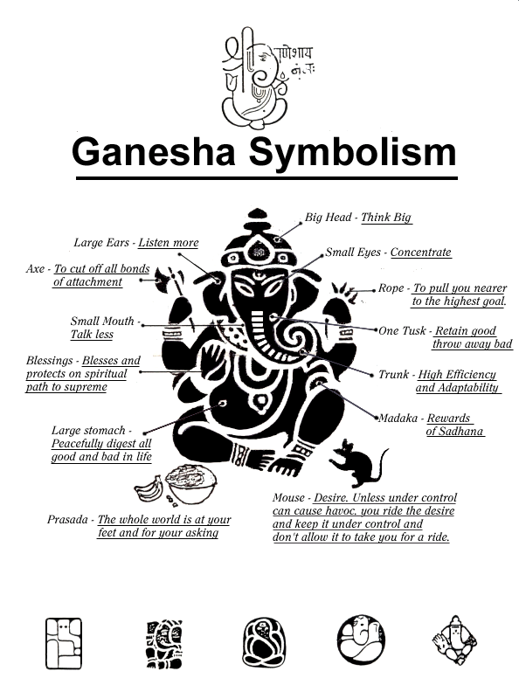

Janmashtami

The festival of Krishna Janamastami is the celebration of Lord Krishna's birthday. Krishna, the eighth incarnation of Lord Vishnu, is a unique character in Hindu history. He was naughty in his childhood days, romantic as a young man, and proved to be a profound philosopher in his adulthood as illustrated by the Bhagwat Geeta.

The birthday of Krishna falls on the Ashtami of Krishna Paksh ( the eighth day of the dark fortnight ) in the month of Bhadrapada ( July-August ), eight days after Raksha Bandhan. The exact date of Krishna's birthday has not been determined but is conjectured to be around 1400 B.C. when the Aryans got settled across the Indo-Gangetic plain. It was the rainy season in India and Krishna was born at midnight, in the prison of Kamsa, during the middle of a perilous rain and storm. Thus goes the story of Krishna's birth.

Kamsa, a despot, was then the king of Mathura. He had imprisoned his father in order to become the king. Devaki was Kamsa’s sister and was married to a noble man Vasudeva. Kamsa one day heard a heavenly voice, saying, " Kamsa, your days of tyranny will soon be over, you will be killed by the eighth child of Devaki." Kamsa got frightened. He immediately imprisoned Devaki and Vasudeva. He did not want to take any chance and killed at birth each and every child of Devaki, until the time came for the delivery of the eighth child. To feel more secured, Kamsa increased the number of prison guards, kept strict vigilance and put Vasudeva in chains. But God planned otherwise.

At midnight when the eighth child was born, the guards fell fast asleep and Vasudeva's chain fell off his hands and feet. Wasting no time, Vasudeva picked up the newborn baby, and carrying it in a basket, he started towards Gokul. Gokul was a village of cowherds, located across the Yamuna river, where his friend Nanda lived. It was a dark stormy night with blinding rain continuously pouring from the sky. When Vasudeva reached the bank of river Yamuna, the river was in spate. The wind and storm were blowing wild, and Vasudeva was in a fix.

" Lord, what should I do," said Vasudeva in a hopeless voice. Suddenly a miracle happened, the river parted and Vasudeva walked over the river bed. Throughout the way Vasudeva and the baby were protected from rain by the hood of the great eternal snake, Vasuki. Finally, Vasudeva reached Nanda's house.

Upon reaching Nanda's house Vasudeva found the mother, Yashoda, and her newborn baby girl in deep sleep. He had no time to think. He quickly exchanged the babies and returned to the prison with the infant girl, while the guards were still asleep.

As soon as Vasudeva entered the prison cell, the door got locked behind him and he was chained again as if nothing happened in between. The guards woke up and heard the cry of the baby. Kamsa was immediately informed and he came running to kill the child. But to his utter surprise he found it to be a girl and not a boy, as he expected. Devaki begged for the newborn baby's life from her brother.

" What can a girl do to you Kamsa ? Spare her life, please ! " appealed Devaki, lying at the feet of her brother. The inhuman Kamsa did not pay attention to the appeal. As he was ready to kill the baby by smashing its head on a big boulder, the child slipped out of his hand and flew towards the sky.

At that moment, a heavenly voice was heard, " Kamsa, the one who shall destroy you still lives. He is growing in Gokul. " Next morning, Nanda and his wife Yashoda discovered the boy, left by Vasudeva, lying in the crib. They were a little puzzled but did not want to fuss about it because they might loose the baby. The baby was of dark complexion, so he was named Krishna.

Kamsa was frightened by the heavenly voice. He immediately sent for Puthana, his wicked maid, and asked her to kill all the babies born on the same day when Devaki gave birth to the baby. Puthana smeared poison on her breast and went around in the town of Gokul to breast-feed the babies born in the month of Bhadrapada. In the beginning people, out of their goodness, did not suspect Puthana's heinous plans, but as time passed, they found out that all the babies whom Puthana fondled were dead. They began to search for Puthana. In the mean time Puthana reached Nanda's house and lovingly asked Krishna's mother, Yashoda, to give the baby to her to love and fondle. Yashoda gave the baby and, without any suspicion, went on with her daily chore.

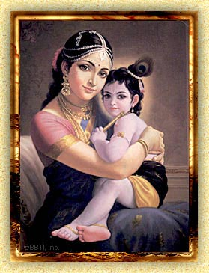
Suddenly there was a loud shriek. Everyone came running to the courtyard and found to their surprise the dead body of Puthana lying on the floor while Krishna was smiling and kicking. People now knew that Krishna was not an ordinary boy. Yashoda happily picked up Krishna and felt safe.

Krishna grew in Yashoda's house until he reached his teens. He later challenged Kamsa and killed him. Then he released his grandfather Ugrasena and reinstated him to his thrown. He respected and loved both his own parents, Vasudeva and Devaki, and his adopted parents, Nanda and Yashoda.

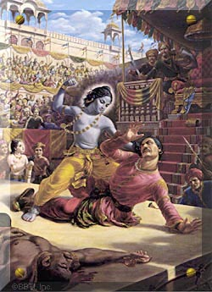
Janamashtami is celebrated with great pomp and show in Hindu temples and homes in Bharat and other countries. The festival is celebrated for two days; on the day when Krishna took birth in the prison of Kamsa at Mathura and also on the following day to commemorate Krishna's presence in the house of Nanda and Yashoda at Gokul. Ardent devotees pray at the middle of the night celebrating Krishna's birth on the first day. Children join the celebration on the next day with worship ( puja ) and sweets ( prasaad ).

Decorations depicting Krishna's birth and his transfer to Gokul, are displayed every where. It is a great fun planning and executing the decoration that depicts Krishna's life in Gokul. The display is left for few days for friends and relatives to enjoy. The grandparents ( or other elders ) narrate to the children the interesting stories of Krishna, his pranks of childhood. Young boys get together and play the Matkhi Todna (breaking the pot), which Krishna used to do when he was in his childhood.

Rangoli is drawn in front of the house depicting the Bala Krishna’s foot steps.



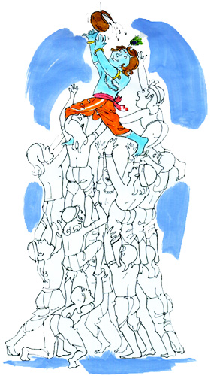

Vijayadashami

AASHWAYUJA SHUKLA DASHAMI
(The Tenth day of the bright half of the lunar month of Aashwayuja)

In Samskritam, 'Vijaya' means Victory and 'Dashami' means 10th day. 'Vijaya Dashami' means victory on the 10th day.

This is among the most auspicious days in the Hindu calendar and comes as the finale of the nine-day festival, Navaraatri. This festival of victory is preceded by worship of Saraswati the Goddess of Learning, Lakshmi, the Goddess of wealth and of Durgaa the Goddess of Strength. Grand processions of all Gods and goddesses are taken out in every town and village on this day, signifying the victory of the forces of righteousness over those of wickedness. Various have been the names of the Goddess of Strength - Durgaa, Mahaa Kaali, Mahishasura Mardini etc., under which that supreme protector of the good and the holy put to rout, time and again, the demoniac forces and established the supremacy of the righteous.

This shows that the vistory is possible only when one has strength, wealth and knowledge.
The story of how Mahishaasura Mardini took birth is striking for its unique message. At one stage the Gods felt powerless against the onslaughts of the demoniac forces headed by Mahishaasura. In answer to their prayers for protection, they were ordered to part with a portion of their divine powers to form into a new Goddess. It was thus that Mahishaasura Mardini took on a physical form as the combined might of all the Gods. The dreaded demon Mahishaasura was slain by Chaamundeshwari after a ceaseless fight of nine days and nights.

The lesson of this legend is so beautifully clear. Even the good and the righteous can succeed against the evil forces only when they come together in an organized endeavor.
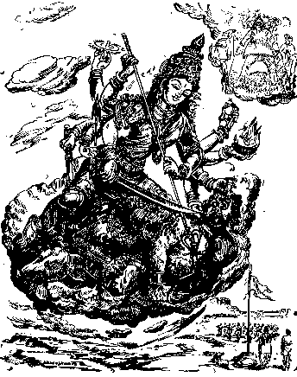

Truly has it been said, ' Sanghe shaktih kalau yuge ' – Being together holds the key to strength in Kaliyuga. And this is the one single, most important lesson which the Hindu people have to learn today.

Vijaya Dashami is the day when Sri Rama killed the daemon Ravana.
Symbolic of the victorious occasion, Raama-Leela is observed with great enthusiasm and eclat in the northern parts of Bharat.

Deepavali
Aashwayuja Krishna Chaturdashi To Kaartika Shukla Dwiteeyaa
(The 14th Day of the dark half of Aashwayuja to the 2nd day of bright half of Kaartik)

If there is one occasion which is all joy and all jubilation for one and all - the young and the old, men and women for the entire Hindu world, it is Deepaavali - the Festival of Lights. Even the humblest of huts will be lighted by a row of earthen lamps. Crackers resound and light up the earth and the sky. The faces of boys and girls flow with a rare charm in their dazzling hues and colors. Illumination - Deepotsavas – in temples and all sacred places of worship and on the banks of rivers symbolize the scattering of spiritual radiance all round from these holy centers. The radiant sight of everybody adorned with new and bright clothes, especially women decorated with the best of ornaments, captures the social mood at its happiest.

And all this illumination and fireworks, joy and festivity, is to signify the victory of divine forces over those of wickedness.
Narakaasura was a demon king ruling over Praagjyotishapura (the present-day Assam). By virtue of his powers and boons secured from God, he became all-conquering. Power made him swollen-headed and he became a menace to the good and the holy men and even the Gods. The Gods headed by Devendra implored Sri Krishna who was at Dwaaraka ( in the present-day Gujarat ) to come to their rescue. Sri Krishna responded. He marched from the western end of the country to its eastern end, Praagjyotishapura, destroyed the huge army which opposed him finally beheaded Narakaasura himself. The populace was freed from the oppressive tyranny and all heaved a sigh of relief. The women kept in captivity by the demon king were freed.

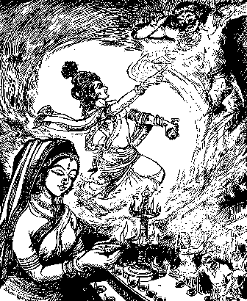 After the slaying of Narakaasura, Sri Krishna bathed himself smearing his body with oil in the early morning of Chaturdashi. Hence the invigorating vogue of taking an early morning `oil-bath' on that day.

Mother Earth, whose son Narakaasura was, requested Sri Krishna that the day be celebrated as one of jubilation. Sri Krishna granted the request and since then the tradition has continued. Mother Earth reconciled herself to the loss of her son and knowing as she did that the Lord had punished her son for the sake of the welfare of the world, she set a glowing example of how one has to brush aside one's personal joys and sorrows in the interest of society. It is this deliverance of the people from the clutches of the asuras that fill the people with joy.
Then follows Amaavaasya, the new moon day, auspicious for offering prayers and gratitude to the bygone ancestors of the family and invoking their memories and blessings for treading the path of right conduct. This is also the sacred occasion for the worship of Lakshmi, the goddess of Wealth and Prosperity. The business community open their New Year's account with Her worship. This reminds us of the famous saying of the sage Vyaasa, ' dharmaadarthashcha kaamashcha...' - it is through right conduct that wealth and fulfilment of desires also accrue.

The third day, i.e., the first day of Kaartik, is named Balipratipada, after the demon king Bali, the ruler of Paataala ( the netherworld ), who had extended his kingdom over the earth also. On that day, Sri Vishnu, taking the form of a dwarfish Brahmin by name Vaamana, approached Bali, for a boon of space equal to his three steps. Bali, known for his charity, gladly granted the boon. Vaamana now grew into a gigantic form; with one step he covered the entire earth, with the second he covered the outer sky, and asked Bali where he should keep his third step. Bali, left with no other choice, showed his own head. Sri Vishnu placed his foot on Bali's head and pushed him down to the netherworld. However, Bali prayed to the Lord that he might be permitted to visit the earth once a year. Now it was the turn of Vishnu to grant the boon. And the people too offer their and respect to him on this day.

The annual visit of Bali is celebrated in Kerala as Onam. It is the most popular festival for Kerala where every Hindu home receives him with floral decorations and lights and festoons adorn all public places. Onam, however, falls on the 16th day of Aavani ( Sowramaana ) in September.

The pratipada is also the day for Govardhana Pooja and Anna Koota ( heap of grains ), the former signifying the Govardhana episode in Sri Krishna's life and the latter conveying affluence and prosperity.

The fourth and final day is Yama Dwiteeya, also called Bahu beej. It is a most touching moment for the family members when even distant brothers reach their sisters to strengthen that holy tie. The sister applies tilak and waves aarati to her brother, and the brother offers loving presents to the sister.

To the Jains, Deepaavali has an added significance to the great event of Mahaaveera attaining the Eternal Bliss of Nirvaana. The passing into Eternity on the same Amaavaasya of Swami Dayananda Saraswati, that leonine sanyasin who was one of the first to light the torch of Hindu Renaissance during the last century, and of Swami Ramatirtha who carried the fragrance of the spiritual message of Hindu Dharma to the western world, have brought the national-cum-spiritual tradition of Deepaavali right up to modern times.


zaiNt mÙa> - þ˜nti mantr˜× (Mantras for Peace)
The following verses are all þ˜nti mantras. The þ˜nti mantra is recited for peace. It is traditionally recited before chanting other mantras, before we begin the studies and at the beginning of any program.

` sh na vvtu, sh naE Éun´ …,
sh vIy¡ krvavhE,
tejiSvnavxItmStu,
ma iviÖ;avhE,
` zaiNt> zaiNt> zaiNt>.
om saha n˜vavatu |
saha nau bhunaktu |
saha vŸryaÕ karav˜vahai |
tejasvin˜vadhŸtamastu |
m˜ vidviÿ˜vahaŸ |
om þ˜nti× þ˜nti× þ˜nti× ||

May Bhagwan protect both of us. May we be nourished together. May we work together. May our studies be brilliant. May we not fight with each other.
Peace. Peace. Peace.

(Note: Here the phrase 'both of us' refer to the teacher and student. This mantra captures the very essence of teaching and learning. Learning is a joint exploration by the Guru and the disciples. The phrase 'our studies' says that it's not the all-knowing teacher teaching the ignorant student, but both making a joint effort in understanding.)

|| Selections from Veda Mantras ||
May all live happily

sveR ÉvNtu suion>,
sveR sNtu inramya>.
sveR ÉÔai[ pZyNtu,
ma kiít! Ê>o-aG-vet!.
` zaiNt> zaiNt> zaiNt>.
sarve bhavantu sukhina|
sarve santu nirämayäù ||
sarve bhadr˜õi paþyantu |
m˜ kaþcit du×khabh˜gbhavet ||
om þ˜nti× þ˜nti× þ˜nti× ||

May all live happily. May all enjoy good health. May all see auspiciousness. May none experience distress. May peace prevail everywhere.
Take Me From darkness to light

` Astae ma sÌmy,
tmsae ma JyaeitgRmy.
m&TyaemaR Am&t¼my,
` zaiNt> zaiNt> zaiNt>.
om asato m˜ sadgamaya |
tamaso m˜ jyotirgamaya ||
m®tyorm˜ am®taðgamaya |
om þ˜nti× þ˜nti× þ˜nti× ||

Bhagawan, lead me from untruth to Truth; Take me from darkness to light; from death to immortality. Let there be peace all around.

inTy ivix ðaeka> - nitya vidhi þlok˜×

(Daily Prayers)
Nityavidhi shlokas are recited at particular times during the day. The following shlokas are a few examples of nityavidhi shlokas. Every action we perform, even mundane things like taking bath, eating, etc., can be turned in to worship by chanting these mantras and contemplating on their meaning.

àat> Smr[m! - pr˜ta× smaraõam
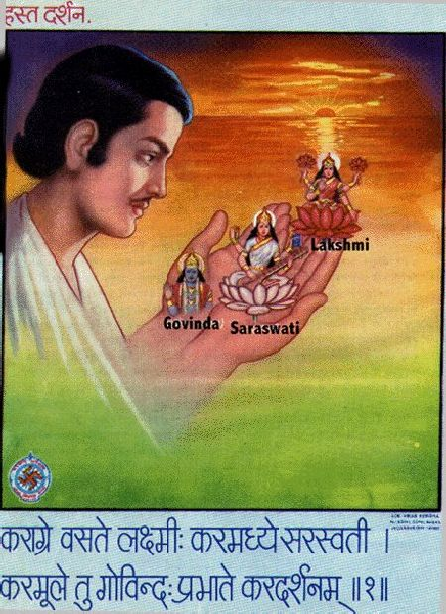
(Morning Prayer)

kra¢e vste lúmI>,
krmXye srSvtI.
krmUle tu gaeivNd>,
à-ate krdzRnm!.
kar˜gre vasate lakÿmŸ×|
karamadhye sarasvatŸ ||
karam¨le tu govinda×|
prabh˜te karadarþanam||

Bhagawati Lakshmi dwells at the tip of the hand. In the center of the palm resides Sarasvati, the Bhagawati of wisdom. At the base of the palm is Govinda. Hence, one should look and meditate on the hand early in the morning.
pQn smye - pa÷hana samaye
(Before commencing Studies)

srSvit nmStu_ym!,
vrde kamêipi[.
iv*arM-< kir:yaim,
isiÏ-Rvtu me sda.
sarasvati namastubhyam|
varade k˜mar¨piõi ||
vidy˜rambhaÕ kariÿy˜mi |
siddhirbhavatu me sad˜||

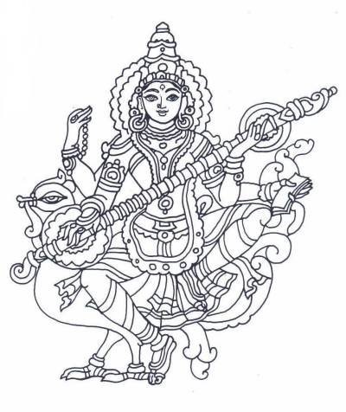
Oh Bhagawati Sarasvati, I bow to you, the fulfiller of my wishes. I begin my studies seeking your blessings so that I shall always be successful.
ÉgviÌta ðaekain - bhagavadgŸt˜ þlok˜ni
(Selected verses from Bhagavad Geeta)

yda yda ih xmRSy Glain-Rvit -art,
A_yuTwanmxmRSy tdaTman< s&jaMyhm!. 4 , 7.
yad˜ yad˜ hi dharmasya gl˜nirbhavati bh˜rata |
abhyutth˜namadharmasya tad˜tm˜naÕ s®j˜myaham || 4 , 7 ||

pirÇa[ay saxUna< ivnazay c Ê:k«tam!,
xmRs<SwapnawaRy sMvaim yuge yuge. 4 , 8.
paritr˜õ˜ya s˜dh¨n˜Õ vin˜þ˜ya ca duÿk®t˜m |
dharmasaÕsth˜pan˜rth˜ya sambhav˜mi yuge yuge || 4 , 8 ||

Whenever there is a decline of Dharma and the rise of Adharma, O Arjuna, then I manifest (or incarnate) Myself. I incarnate from time to time for protecting the good, for destroying the wicked, and for establishing Dharma, the world order.

Ah< vEñanrae -UTva àai[na< dehmaiït>,
àa[apan smayu< pcaMyÚ< ctuivRxm! .
ahaÕ vaiþv˜naro bh¨tv˜, pr˜õin˜Õ deham˜þrita× |
pr˜õ˜p˜na sam˜yuktaÕ, pac˜myannaÕ caturvidham ||
I, says Bhagawan, am the Fire in you, I am residing in body of living beings, I am in the air you inhale and exhale, I am in the food you take.

jatSy ih Øuvae m&TyuØuRv< jNm m&tSy c,
tSmadpirhayeR=weR n Tv< zaeictumhRis. 2 , 27.
j˜tasya hi dhruvo m®tyurdhruvaÕ janma m®tasya ca |
tasm˜daparih˜rye'rthe na tvaÕ þocitumarhasi || 2 , 27 ||

Because, death is certain for the one who is born, and birth is certain for the one who dies. Therefore, you (Arjuna) should not lament over the inevitable.

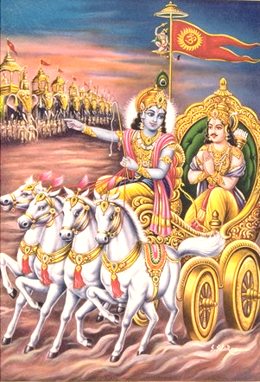

There are 13 mantras which are different names of Sun God. We should chant a mantra before each Surya Namaskar.

The mantras are as follows:
Om Mitraaya Namah
Om Ravaye Namah
Om Suryaaya Namah
Om Bhaanave Namah
Om Khagaaya Namah
Om Puushne Namah
Om Hiranyagarbhaaya Namah

Om Mareechaye Namah
Om Aadityaaya Namah
Om Savitre Namah
Om Arkaaya Namah
Om Bhaaskaraaya Namah
Om Shree Savitru Suurya Naaraayanaaya Namah

This aasana (exercise) is performed at sun-rise and starts with a salutation to Sun God, Sooryanamaskar (standing) posture:

- Soorya Namaskar Sthiti (Starting Posture):
  - Ek: Join the heels, hands on the side, fingers facing down and palm open.
  - DO: Join the toes.
  - Teen: Join your hands to form Namaste position. Palms should be pressing against each other and the thumb joint should be at sternum.



Starting Position and Ten

Nine
Bring the right foot forward and stand up as in Do.

One
Slowly raise hands with biceps touching the ears and hands in namaste posture. Bend backwards from waist. Do not bend the knees. Look towards palm.
In this posture, breathing is normal and slow. Face should be normal and relaxed.

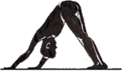
Seven
Form a mountain like posture. Push your chin towards the chest. Heels should touch the floor.

Eight
bring your left foot forward all the way between the hands.


Two
Slowly bend forward from the waist. Try to touch palm to the floor on either side of your legs. Do not bend the knees. Nose should touch the knees. People with back problems should not bend too much. Bend only as much it is comfortable.
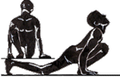
Three
Take your left foot back. Left kneee should touch the floor. Two palms should be completely on the ground and the right foot should be in between the two hands. Fingers should be pointing to the front. Lean forward on the right knee, so that calf and thigh muscles press against each other chest rests on the thigh. Look up and make a concave on your back.


Four
Take right foot back and join with left foot. Arms should be straight. Most of the weight will be on the arms. The body should be in one plane like a slide.


Six
Come forward and bend back as much as you can. Abdomen should come between your hands. Look back from the top. Two legs should be joined.

Five
Bend your arms and touch your feet, knees, chest and forehead to the ground. Do not touch abdomen or nose

Yogasan
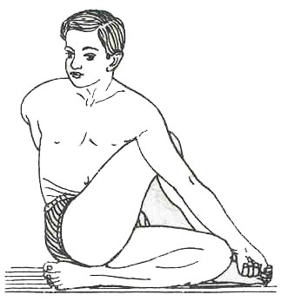

Ardha-Matsyendrasan
Time: 2 minutes each side.
Method:
Bend left knee, place left foot under right hip. Bend right knee, place right foot on left side of left knee. Hold left knee or right foot with the left hand - keep right knee on the left of left arm. Turn tunk to right, look back over right shoulder, right hand on ground or on waist as close to left thigh as possible. Repeat with left knee bent and trunk turning to left.
NOTE:
You may also hold hold hands through the gap below the raised knee.
Benefits:
Increase the elasticity of the spine, and massage the abdomen and internal organs.

Bhadrasan
Time: 2 minutes
Method:
Sit holding feet together, heels as close to groin as possible, head up, chin down, normal breathing.
Benefits:
Specially recommended for those suffering from urinary disorder. The pelvis, the abdomen and the back get stimulated through a plentiful supply of blood. Keeps the kidneys, the prostate and the bladder healthy.
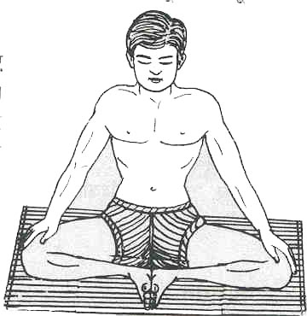
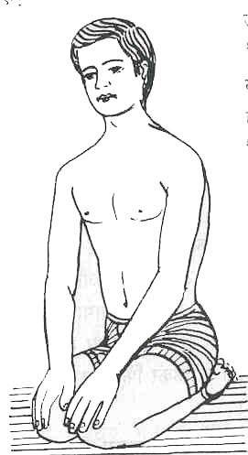

Vajrasan
Time: 2 minutes
Method:
Sit on your heels. Hands on knees, abdomen drawn in, chest up, back straight, shoulders squared, head erect. Normal breathing.

Benefits:
Aids digestion and helps cure sciatica.

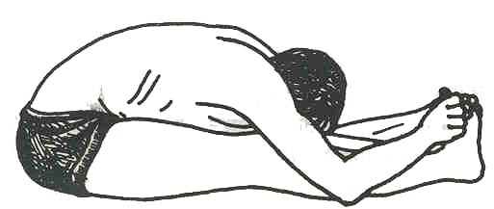
Paad-Pashchimottanasan
Time: 2 minutes
Method: Lie on your back, legs straight, arms overhead, hands together, palms facing up. Sit up, take hands overhead, back straight, then bend forward to hold the big toes, head between arms and touching the knees.

Benefits:
Reduces abdominal fat. Removes wind from the intestines and increases appetite.

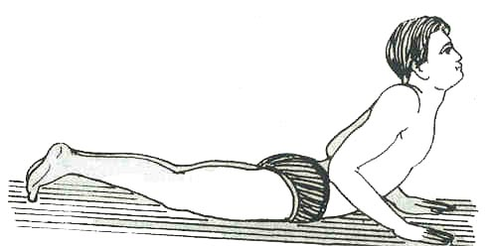

Bhujangasan

Time: 1/2 minutes.
Method: Lie on your stomach, forehead on the ground, hands under shoulders. Raise your upper body by the strength of the back muscles, head up. Don't take help of the hands, they may remain on the ground or held on the back over the hips.
Benefits:
Helps in keeping the dorsal spine elastic and strong. Backache due to overstrain can be thus relieved. Helps considerably in reducing abdominal fat.

Dhanurasan
Time: 1/2 minute
Method: Lie on your stomach. Bend knees, hold the ankles. Pull your hands and push with your legs, knees together, till the trunk forms an arch
with only the stomach on the ground. Look up. After releasing the posture lie for a while in Shavasan.
Benefits:
Reduces abdominal fat. The compressing of the spinal column, pressing the nerves with the scapulae (the winged bones at the back attached to the arms) minimizes blood circulation while in the asan. But when the pose is released a greater supply of blood is endured to those very regions increasing spinal flexibility and definitely raising the vitality.
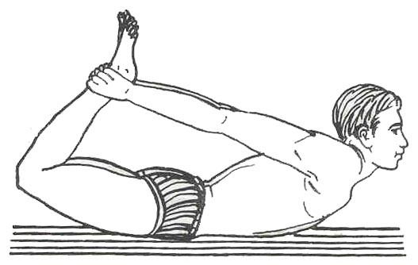

Matsyasan
Time: 1/2 minutes.
Method: Sit with legs an in Padmasan - knees bent, feet on opposite thighs, heels towards the abdomen. Lie on your back. Placing hands near the head for support lift your back above the ground, keep the top of your head on the ground over a padded surface, e.g., a towel. Keep your hands an your feet. Normal breathing.
Benefits:
Makes the neck flexible and strong, increases the size of the rib cage, widens the windpipe and thus helps deep breathing. Relieves the neck after Sarvangasan.

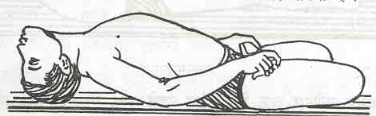

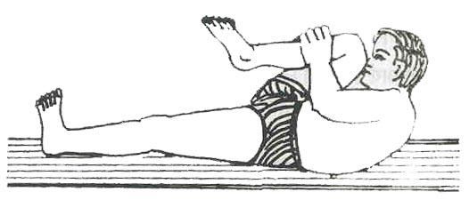

Pavan-Muktasan

Time: 1/2 minutes each leg.
Method: Lie down on your back. Breath in. Then fold the left leg from the knees. Hold the fingers together and bring the folded leg to touch the stomach. Lift the head and touch the nose to the knee. The other leg remains straight. Hold the breath. Come to original position and leave the breath. Follow the same for the other leg.
NOTE: This asan can also be done with both the knees folded.
Benefits: Removes gas from the abdomen and reduces abdominal fat. Increases the flexibility of the knees and hips.

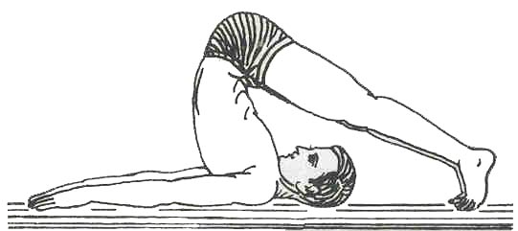

Halasan

Time: 2 minutes
Method: Lie on your back, arms alongside. Raise legs an in Sarvangasan (you may take help of hands on the hips), then lower them overhead, knees straight, ankles stretched, toes pointed and touching the ground. Arms stay on ground as in the beginning, palms on the ground. The posture resembles the shape of a plough.
Benefits:
Makes the spine flexible, creates energy, and blood of the muscles of the back. Aids the functioning of the thyroid and thymus glands thus helping retain the individual's youthful physical characteristics for a longer period.

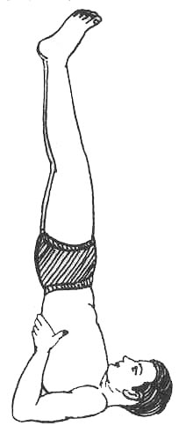

Sarvangasan

Time: 2 minutes
Method: Lie on your back, arms alongside. Raise both legs together - taking support of hands on the hips and the
elbows on the ground. Straighten the body - feet, knees, hips and back form one vertical column from the base of the neck to the tip of the toes, feet stretched, toes pointed, chin pressed against the chest. Normal breathing.
Benefits:
Promotes healthy secretion of the circulatory, respiratory, alimentary and genito-urinary systems. Keeps the spine flexible preventing the bones from early ossification. Supplies large quantity of blood to the spinal roots of the nerves, thereby giving them sufficient nourishment.

ho'nge' kAm yAb, ho'nge' kAm yAb  hum ho'nge' kAm yAb Ek din  ho' ho'man me' hai vishwAs  pUrA hai vishwAs  hum ho'nge' kAm yAb Ek din || | We will be successful  One day, we will be successful.  The confidence is in us  Full confidence, we have in us  One day we will be successful.
ho'ge' shAnti chAro'm Or  ho'gee shAnti chAro'm Or  ho'gee shAnti chAro'm Or Ek din ||  ho' ho'man me' hai vishwAs  pUrA hai vishwAs  ho'gee shAnti chAro'm Or Ek din || | There will be peace every where  There will be peace every where  One day, there will be peace all around.  Full confidence, we have in us  One day we will be successful.
hum chale'nge' sAth-sAth  DAl hAtho'm me' hAth  hum chale'nge' sAth-sAth Ek din ||  ho' ho'man me' hai vishwAs  pUrA hai vishwAs  hum chale'nge' sAth-sAth Ek din || | We all will walk together  Holding hand in hand.  One day, we all will walk together.  Full confidence, we have in us  One day we will be successful.
nahe' Dar kisee kaa Aj  nahee bhay kisee kaa Aj  nahe' Dar kisee kaa Aj kE din ||  ho' ho'man me' hai vishwAs  pUrA hai vishwAs  nahe' Dar kisee kaa Aj kE din || | No fear of anything today.  Not afraid of any one today.  One day we all will be fearless.  Full confidence, we have in us  One day we will be successful.

  The Vanguard Of  Hindu Swayamsevak Sangh, USA  Six million women and men in two dozen countries across six continents, the world’s largest volunteer organization!  Every one has a role to play and a way to contribute. Offer your talents, time and resources in this important task of building a strong Hindu society and serving the cause of Sanatana Dharma.  You may join this effort by  - Regularly attending the Shakha near to you.  - Tell your friends about the HSS activities  - Attend festivals and other events conducted by HSS.  - Offer your skills like web site creation, artistic work, writing, speaking etc. to the cause of Hindu society.  - Any other way you can think of …  Hindu Resources on Web  http://www.hindunet.org  http://www.freeindia.org  http://www.hinduunity.org  http://members.tripod.com/~sudheerb/  http://www.hindubooks.org/  http://www.hvk.org/  http://hssworld.org  http://rss.org  http://hindumythology.com/  http://hindukids.org  http://sarasvati.simplenet.com  Shakha in Bay Area and Contacts | Sunnyvale  Sunnyvale  Atul Athavale  408-739-7074  Cupertino  Swarraj Kulkarni  408-777-0487  San Jose  Nitin Shroff  408-227-1957  Fremont/Milpitas  Deepa Jaiswal  408-946-4283  Ardenwood  Ramesh Bhatta  510-487-0993  San Ramon  Shyam Penumaka  925-820-9403  Sacremento  Vijay Bhaskar  916-638-1271  For information on future shakhas,  Gautam Desai  510-623-7541  Dharmendra R  408-481-9595  Email: bayarea@hssworld.org  http://www.hssworld.org |   The global movement dedicated to organizing the Hindu society world wide.    dhanyavaad Thank You

