Hindu Heritage Camp

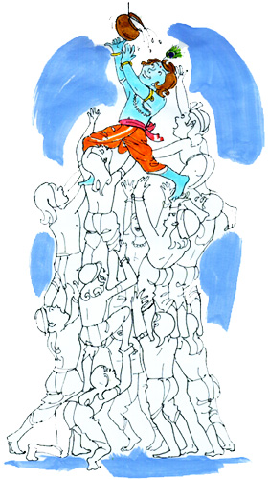

CONTENTS

CHAPTER | PAGE
SONGS (GEET)
Camp Song | 3
Arti | 4
STORIES
Dr. Rajendra Prasad | 6
Netaji Subash Chandra Bose | 8
Dr. C.V. Raman | 11
Dr. Shrinivasa Ramanujam | 12
Rana Pratap | 14
Mir Birbal | 16
Tenali Rama | 22
Shloka
Morning time Shlokas | 27
Shlokas on Unity | 27
In praise of the Gods | 27
Shlokas for bedtime | 29
Soorya Namaskar | 30
YogAsan | 32

CAMP SONG

Sootra sanghatan, sambhal jyoti, ye jale
koti koti, deepa baala, jyoti ye jale ||
vishwa, andhakaara ke, vinaash keliye
chira ateetke, dhaval, prakaash keliye
budhi ke, vivek ke, vikaas keliye
vrudhi ke, samrudhi ke, prayaas keliye
tyaag keliye, mashaal jyoti, ye jale ||
koti koti, deepa baala, jyoti ye jale
Sootra sanghatan, sambhal jyoti, ye jale
koti koti, deepa baala, jyoti ye jale||
Koti koti, kanTha ki, pukaar ek ho

Koti koti, budhi ka, vichaar ek ho
koti koti, praaN ka, shrungaar ek ho
ek dhyeya, aur jeet, haar ek ho
vishwa Ko, bana nihaal, jyoti ye jale||
Koti koti, deepa baala, jyoti ye jale
sootra sanghatan, sambhal jyoti, ye jale
koti koti, deepa baala, jyoti ye jale

ARTI --Om Jai Jagdish Hare

Om jai Jagdish hare  Swami jai Jagdish hare  Bhakt jano ke sankat  Das jano ke sankat  Kshan men door kare  Om jai Jagdish hare  Mat pita tum mere  Sharan padun main kiski  Swami sharan padun main kiski  Tum bin aur na dooja  Prabhu bin aur na dooja  Aas karun main jiski  Om jai Jagdish hare  Tum puran Parmatam  Tum Antaryami  Swami tum Antaryami  Par Brahm Parmeshwar  Par Brahm Parmeshwar  Tum sabke swami  Om jai Jagdish hare  Tum ho ek agochar  Sab ke pranpati  Swami sab ke pranpati  Kis vidh milun Gosain  Kis vidh milun Dyalu  Tum ko main kumti  Om jai Jagdish hare  Deen bandhu dukh harta  Thakur tum mere  Swami Thakur tum mere  Apne haath uthao  Apni sharani lagao  Dwar pada hoon tere  Om jai Jagdish hare  Vishay vikar mitao  Paap haro Deva  Swami paap haro Deva  Shradha bhakti badao  Shradha prem badao  Santan ki seva  Om jai Jagdish hare  Om jai Jagdish hare  Swami jai Jagdish hare  Bhakt jano ke sankat  Das jano ke sankat  Kshan men door kare  Om jai Jagdish hare | Oh Lord of the whole Universe  Mighty Lord of the whole Universe  All Thy devotees' agonies  All Thy devotees' sorrows  Instantly Thou banisheth  Oh Lord of the whole Universe  Thou art my Mother and Father  At Thy feet I seek eternal truth  Lord, at Thy feet I seek eternal truth  There's none other than Thee, Lord  There's none other than Thee, Lord  Guardian of all our hopes  Oh Lord of the whole Universe  Thou art Godly perfection  Omnipotent Master of all  My destiny's in Thy Hand  Supreme Soul of all Creation  Oh Lord of the whole Universe  Thou art beyond all perception  Formless and yet multiform  formless and yet multiform  Grant me a glimpse of Thyself  Grant me a glimpse of Thyself  Guide me along the path to Thee  Oh Lord of the whole Universe  Friend of the helpless and feeble  Benevolent saviour of all  Lord, benevolent saviour of all  Offer me Thy hand of compassion  Offer me Thy hand of compassion  I seek refuge at Thy feet  Oh Lord of the whole Universe  Surmounting the earthly desires  Free from the sins of this life  Lord, free from the sins of this life  Undivided faith and devotion  Undivided faith and devotion  In eternal service unto Thee  Oh Lord of the whole Universe  Oh Lord of the whole Universe  Mighty Lord of the whole Universe  All Thy devotees' agonies  All Thy devotees' sorrows  Instantly Thou banisheth  Oh Lord of the whole Universe


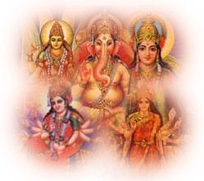



Dr. Rajendra Prasad, son of Mahadev Sahai, was born in Zeradei, Bihar on December 3, 1884. Being the youngest in a large joint family "Rajen" was greatly loved. He was strongly attached to his mother and elder brother Mahendra.
Rajen was a brilliant student; standing first in the entrance examination to the University of Calcutta, he was awarded a Rs.30/month scholarship. He joined the famed Calcutta Presidency College in 1902. His scholarship, ironically, would pose the first test of his patriotism. Gopal Krishna Gokhale had started the Servants of India Society in 1905 and asked Rajen to join. So strong was his sense of duty toward his family and education that he, after much deliberation, refused Gokhale. But the decision would not rest easy on him. Rajen recalled, "I was miserable" and for the first time in his life his performance in academia declined, and he barely cleared his law examinations.

Having made his choice, however, he set aside the intruding thoughts, and focused on his studies with renewed vigor. In 1915, Rajen passed the Masters in Law examination with honors, winning a gold medal. Subsequently, he completed his Doctorate in Law as well.
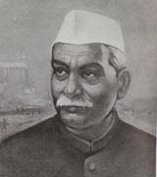
As an accomplished lawyer, however, Rajen realized it would be only a matter of time before he would be caught up in the turmoil of the fight for independence. While Gandhiji was on a fact finding mission in Chamaparan district of Bihar to address grievances of local peasants, he called on Rajendra Prasad to come to Champaran with volunteers. Dr. Prasad rushed to Champaran. Initially he was not impressed with Gandhiji's appearance or conversation. In time, however, Dr. Prasad was deeply moved by the dedication, conviction and courage that Gandhiji displayed. Here was a man alien of the parts, who had made the cause of the people of Champaran his own. Dr. Prasad decided that he would do everything he could to help, with his skills as a lawyer and as an enthusiastic volunteer.

Whenever the people suffered, Dr. Prasad was present to help reduce the pain. In 1914 floods ravaged Bihar and Bengal. Dr. Prasad became a volunteer distributing food and cloth to the flood victims. In 1934, Bihar was shaken by an earthquake, which caused immense damage and loss of property. Floods and an outbreak of malaria, which heightened misery, followed the quake, devastating by itself. Dr. Prasad dove right in with relief work, collecting food, clothes and medicine. His experiences here led to similar efforts elsewhere too. In 1935, an earthquake hit Quetta. Dr. Prasad was not allowed to lend a hand because of Government restrictions. Nevertheless, he set up relief committees in Sind and Punjab for the homeless victims who flocked there.

Dr. Prasad called for non-cooperation in Bihar as part of Gandhiji's non-cooperation movement. Dr. Prasad gave up his law practice and started a National College near Patna, 1921. The college was later shifted to Sadaqat Ashram on the banks of the Ganga. The non-cooperation movement in Bihar spread like wildfire. Dr. Prasad toured the state, holding public meeting after another, collecting funds and galvanizing the nation for a complete boycott of all schools, colleges and Government offices. He urged the people to take to spinning and wear only khadi. Bihar and the entire nation were taken by storm, the people responded to the leaders' call. The machinery of the mighty British Raj was coming to a grinding halt

Dr. Prasad stood by his mentor, seeing the wisdom behind Gandhiji's actions. In March 1930, Gandhiji launched the Salt Satyagraha. A salt Satyagraha was launched in Bihar under Dr. Prasad. Nakhas Pond in Patna was chosen as the site of the Satyagraha. Batch after batch of volunteers courted arrest while making salt. Many volunteers were injured. Dr. Prasad called for more volunteers. Public opinion forced the Government to withdraw the police and allow the volunteers to make salt. Dr. Prasad then sold the manufactured salt to raise funds. He was sentenced to six months imprisonment.

His service on the various fronts of the movement for independence raised his profile considerably. Dr. Prasad presided over the Bombay session of the Indian National Congress in October 1934. Following the resignation of Subhash Chandra Bose as the President of the Congress in April 1939, Dr. Prasad was elected President. He did his best to heal the rifts created between the incompatible ideologies of Subhash Chandra Bose and Gandhiji. Rabindranath Tagore wrote to Dr. Prasad, "I feel assured in my mind that your personality will help to soothe the injured souls and bring peace and unity into an atmosphere of mistrust and chaos..."

In July 1946, when the Constituent Assembly was established to frame the Constitution of India, Dr. Rajendra Prasad was elected its President. Two and a half years after independence, on January 26, 1950, the Constitution of independent India was ratified and Dr. Rajendra Prasad was elected the nation's first President. Dr. Prasad transformed the imperial splendor of Rashtrapati Bhavan into an elegant "Indian" home. Dr. Prasad visited many countries on missions of goodwill, as the new state sought to establish and nourish new relationships. He stressed the need for peace in a nuclear age.
In 1962, after 12 years as President, Dr. Prasad retired, and was subsequently awarded the Bharat Ratna, the nation's highest civilian award. With the many tumults of his vigorous and accomplished life, Dr. Prasad recorded his life and the decades before independence in many books, among the more noted of which are "Satyagraha at Champaran" (1922), "India Divided" (1946), his autobiography "Atmakatha" (1946), "Mahatma Gandhi and Bihar, Some Reminisences" (1949), and "Bapu ke Kadmon Mein" (1954). Dr. Prasad spent the last few months of his life in retirement at the Sadaqat Ashram in Patna. He died on February 28, 1963. In her first citizen, India had imagined a life of possibilities, and seen an unsurpassed dedication to making them real.

Subhas Chandra was born on January 23rd 1897 in Cuttack (in present day Orissa) as the ninth child among fourteen, of Janakinath Bose, an advocate, and Prabhavatidevi, a pious and God-fearing lady. A brilliant student, he topped the matriculation examination of Calcutta province and passed his B.A. in Philosophy from the Presidency College in Calcutta. He was strongly influenced by Swami Vivekananda's teachings and was known for his patriotic zeal as a student. His parents' wishes kept him away from the Indian freedom struggle and led him into studies for the Indian Civil Service in England. Although he finished those examinations also at the top of his class (4th), he could not complete his aprecentship and returned to India, being deeply disturbed by the Jallianwalla Bagh massacre. He came under the influence of Mahatma Gandhi and joined the Indian National Congress (a.k.a. Congress). Gandhiji directed him to work with Deshbandhu Chittaranjan Das, the Bengali leader whom Bose acknowledged as his political guru.

Bose was outspoken in his anti-British stance and was jailed 11 (eleven) times between 1920 and 1941 for periods varying between six months and three years. He was the leader of the youth wing of the Congress Party, in the forefront of the trade union movement in India and organized Service League, another wing of Congress. He was admired for his great skills in organization development.

Bose advocated complete freedom for India at the earliest, whereas the Congress Committee wanted it in phases, through a Dominion status. Other younger leaders including Jawaharlal Nehru supported Bose and finally at the historic Lahore Congress convention, the Congress had to adopt Poorna Swaraj (complete freedom) as its motto. Bhagat Singh's martyrdom and the inability of the Congress leaders to save his life infuriated Bose and he started a movement opposing the Gandhi-Irvin Peace Pact. He was imprisoned and expelled from India. But defying the ban, he came back to India and was imprisoned again!

Clouds of World War II were gathering fast and Bose warned the Indian people and the British against dragging India into the war and the material losses she could incur. He was elected president of the Indian National Congress twice in 1937 and in 1939, the second time defeating Gandhiji's nominee. He brought a resolution to give the British six months to hand India over to the Indians, failing which there would be a revolt. There was much opposition to his rigid stand, and he resigned from the post of president and formed a progressive group known as the Forward Block (1939).

The second World War broke out in September of 1939, and just as predicted by Bose, India was declared as a warring state (on behalf of the British) by the Governor General, without consulting Indian leaders. The Congress party was in power in seven major states and all state governments resigned in protest.

Subhas Chandra Bose now started a mass movement against utilizing Indian resources and men for the great war. To him, it made no sense to further bleed poor Indians for the sake of colonial and imperial nations. There was a tremendous response to his call and the British promptly imprisoned him. He took to a hunger strike, and after his health deteriorated on the 11th day of fasting, he was freed and was placed under house arrest. The British were afraid of violent reactions in India, should something happen to Bose in prison.

Bose suddenly disappeared in the beginning of 1941 and it was not until many days that authorities realized Bose was not inside the house they were guarding! He traveled by foot, car and train and resurfaced in Kabul (now in Afghanistan), only to disappear once again. In November 1941, his broadcast from German radio sent shock waves among the British and electrified the Indian masses that realized that their leader was working on a master plan to free their motherland. It also gave fresh confidence to the revolutionaries in India who were challenging the British in many ways.

The Axis powers (mainly Germany) assured Bose military and other help to fight the British. Japan by this time had grown into another strong world power, occupying key colonies of Dutch, French, and British colonies in Asia. Bose had struck alliance with Germany and Japan. He rightly felt that his presence in the East would help his countrymen in freedom struggle and second phase of his saga began. It is told that he was last seen on land near Keil canal in Germany, in the beginning of 1943. He undertook a most hazardous journey under water, covering thousands of miles, crossing enemy territories. He was in the Atlantic, the Middle East, Madagascar and the Indian Ocean. Battles were being fought over land, in the air and there were mines in the sea. At one stage he traveled 400 miles in a rubber dingy to reach a Japanese submarine, which took him to Tokyo. He was warmly received in Japan and was declared the head of the Indian army, which consisted of about 40,000 soldiers from Singapore and other eastern regions. Bose called it the Indian National Army (INA) and a government by the name "Azad Hind Government" was declared on the 21st of October 1943. INA freed the Andaman and Nicobar islands from the British and were renamed as Swaraj and Shaheed islands. The Government started functioning.
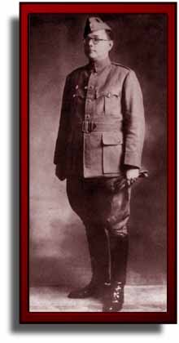

Bose wanted to free India from the Eastern front. He had taken care that Japanese interference was not present from any angle. Indians managed army leadership, administration and communications only. Subhash Brigade, Azad Brigade and Gandhi Brigade were formed. INA marched through Burma and occupied Coxtown on the Indian Border. A touching scene ensued when the solders entered their 'free' motherland. Some lay down and kissed, some placed pieces of mother earth on their heads, others wept. They were now inside of India and were determined to drive out the British! Delhi Chalo (Let's march to Delhi) was the war cry.
The bombing of Hiroshima and Nagasaki changed the history of mankind. Japan had to surrender. Bose was in Singapore at that time and decided to go to Tokyo for his next course of action. Unfortunately, the plane he boarded crashed near Taipei and he died in the hospital of severe burns. He was just 48.

The Indian people were so much enamored of Bose's oratory and leadership qualities, fealressness and mysterious adventures, that he had become a legend. They refused to believe that he died in the plane crash. The famous Red Fort trial where Bose's generals and the INA officers were tried became landmark events. Initially, the British Government thought of a court-martial, but there was a countrywide protest against any kind of punishment. For common Indians, Axis and Allied powers hardly mattered, but they could not tolerate punishment of fellow countrymen who were fighting for freedom. The British Government was in no position to face open rebellion or mutiny and a general amnesty for INA soldiers was declared.
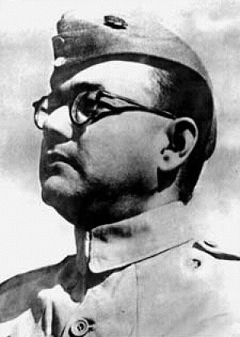 Had he lived, Subhas Chandra Bose could have given a new turn to Independent India's political history. But he lives on eternally in the Indian mind, more famous after his death.
While Bose's approach to Indian freedom continues to generate heated debate in the Indian society today, there is no denying of his burning patriotism, his tireless efforts to free India from inside and outside and his reckless adventures in trying to reach his goals. His exploits later became a legend due to the many stories carried by the disbanded INA soldiers who came from every nook and corner of our great country.



Raman was born on Nov 7, 1888, in Tiruvanaikkaval, Madras. He attended the A.V.N. College and then the Presidency College of the University of Madras, from where he received his B.A. degree. In 1906, at the age of eighteen, he published his first paper in the Philosophical Magazine. He received his M.A. degree in 1907 with top honours. Higher studies in England were ruled out on medical grounds and opportunities for a research career in India were nil. He decided to join the coveted Indian Civil Services (ICS). To join the ICS, one had to appear for an examination in England, so he took the next best bet, the Financial Civil Service (FCS).
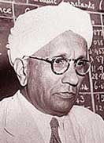

In 1907, he married Loksundari and that very year was posted as Assistant Accountant-General in Calcutta. He worked for ten years in the Indian Finance Department, and even there continued his research and published no fewer than 30 papers.

In 1917, Raman was offered the Palit Chair for Physics by Sir Asutosh Mookerjee, the Vice-Chancellor of the Calcutta University. Even thouhgh it meant huge pay cut (from Rs 1100 to Rs 600), Raman resigned from his Government job and joined the University of Calcutta.

In 1921, Raman represented the University of Calcutta at the British Universities Congress at Oxford and delievered a lecture before the Royal Society of London on the theory of stringed instruments. In 1924, he was elected Fellow of the Royal Society, London and was knighted by the British Government in India in 1929

While at Calcutta, he made significant contributions to the field of vibration and sound, musical intruments, ultrasonics, diffraction, meterological and colloid optics, photoelectricity, x-ray diffraction, magnetism, dielectrics and Raman effect.

In 1930, he received the Nobel Prize in physics for the discovery of the Raman effect thus becoming the first Asian to receive a Nobel Prize in Science.

In 1932, following personal clashes with Saha; Raman resigned from the University of Calcutta and assumed the Directorship of the Tata Institute of Sciences (now known as the Indian Institute of Science), Bangalore.

In 1947, Raman founded an institution of his own, near the offices of the Indian Academy of Science, which he had also founded in 1935.

Raman died on Nov. 21, 1970, at the age of 82, and was cremated in his rose garden.

Srinivasa Ramanujan was one of India's greatest mathematical geniuses. He made substantial contributions to the analytical theory of numbers and worked on elliptic functions, continued fractions, and infinite series.

Ramanujan was born in his grandmother's house in Erode, a small village about 400 km southwest of Madras. When Ramanujan was a year old his mother took him to the town of Kumbakonam, about 160 km closer to Madras. His father worked in Kumbakonam as a clerk in a cloth merchant's shop. In December 1889 he contracted smallpox.

When he was nearly five years old, Ramanujan entered the primary school in Kumbakonam although he would attend several different primary schools before entering the Town High School in Kumbakonam in January 1898. At the Town High School, Ramanujan was to do well in all his school subjects and showed himself an able all round scholar. In 1900 he began to work on his own on mathematics summing geometric and arithmetic series.
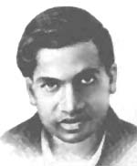

Ramanujan was shown how to solve cubic equations in 1902 and he went on to find his own method to solve the quartic. The following year, not knowing that radicals could not solve the quintic, he tried (and of course failed) to solve the quintic.

It was in the Town High School that Ramanujan came across a mathematics book by G S Carr called Synopsis of elementary results in pure mathematics. This book, with its very concise style, allowed Ramanujan to teach himself mathematics, but the style of the book was to have a rather unfortunate effect on the way Ramanujan was later to write down mathematics since it provided the only model that he had of written mathematical arguments. The book contained theorems, formulas and short proofs. It also contained an index to papers on pure mathematics, which had been published in the European Journals of Learned Societies during the first half of the 19th century. The book, published in 1856, was of course well out of date by the time Ramanujan used it.

By 1904 Ramanujan had begun to undertake deep research. He investigated the series (1/n) and calculated Euler's constant to 15 decimal places. He began to study the Bernoulli numbers, although this was entirely his own independent discovery.

Ramanujan, on the strength of his good schoolwork, was given a scholarship to the Government College in Kumbakonam, which he entered in 1904. However the following year his scholarship was not renewed because Ramanujan devoted more and more of his time to mathematics and neglected his other subjects. Without money he was soon in difficulties and, without telling his parents, he ran away to the town of Vizagapatnam about 650 km north of
Madras. He continued his mathematical work; however, and at this time he worked on hypergeometric series and investigated relations between integrals and series. He was to discover later that he had been studying elliptic functions.

In 1906 Ramanujan went to Madras where he entered Pachaiyappa's College. His aim was to pass the First Arts examination that would allow him to be admitted to the University of Madras. He attended lectures at Pachaiyappa's College but became ill after three months study. He took the First Arts examination after having left the course. He passed in mathematics but failed all his other subjects and therefore failed the examination. This meant that he could not enter the University of Madras. In the following years he worked on mathematics developing his own ideas without any help and without any real idea of the then current research topics other than that provided by Carr's book. Continuing his mathematical work Ramanujan studied continued fractions and divergent series in 1908. At this stage he became seriously ill again and underwent an operation in April 1909 after which he took him some considerable time to recover. He married on 14 July 1909 when his mother arranged for him to marry a nine year old girl S Janaki Ammal. Ramanujan did not live with his wife, however, until she was twelve years old.

Ramanujan continued to develop his mathematical ideas and began to pose problems and solve problems in the Journal of the Indian Mathematical Society. He devoloped relations between elliptic modular equations in 1910. After publication of a brilliant research paper on Bernoulli's numbers in 1911 in the Journal of the Indian Mathematical Society he gained recognition for his work. Despite his lack of a university education, he was becoming well known in the Madras area as a mathematical genius.

The University of Madras gave Ramanujan a scholarship in May 1913 for two years and, in 1914, Hardy brought Ramanujan to Trinity College, Cambridge, to begin an extraordinary collaboration. Setting this up was not an easy matter. Ramanujan was an orthodox Brahmin and so was a strict vegetarian. His religion should have prevented him from travelling but this difficulty was overcome, partly by the work of E H Neville who was a colleague of Hardy's at Trinity College and who met with Ramanujan while lecturing in India.

On 16 March 1916 Ramanujan graduated from Cambridge with a Bachelor of Science by Research (the degree was called a Ph.D. from 1920). He had been allowed to enrol in June 1914 despite not having the proper qualifications. Ramanujan's dissertation was on Highly composite numbers and consisted of seven of his papers published in England.


Rana Pratap (1540-1597), as he is popularly called in India, was born in the kingdom of Mewar, in modern-day Rajasthan, which was ruled by his father. In 1568, Akbar conquered Chittaur, Mewar's capital. In 1572, Pratap became Rana (king) of Mewar with the support of the elder nobles. He then began a life-long war against Akbar.
At a time when the formidable fort of Chittaur, his ancestral home, was under Mughal occupation and his co-Rajputs such as Raja Man Singh of Jaipur were part of Akbar's council. He stood alone in fighting the Mughal supremacy over Rajputana. He lived a life of a fugitive drawn away from Chittaur by Akbars's onslaught. He cherished a dream of regaining the lost glory of Mewar. Many a times Akbar tried to win him over by his friendly gestures but Maharana was unrelenting, he refused to surrender and even returned Akbar's special emissary Raja Man Singh, of Amber, saying that he is not ready to talk to a person who got his sister married to a foreigner.
Insulted, Raja Man Singh came back with a huge Mughal army. Later a gruesome and bloody battle followed between Rana Pratap's forces and Mughal forces, which were lead by fellow Rajput rulers who had joined hands with Akbar, in Haldi Ghati, the year was 1576. Many soldiers of Mewar were killed or captured but Pratap wasn't. He escaped to the hills in his legendary horse Chetak.
Later on, he organized a small army of Bheels (a tribe of India) and started a Guerrilla war against Akbar. In the later stages of his life he re-conquered some parts of Mewar but due to failing health and an untimely death his long cherished goal of winning back Chittaur, remained unaccomplished.

Rana Pratap was another great Raiput king. He was Rana Sanga's grandson. He was as brave as his grandfather. Akbar ruled in Delhi at that time. Akbar had captured Chitor and left it in ruins. Out of fear of Akbar some Rajputs joined Akbar, Akbar wanted Pratap, too, to come over to his side. He sent some of his Rajput followers to the Rana to persuade him to make his peace with Akbar.

They told him, "Why don't you join Akbar? He has a very big army. You cannot defeat him."
A big battle was fought at Haldighat between Rana Pratap and Akbar. The Rana fought like a lion. Several thousand Rajput soldiers died. The Rana and his noble horse Chetak were wounded. Chetak later died. The Rana took to the hills.

From there fought Akbar's army.

The Rana and his family lost everything. They became poor. Yet, he went on fighting till he died. Ever since, people sing of the glorious deeds of Rana Pratap and of his noble horse Chetak.
The Rana said "No".
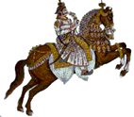
Mughal period gained in glory and power during Akbar's long reign of nearly forty years. Most of the part of Akbar's rule went on consolidating Mughal territory over India. He was a general par excellence. When Gujarat revolted against the Mughal rule in 1573, he marched from his capital Fatehpur-Sikri to Ahmadabad, a distance of 600 miles, with 3,000 horsemen in nine days. He defeated a large army of insurgents on the eleventh day from departure and was back in his capital again in another 32 days. This secured Gujarat for the Mughals for the next 185 years.
Akbar's first and the hardest campaign was against the Rajputs. Rajputs at that time although were formidable but were very divided. Until subdued they presented a permanent threat to the Mughal hegemony in northern India. The nearest state of Jaipur was first won over, and in 1568-69 the two great fortresses of Chittaur and Ranthambor were captured. Yet Udaipur and Mewar were unrelenting. Although due to his tremendous military skills Akbar had got hold of the major part of Rajputana, yet these two dominions, especially that of Mewar was not ready to accept his supremacy.
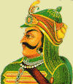

No history book on India will be complete without his description. He was the grandson of none other than the great Rana Sanga. Although not a great administrator and statesman as his grandfather was he was just like his grandfather in terms of courage and self-respect.


As we all know, Birbal was not only Akbar’s favourite minister but also a minister dearly loved by most of the commoners, because of his ready wit and wisdom. People used to come to him from far and wide for advise on personal matters too.

However, there was a group of ministers that were jealous of his growing popularity and disliked him intensely. They outwardly showered him with praise and compliments, but on the inside they began to hatch a plot to kill him.

One day they approached the king’s barber with a plan. As the barber was extremely close to the king, they asked him to help them get rid of Birbal permanently. And of course, they promised him a huge sum of money in return. The wicked barber readily agreed. The next time the king required his services, the barber started a conversation about Akbar’s father who he also used to serve. He sang praises of his fine, silky-smooth hair. And then as an afterthought he asked the king that as he was enjoying such great prosperity, had he made an attempt to do anything for the welfare of his ancestors?

The king was furious at such impertinent stupidity and told the barber that it was not possible to do anything because they were already dead. The barber mentioned that he knew of a magician who could come of help. The magician could send a person up to heaven to enquire about his father’s welfare. But of course this person would have to be chosen carefully; he would have to be intelligent enough to follow the magicians instructions as well as make on-the-spot decisions. He must be wise, intelligent and responsible. The barber then suggested the best person for the job – the wisest of all ministers, Birbal.

The king was very excited about hearing from his dead father and asked the barber to go ahead and make the arrangements immediately. He asked him what was needed to be done. The barber explained that they would take Birbal in a procession to the burial grounds and light a pyre. The magician would then chant some ‘mantras’ as Birbal would ascend to the heavens through the smoke. The chantings would help protect Birbal from the fire.

The king happily informed Birbal of this plan. Birbal said that he thought it a brilliant idea and wanted to know the brain behind it. When learning that it was the barber’s idea, he agreed to go to heaven on condition that he be given a large some of money for the long journey as well as one month’s time to settle his family so that they had no trouble while he was gone. The king agreed to both conditions.

In the duration of this month, he got a few trustworthy men to build a tunnel from the funeral grounds to his house. And on the day of the ascension, after the pyre had been lit, Birbal escaped through the concealed door of the tunnel. He disappeared in to his house where he hid for a few months while his hair and beard grew long and unruly.
In the meantime his enemies were rejoicing as they thought that they had seen the last of Birbal. Then one day after many, many months Birbal arrived at the palace with news of the king’s father. The king was extremely pleased to see him and ready with a barrage of questions. Birbal told the king that his father was in the best of spirits and had been provided with all the comforts except one.

The king wanted to know what was lacking because now he thought he had found a way to send things and people to heaven. Birbal answered that there were no barbers in heaven, which is why even he was forced to grow his own beard. He said that his father had asked for a good barber.

So the king decided to send his own barber to serve his father in heaven. He called both the barber and the magician to prepare to send him to heaven. The barber could say absolutely nothing in his own defence as he was caught in his own trap. And once the pyre was lit he died on the spot.

Akbar was very fond of Birbal. This made a certain courtier very jealous. Now this courtier always wanted to be chief minister, but this was not possible as Birbal filled that position.

One day Akbar praised Birbal in front of the courtier. This made the courtier very angry and he said that the king praised Birbal unjustly and if Birbal could answer three of his questions, he would accept the fact that Birbal was intelligent. Akbar always wanting to test Birbals wit readily agreed.
The three questions were
1. How many stars are there in the sky
2. Where is the centre of the Earth and
3. How many men and how many women are there in the world.

Immediately Akbar asked Birbal the three questions and informed him that if he could not answer them, he would have to resign as chief minister.

To answer the first question, Birbal brought a hairy sheep and said, “There are as many stars in the sky as there is hair on the sheep’s body. My friend the courtier is welcome to count them if he likes.”

To answer the second question, Birbal drew a couple of lines on the floor and bore an iron rod in it and said “this is the centre of the Earth, the courtier may measure it himself if he has any doubts.”

In answer to the third question, Birbal said “Counting the exact number of men and women in the world would be a problem as there are some specimens like our courtier friend here who cannot easily be classified as either. Therefore if all people like him are killed, then and only then can one count the exact number.”
In the northern country there is a village named Tennali. In it was born a Brahman boy named Rama. Once a Sanyasi met this boy in the street and wondering at his beauty and rare qualities taught him a certain incantation and said:- "My dear fellow, if you, in the course of a single night, repeat this incantation in the presence of the goddess Kali three crores of times, she will appear before you with her one thousand faces. If you be not overcome with fear of her presence you can secure from her whatever boons you may desire." From the day Rama was waiting for an auspicious time to go to the Kali temple near his village. And duly as the time came, he stood before the goddess and repeated the incantation as he had been taught. At the end Kali appeared before him with her one thousand faces, two hands and fearful shape. The little fellow, however, was not at all afraid, but laughed at the goddess. Whereupon Kali asked him in a stern voice, "Why do you laugh?" And Raman replied:- "Mother, we men have each but one nose and two hands' yet when we catch cold, we find it very difficult to blow our single nose with our two hands. If ever you who have one thousand noses should suffer from cold I wonder how little those two hands will avail you!" Pleased at the lad's wit the goddess said "Ah boy! inasmuch as you have jested with me you shall from this day become a jester-Vikatakavi." And the boy said readily "Mighty goddess, you have given me a very find boom. If I read my title from right to left I am a jester, and if from left to right, I am a jester still." The goddess was all the more pleased about this and said:- "For your intelligence you shall be a court-jester and all in the king's assembly shall ever praise you for your wit." After having said so, the goddess vanished. And Rama ever since the day attained more and more celebrity as a jester and at last reached the court of Rayar and continued to live there.

The Rayar gave to each house in his town a kitten and a cow, and ordered that each kitten should be reared on the milk of the cow. Like others Tennalirama received a cow and a kitten. All the householders milked their cows and gave the whole yield to their kittens. But Tennalirama on the very first day milked his cow and placed it boiling-hot near the kitten. It eagerly placed its mouth in the vessel and got scalded. From that day forward the kitten used to run away the moment it saw the milk. Tennalirama then consumed the entire milk of the cow, which had been intended for the kitten. After six months, the Rayar ordered all the kittens to be brought that he might see them. And of all the kittens Tennalirama's alone was very lean. It appeared to be almost dying. "Why has this grown so lean?" asked the Rayar. "It runs away at sight of milk; what can I do?" said Tennalirama. The Rayar at once ordered some milk to be offered to it in his presence. And when it saw the milk it became afraid and ran away. The Rayar ordered it to be caught, and on examining it he saw half of its mouth scalded. But he was pleased with the joke, and laughed as he said: "There is a proverb which says that the scalded cat never approaches the hearth. Even so you have once placed hot milk before it and made it dread the very sight of milk."

One day a learned man named Vidyasagara versed in several sciences came to court of the Rayar. All the learned men in the Rayar's court were seized with fear and applied to Tennalirama in their difficulty: "There is a vast difference between his proficiency and our proficiency. If he conquers us in debate, it will be a great shame to all of us, and the Rayar will then disregard us. What shall we do?" Tennalirama said: "You need not fear. I shall contrive some means to foil him."
Then on a certain day that learned man - Vidyasagara - came to the Rayar's assembly for a disputation. Tennalirama had previously made up a bundle of the dried twigs of the sesamum plant arranged in the shape of a palm leaf book; and he had tied this book with the rope, which is generally used in tying buffaloes. This volume he had tied up in a piece of cloth. With this bundle he came and sat before that doctor of all sciences. On seeing the (supposed) volume the doctor asked: "What is the name of this book?" and Tennalirama said" "This is the book names Sesamum-twig-dried-buffalo-bandage." On hearing this, the doctor was much perplexed and thought to himself: "What! after having mastered so many sciences, it is a wonder that we have not even heard of the name of this book." While he was thus lost in thinking, Tennalirama asked the pandit: "You bear the reputation of having read all the sciences?" To this he replied" "I shall answer you tomorrow" and went away to the place where he was anxiously and at last came to a decision: "We are not able to understand even the title of the book. How, then, can we know the subjects treated of in it? We must needs incur shame if we continue to stay here." So he decamped in the morning long before the day dawned. And when the Rayar heard that the doctor of all the sciences had decamped even without taking formal leave, he sent for Tennalirama and asked him how he had put the great doctor to flight. The jester said: "By means of this book - Seasamum-twig-dried-buffalo-bandage." "Unite that book," said the Rayar. He did so. And when Rayar saw than dried sasamum twigs were tied up by the rope generally used for tying up buffaloes he understood the meaning of the several words and laughed saying: "I see, it was by a combination of all these words that you contrived to send away the pandit."

A certain learned man composed a poem in praise of the Rayar. He has never treated Tennalirama with respect, but always slighted him. One day a public reading of the work was ordered: and when some verses had been read, the reader paused, apparently and unable to proceed, for the next verse was wanted in one foot. The omission was indicated in the manuscript by a mark at the right place, but was not supplied on that page or on any of the next five pages that were too closely written. On the sixth page however, the same mark appeared and under it the missing foot. The poet then directed his attention to the sixth page and asked him to read from there. Saying the verse was read and the discussion ended then. And the poet presented himself in the Rayar's assembly the next day to receive his prize. Of course Tennalirama was there too. He had got his crown entirely shavel, leaving only two or three short stumps of hair in the place of the lock of hair on his head: this he had removed and now kept it separately by his side. When all was ready, he took his seat in front of the poet, and as the Rayar turned round to where he was, he removed his turban, and after touching with his fingers the stumps of hair on his head, went on arranging the lock of hair which was beside him. The Rayar on seeing this asked him: "What is this?" And he replied:- "While getting shavel, I ordered that the lock of hair on my head should be removed. But I soon changed my mind, and as it was not altogether too late, I ordered a few stumps to be left in the right place as a mark (of omission) intending to bear the lock about me separately. And it is a course of action approved by poets and learned men." The Rayar questioned: "How do you say approved by them?" To this he replied: - "This learned man who now sits in your presence was exhibiting his work yesterday. What was wanting in a verse on a certain page, he supplied from what was written on the sixth page from that. My action therefore has a worthy precedent." The poet was much ashamed and hung down his head while the Rayar and the whole court laughed.

There was a wrestler named Atisura. He had conquered the wrestlers of various courts and came to the kingdom of the Rayar with many badges. All the wrestlers in the kingdom of the Rayar took alarm and were in a great fix. Tennalirama saw this and asked them why they were so dispirited. They said: "Up to this time we have been living under this Maharaja with respect. Now the time has come for us to lose our respect and our living also. A wrestler has come to reduce us to this position. What shall we do?" Tennalirama said: "Have no fear. Give me all your badges and follow me as your chief." He then put on all the badges, and assuming the name of Virakesary, took up his position with his followers in a tent opposite to that of Atisura. That wrestler thought within himself: "This chief seems to be my rival. Let me first of all ascertain his merit." So he sent word to Virakesari that he had come to see him. And Tennalirama sent back the following message: "You need not come here now. You can make known your business in the Rayar's presence tomorrow." Atisura, on hearing this, was much afraid at heart, thinking, “What sort of wrestler may he be?" Next day the Rayar permitted Atisura and Virakesari to wrestle in his presence. Then Virakesari asked Atisura: "Is your method of wrestling the scientific method or the physical-force method?" Atisura replied: "It is the scientific method." And then Virakesari said: "I shall show some symbols of the scientific method of wrestling. If you explain what those symbols mean, I shall deem it proper to wrestle with you." Atisura said: "Let it be so." Thereupon Virakesary joined together the three middle fingers of Atisura's hand, and hit his own chest with them, placed his adversary's two palms extended on his own shoulders, described a circle round his neck with the front finger, showed his right palm hanging upside down up to the hip, and waved his left fist. The wrestler saw all these symbols, but could make nothing of them. He thought over all the symbols that he had learnt in wrestling, but it vain. Having waited for some time, Tennalirama snatched from him all the badges, which he had acquired in other, places and, sounding his victorious drum, entered his tent. The next day the Rayar asked: - "Tennalirama! What is the meaning of those symbols which you displayed yesterday?" And Tennalirama, showing those symbols again, explained "Atisura! If I approach you, you pierce me with your dagger in my chest and kill me. I shall then drop down stretched on the ground with my face upwards. Then who will protect my wife and child? On hearing this, the Rayar laughed heartily.

The Rayar built a storied house in beautiful style. He than sent for a painter and ordered him to prepare suitable pictures for the mansion. After finishing his work, the painter intimated the fact to the Rayar. The Rayar proceeded to that house accompanied by his ministers and others, and as he was going through the several parts of that house admiring the work all along, Tennalirama noticed a picture that was painted sideways. And he asked "Great King! This picture displays the limbs of only one side. Where are those of the other side?" To this the Rayar said: "You must imagine it all. Don't you know this?" And as he said so, he laughed. "Yes, I understand it now" said Tennalirama in apparent sincerity. Some time after Tennalirama said to the Rayar one day: "From the day we visited your new mansion, I have been practising painting. I have become an expert in it now. You must witness my beautiful execution now." "Indeed!" said the Rayar; and as the paintings in his palace had become old, he added: "You can then rub away all these old paintings and execute new ones in their places." He then gave him betel leaf and nuts for the work, vacated that house, and removed to another building. Tennalirama then rubbed away all the beautiful original paintings. He painted a nail in one place, a finger in another place, a hand in a third; thus, in his own way he filled the whole house with his daubs and spoiled its look utterly. He then went to the Rayar and said: "I have finished all my paintings. You must kindly favour me with a visit." The Rayar taking it to be true entered the building accompanied by several people. On seeing the pictures he said: "What! Tennalirama! I see only odd limbs and fragments." Tennalirama said: "You must imagine all the other portions to exist on the other side. What! Have you forgotten that obvious thing?" The Rayar exclaimed "O! I have been deceived. You have spoiled the whole building." He was at the same time much ashamed and returned to his palace in anger.

Tennalirama appeared to be very sorry one day, and the Rayar on seeing him said: "Why are you sorry? What do you want?" Tennalirama replied "Alas! The astrologers have said that I shall die in the course of a month or two. But I am not at all thinking of my life now. I am only grieving that after I am gone there will be none to protect my family as I have been protecting it." The Rayar spoke, "Do not at all be anxious about it. I shall protect your family ten times more carefully than you have been doing. This is not at all a great affair. Thus the Rayar consoled him. Then Tennalirama pretended to get worse daily and at last contrived to spread a rumour that he was no more. He had already secured in a safe place all the money, jewels and vessels that were in his box, and put himself into that big box. As soon as the Rayar heard that Tennalirama was dead, he sent some soldiers and ordered them to bring away at once the jester's moneybox, expecting to find in it a large fortune. And they accordingly brought it to the place. The moment it came, the Rayar with great avarice opened the box and looked in. On seeing Tennalirama there, he exclaimed, "What! they all said that you were dead." Tennalirama said:- "How can I die confiding in you? are you the person who will protect my family?" The Rayar was ashamed and remained silent.

Morning Time Shlokas
He who has a look, which makes heart and mind happy,
He who has the mindset of a yogi
He who has control of his wakened state
May I remember you with all my heart as I wake up.

Pratah smarami hridi
samsphura ta twam
Satchitsukham paramahansa
gatim turiyam
Yat swapna jagara
sushupta mavaiti nityam
Tad brahma nishkalamaham
na cha bhuta sanghaha.

Shlokas on Unity

Sangatana mantram
sam gachadvam sam va dadva
sam vo manamsi jaanataam
deva baagam yatha purve
sam janaana upaasathe

Lets walk together, speak in one voice, think as one mind .
This how the Gods attained their divinity and we should worship that

In Praise of the Gods

Hanuman:
Manojavam maarutatulyavegam jitendriam buddhimataam varistam
Vaataatmajam vaanara yudhamukhyam sriraama dutam shirasaa namaami
I prostrate to the lord Hanuman the son of wind God, who is swift
like the mind and wind, mastered the senses, intellect, foremost
among the vaanaraas or monkeys and the devotee of Lord Rama.

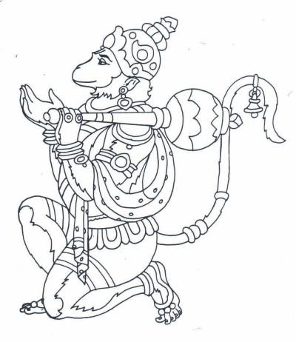

Lord Krishna:
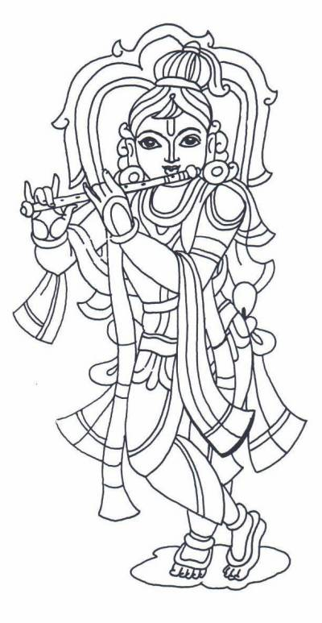
Vasudeva sutam devam kamsachaanoora mardanam
Devakee paramaanandam krishnam vande jagadgurum
I salute the great Lord Krishna, the preceptor of the worlds, the beloved son of Devaki and Vasudeva and the suppressor of Kamsa and Chaanoora.

Godess Saraswati:
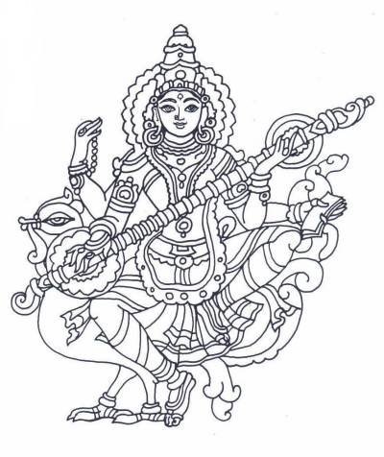
Saraswathi mahaabhaage vidye kamala lochane
Vidyaaroope vishaalaakshi vidyaam dehi namastute
O most auspicious Goddess of knowledge! The one with beautiful
and big eyes that resemble the lotus petals, O bestower of wisdom,
mother Saraswathi, kindly bless me with knowledge. I salute you.
Lord Sri Rama:
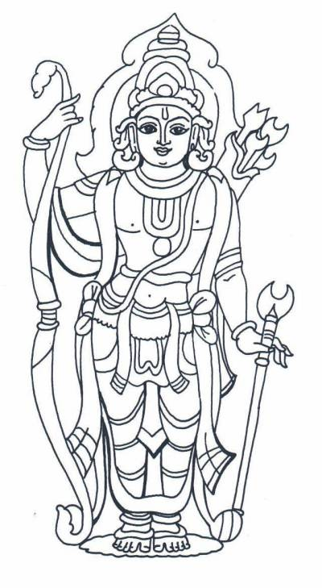
Sri Rama Raama Raameti Rame Raame Manorame
Sahasra Naama tattulyam Raama naama varaanane

Bedtime Shlokas
raamam SkaNdam! hanUmaNtam! vEnateyam! Vrukodaram!
Shayane yahasmarennityam duswapna stasyanasyati
If one remembers Rama, Skanda( Subramanya), Hanumantha,
VainatEya(Garuda ),Vrikodaram( one who has great appetite ie; Bhima) before
going to bed then that person doesn't get any bad dreams .

There are 13 mantras, which are different names of Sun God. We should chant a mantra before each Surya Namaskar.

The mantras are as follows:
Om Mitraaya Namah
Om Ravaye Namah
Om Suryaaya Namah
Om Bhaanave Namah
Om Khagaaya Namah
Om Puushne Namah
Om Hiranyagarbhaaya Namah

Om Mareechaye Namah
Om Aadityaaya Namah
Om Savitre Namah
Om Arkaaya Namah
Om Bhaaskaraaya Namah
Om Shree Savitru Suurya Naaraayanaaya Namah

This aasana (exercise) is performed at sun-rise and starts with a salutation to Sun God, Sooryanamaskar (standing) posture:

Soorya Namaskar Sthiti (Starting Posture):
  - Ek: Join the heels, hands on the side, fingers facing down and palm open.
  - DO: Join the toes.
  - Teen: Join your hands to form Namaste position. Palms should be pressing against each other and the thumb joint should be at sternum.



Starting Position and Ten

In this posture, breathing is normal and slow. Face should be normal and relaxed.
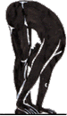
Nine
Bring the right foot forward and stand up as in Do.

One
Slowly raise hands with biceps touching the ears and hands in namaste posture. Bend backwards from waist. Do not bend the knees. Look towards palm.
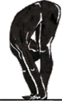
Two
Slowly bend forward from the waist. Try to touch palm to the floor on either side of your legs. Do not bend the knees. Nose should touch the knees. People with back problems should not bend too much. Bend only as much it is comfortable.
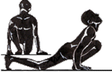
Three
Take your left foot back. Left kneee should touch the floor. Two palms should be completely on the ground and the right foot should be in between the two hands. Fingers should be pointing to the front. Lean forward on the right knee, so that calf and thigh muscles press against each other chest rests on the thigh. Look up and make a concave on your back.

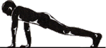
Four
Take right foot back and join with left foot. Arms should be straight. Most of the weight will be on the arms. The body should be in one plane like a slide.

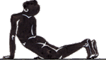
Six
Come forward and bend back as much as you can. Abdomen should come between your hands. Look back from the top. Two legs should be joined.

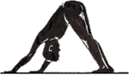
Seven
Form a mountain like posture. Push your chin towards the chest. Heels should touch the floor.
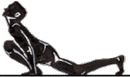
Eight
bring your left foot forward all the way between the hands.
Five
Bend your arms and touch your feet, knees, chest and forehead to the ground. Do not touch abdomen or nose

Halasan
Time: 2 minutes
Method:
Lie on your back, arms alongside. Raise legs an in Sarvangasan (you may take help of hands on the hips), then lower them overhead, knees straight, ankles stretched, toes pointed and touching the ground. Arms stay on ground as in the beginning, palms on the ground. The posture resembles the shape of a plough.
Benefits:
Makes the spine flexible, creates energy, and blood of the muscles of the back. Aids the functioning of the thyroid and thymus glands thus helping retain the individual's youthful physical characteristics for a longer period
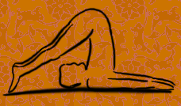

Dhanurasan

Time: 1/2 minute
Method:
Lie on your stomach. Bend knees, hold the ankles. Pull your hands and push with your legs, knees together, till the trunk forms an arch with only the stomach on the ground. Look up. After releasing the posture lie for a while in Shavasan.
Benefits:
Reduces abdominal fat. The compressing of the spinal column, pressing the nerves with the scapulae (the winged bones at the back attached to the arms) minimizes blood circulation while in the asan. But when the pose is released a greater supply of blood is endured to those very regions increasing spinal flexibility and definitely raising the vitality.
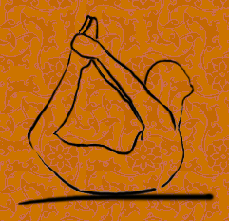

Chakrasan
Time: 1/2 minute
Method:
Lie on your back. Bend knees, place feet apart and close to hips, place hands overhead, palms besides ears and shoulders. Push with hands and, without moving feet, raise trunk as high as possible to curve the back into an arch, look on the ground between the hands.
Benefits:
Builds a flexible back, stimulates the nerves of the spine. One of the powerful back bending postures.
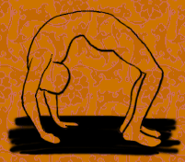

Bhujangasan
Time: 1/2 minutes.
Method:
Lie on your stomach, forehead on the ground, hands under shoulders. Raise your upper body by the strength of the back muscles, head up. Don't take help of the hands, they may remain on the ground or held on the back over the hips.
Benefits:
Helps in keeping the dorsal spine elastic and strong. Backache due to overstrain can be thus relieved. Helps considerably in reducing abdominal fat.

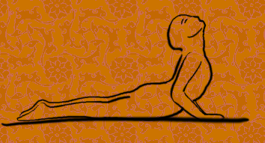
Sarvangasan
Time: 2 minutes
Method:
Lie on your back, arms alongside. Raise both legs together - taking support of hands on the hips and the elbows on the ground. Straighten the body - feet, knees, hips and back form one vertical column from the base of the neck to the tip of the toes, feet stretched, toes pointed, chin pressed against the chest. Normal breathing.
Benefits:
Promotes healthy secretion of the circulatory, respiratory, alimentary and genito-urinary systems. Keeps the spine flexible preventing the bones from early ossification. Supplies large quantity of blood to the spinal roots of the nerves, thereby giving them sufficient nourishment.
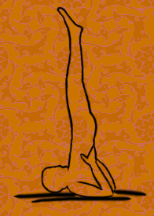

Paripoorna NavAsan

Time: 2 minutes
Method: Bend your knees so that your feet are flat on the floor, facing forward. Lift your arms so that they extend straight in front of you, shoulder-distance apart, palms facing each other. Lean back to balance on your sitting bones, throughout the pose. Lift your feet off the floor and extend your legs straight in front of you, keeping them in contact with each other.
Release your shoulders away from your ears. Keep your chest lifted and a forward rotation of your pelvis. Breathe smoothly and comfortably through your nose. Relax all of your facial muscles, neck, and throat. For assistance in the pose, support your legs with your hands; or do the pose facing the wall with your feet on the wall.
To come out of the pose, bend your knees, placing your feet flat on the floor. Extend your legs on the floor in front of you and relax your arms at your sides. Return to Dandaasan

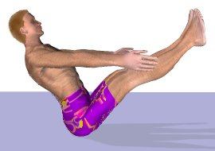

Padmasana

Time: 2 minutes
Method: ( It is the Best Asana for Practicing Meditation.) Technique:-Sit on a Floor and Place your Legs Straight and then Put Right Foot Ankle on your Left Knee and Left Foot Ankle on your Right Knee as both of the Ankles must be Near to your Naval ( asq in the Figure ) and keep your Spine Straight.Put your Hands on Knees in Gyan Mudra ( See in a Figure )
Benefits:
(1) :- Best Asana for Meditation and Concentration.
(2) :- It is Very Good for Sciatica pain.
(3) :- Removes the Gastric Problems and Improves Digestion.
(4) :- Body Remains Active with this Asana.
Important Note :- In the Begining it may be Tough but with Practice it will Become easy.

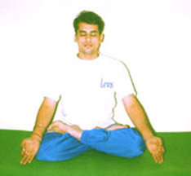

Veerabhadrasan I

Time: 2 minutes
Method: Be barefoot. Begin in Tadasana. Step your feet about four feet apart. Lift your arms over your head, shoulders down, palms touching each other. Pivoting on your heels, turn your left foot in 45 degrees and your right foot out 90 degrees. Turn to the right, squaring your shoulders with the wall that your right foot is facing. Be strong and active in your left leg as you bend your right leg. Keep your left heel on the floor and your right shin perpendicular to the floor. Throughout the pose, keep your left leg straight. Align the middle of your right knee with the middle of your right foot. Tuck your tailbone as you rotate your pelvis back. Lift your sternum, release your shoulders, and stretch your arms up. As your spine and arms stretch upward, keep the neck, throat, and jaw relaxed. Soften your gaze; quiet your hearing. Breathe evenly and comfortably through your nose.
To come out of the pose, push into the floor with your left foot as you unbend your right leg. Turn your body back to center. Repeat on the other side by pivoting on your heels to the other side.
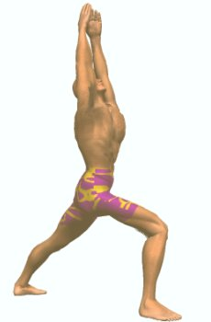

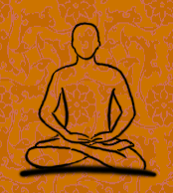
Veerabhadrasan II

Time: 2 minutes
Method: Be barefoot. Start in Tadasana. Step your feet about four feet apart. Lift your arms shoulder height and stretch them out to the sides. Pivoting on your heels, turn your left foot in 45 degrees and your right foot out 90 degrees. Be very strong and active in your left leg as you bend your right leg. Allow your right shin to be perpendicular to the floor. Align the middle of your right knee with the middle of your right foot. Tuck your tailbone as you rotate your pelvis back. Lift your sternum, release your shoulders, and stretch your arms. Turn your head to look over your right hand. As your spine and neck stretch upward, keep the neck, throat, and jaw relaxed. Your chin is parallel to the floor. Keep your spine on the plumb. Soften your gaze; quiet your hearing. Breathe evenly and comfortably through your nose. To come out of the pose, push into the floor with your left foot as you unbend your right leg. Repeat on the other side.

