
(HSS)



Hindu Heritage Camp

SOORYA NAMASKAR

Surya Namaskar is a combination of few Yogasana postures. This is a well balanced set of movements that will stretch all the muscles in the body and keep the body and mind healthy. There are 13 mantras which are different names of Sun God. We should chant a mantra before each Surya Namaskar.

` imÇay nm>
` rvye nm>
` sUyaRy nm>
` Éanve nm>
` ogay nm>
` pU:[e nm>
` ihr{ygÉaRy nm>
` mrIcye nm>
` AaidTyay nm>
` sivÇe nm>
` AkaRy nm>
` ÉaSkray nm>
` ïI sivt& sUyR naray[ay nm>
om miträya namaù
om rabaye namaù
om suryäya namaù
om bhänave namaù
om khagäya namaù
om puñëe namaù
om hiraëyagarbhäya namaù
om maricaye namaù
om adityäya namaù
om sabitre namaù
om arkäya namaù
om bhäskaräya namaù
om çri savitru suryanäräyaëäya namaù

Soorya Namaskar Sthiti (Starting Posture):
From Aarama, come to Soorya Namaskar-Sthiti (starting posture) in 3 counts: Ek-Do-Teen. These are the actions to be performed in three counts.



@k Ek: Join the heels, hands on the side, fingers facing down and palm open.
dae Do: Join the toes.
tIn Teen: Join your hands to form Namaste position. Palms should be pressing against each other and the thumb joint should be at sternum (Solar Plexes).

In this posture, breathing is normal and slow. Face should be normal and relaxed.

Following is a brief description of 10 steps in Surya Namaskar.

@k (Ek): As you breathe in...
Slowly raise your hands with biceps touching the ears and hands in namaste posture. Slowly bend backwards from your waist. Do not bend the knees. Look towards your palm.


dae (Do): Whie breathing out...
Slowly bend forward from the waist. Try to touch your palm to the floor on either side of your legs. Do not bend the knees. Nose should touch the knees. People with back problems should not bend too much. Bend only as much it is comfortabe.
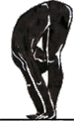

tIn Teen: As you breathe in...
[Note: The description is for odd numbered namaskars (1st, 3rd, 5th, etc.)
For even numbered ones (2nd, 4th,..) interchange left and right leg ]
Take your left foot back. Left kneee should touch the floor. Two palms should be completely on the ground and the right foot should be in between the two hands. Fingers should be pointing to the front. Lean forward on the right knee, so that calf and thigh muscles press against each other chest rests on the thigh. Look up and make a concave on your back.

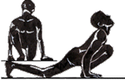

car Chaar: Whie breathing out...
Take right foot back and join with left foot. Arms should be straight. Most of the weight will be on the arms. The body should be in one plane like a slide.
Look 5 feet in front of you on the floor.


pa<c Paanch: Hold your breath
Bend your arms and touch your feet, knees, chest and forehead to the ground. Do not touch abdomen or nose (you don't want to breathe in the dust!)

De Che: As you breathe in...
Come forward and bend back as much as you can. Abdomen should come between your hands. Look back from the top. Two legs should be joined.
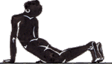

sat Saat: Whie breathing out...
Form a mountain like posture. Push your chin towards the chest. Heels should touch the floor.
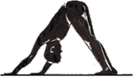

AaQ Aat: As you breathe in...
[Note: The description is for odd numbered namaskars (1st, 3rd, 5th, etc.)
For even numbered ones (2nd, 4th,..) replace left leg with right leg]
bring your left foot forward all the way between the hands. Exactly like teen.



naE Nau: While breathing out...
Bring the right foot forward and stand up as in Do.
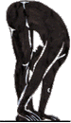

ds Das:
Back to Soorya Namaskar Sthiti.

At the end of all the Soorya Namaskars, give the command "Aarama" Ek-Do-Teen.
Ek: Drop the hands on your sides. Palm facing down.
Do: Spread the toes and form V-Shape with the feet.
Teen: Aarama position

Surya Namaskar at a Glance

Position and Ten

Nine
Eight
Seven
Six
Mantras

om miträya namaù
om rabaye namaù
om suryäya namaù
om bhänave namaù
om khagäya namaù
om puñëe namaù
om hiraëyagarbhäya namaù
om maricaye namaù
om adityäya namaù
om sabitre namaù
om arkäya namaù
om bhäskaräya namaù
om çri savitru suryanäräyaëäya namaù

Five

One
Two
Three
Four

HHC Geet

ihNÊ jge tae ivSv jgega
hindu jage to visva jagegä
manv ka ivSvas jgega.
mänava kä visväsa jagegä||
Éed Éavna tms! hqega
bheda bhävanä tamas haöegä
smrsta Aièt brsega
samarasatä amriata barasegä
ihNÊ jgega ivSv jgega.
hindu jagegä visva jagegä||
ihNÊ sda se ivSv bNxu hE
hindu sadä se visva bandhu hai
jf cetn Apna mana hE
jaòa cetana apanä mänä hai
manv pzu té igir sirta me
mänava paçu taru giri saritä me
@k äü kae phcana hE
eka brahma ko pahacänä hai
jae cahe ijs pw se Aaye
jo cähe jisa patha se äye sädhaka
saxk keNÔ ibNÊ p÷Ncega
kendra bindu pahuncegäa
ihNÊ jgega ivSv jgega.
hindu jagegä visva jagegä||
#sI sTy kae ivivx púy se
isé satya ko vividha pakñya se
vedae< me hmne gaya wa
vedoà me hamane gäyä thä
inkq ibQakr #sI tTv kae
nikaöa biöhäkara isé tatva ko
%pin;dae me< smHaya wa
upaniñado meà samajhäyä thä
miNdr mQ guéÖare ja kr yhI
mandira maöha gurudväre jä kara
Jyan sTsNg imlega
yahé jyäna satsanga milegä
ihNÊ jgega ivSv jgega.
hindu jagegä visva jagegä||
ihNÊ xmR vh isNxu Aql hE
hindu dharma vaha sindhu aöala hai
ijsme sb xara imltI hE
jisame saba dhärä milaté hai
xmR AwR AaEr kam maeúy ik
dharma artha aura käma mokñya ki
ikrne lhr lhr ioltI hE
kirane lahara lahara khilaté hai
#sI pu[R me pu[R jgt ka
isé purëa me purëa jagata kä
jIvn mxu s<pu[R )lega
jévana madhu sampurëa phalegä
ihNÊ jgega ivSv jgega.
hindu jagegä visva jagegä||
#s pavn ihNÊTv suxa kI
isa pävana hindutva sudhä ké
r]a àa[ae se krnI hE
rakñä präëo se karané hai
jg kae AayR izl kI iz]a
jaga ko ärya çila ké çikñä
inj jIvn se isolanI hE
nija jévana se sikhaläné hai
Öez ¬ez Éy sÉI hqaye
dveça kleça bhaya sabhé haöäye
paCjNy i)r se gu<jega
päcjanya phira se guïjegä
ihNÊ jgega ivSv jgega.
hindu jagegä visva jagegä||

Door Décor (Toran)

Time For the activity: 15-20 min

Things needed: Green colored craft paper, Cord string, Foam flowers, glue, glitter and scissor

How to make:
We always hang torans on the door especially on our festivals. Usually, they are made from the fresh flowers and leaves. For the sake of this activity, we are going to make leaves from the craft paper and foam flowers. It is a very interesting activity.

Step 1: Fold the green colored craft paper in such a way that 4 folds are made on top of one other. Draw a leaf on the paper with pencil and carefully cut the leaf shape with scissor. Draw a vine with the glue and put the glitter on it. Now the leaf is ready with the glittered vines. This step will make 7-8 leaves.

Step 2: Tie the leaves to the cord at equal distance from each other. In between the two leaves, glue or staple the foam flowers on the cord. You can décor the flowers with another small flower or with glitter.

Your toran is ready. In any season, you can décor your home door in a traditional way.

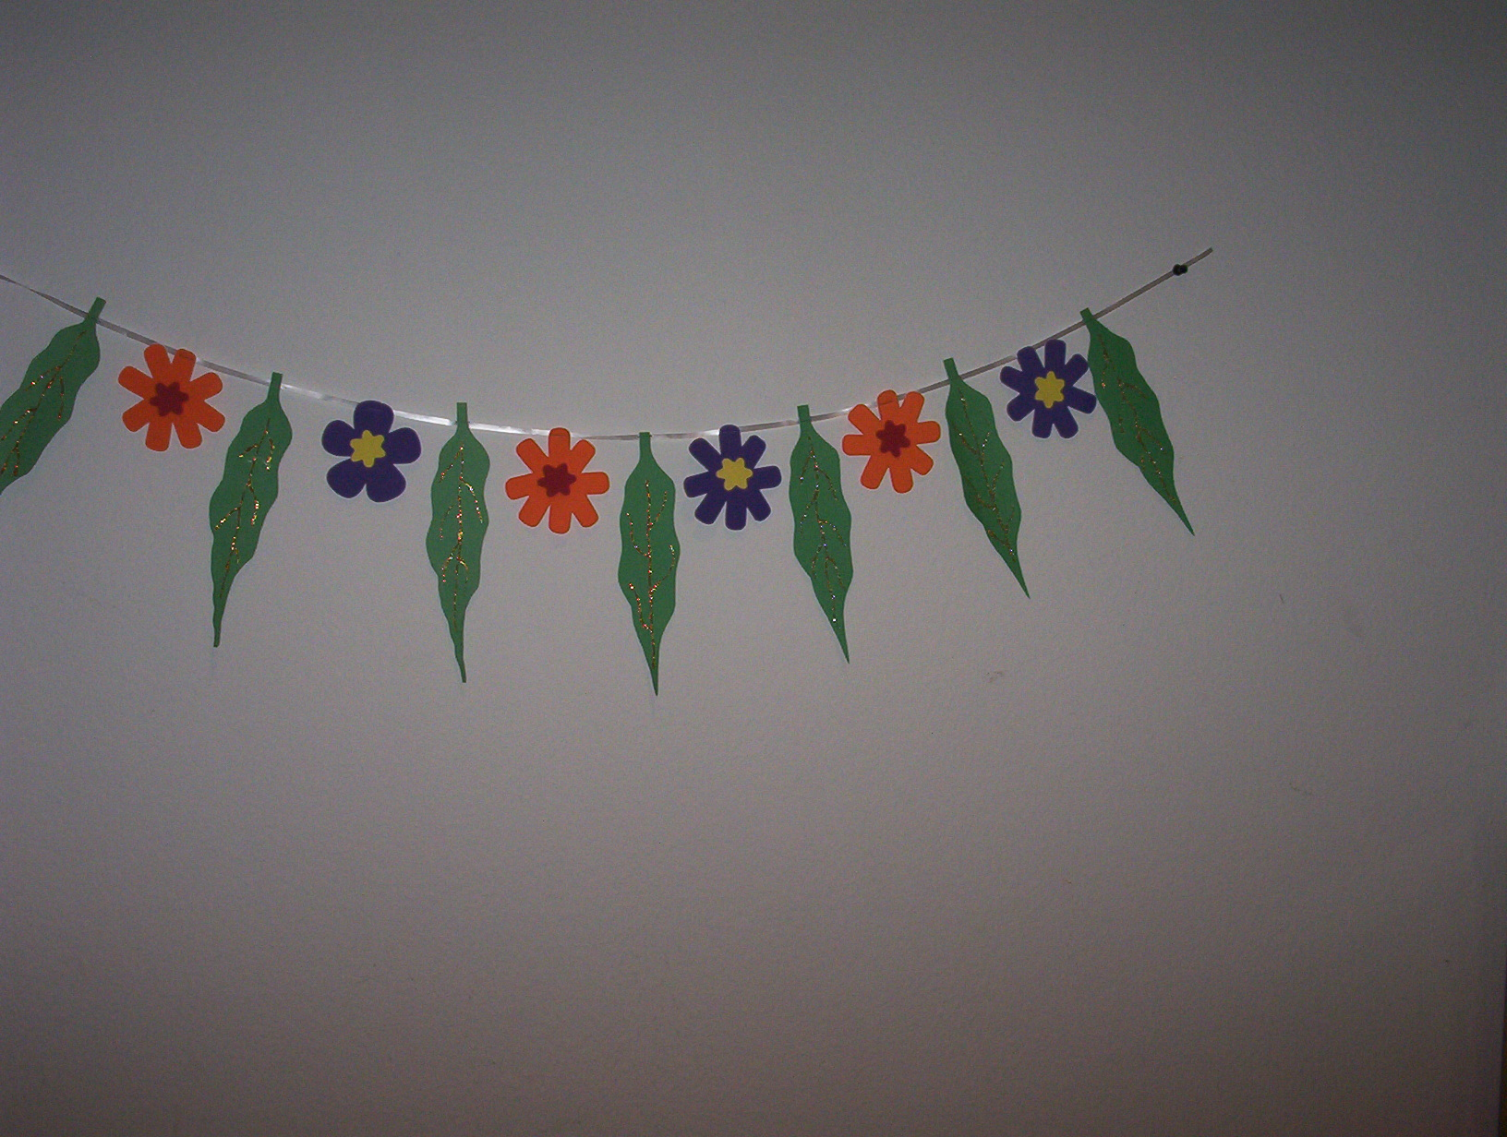
Hindu Swayamsevak Sangh

To receive information on future HSS events and for other information,
call xxx-xxx-xxxx

Visit our following websites:

- www.hssworld.org for more information on HSS worldwide
- www.balagokulam.org for information on Balagokulam resources



Thank You

