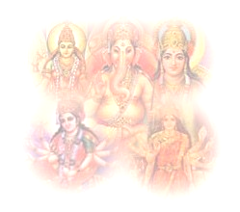

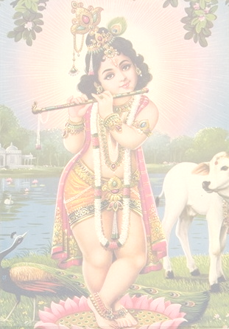


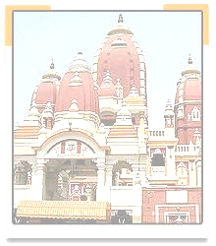
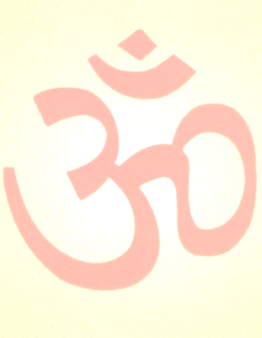
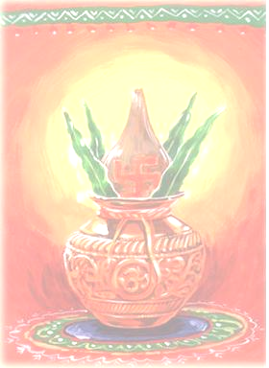
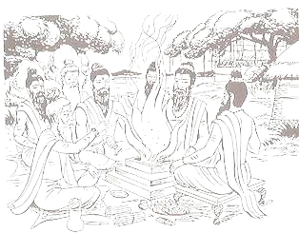
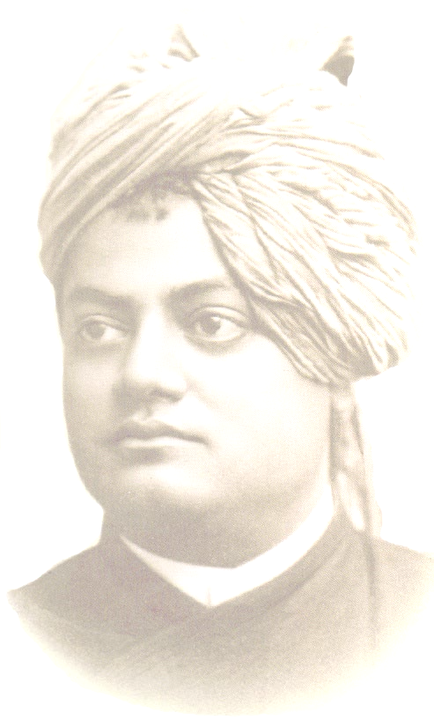
Hindu Heritage Camp

Sanskruti
Culture


Name: _____________________________________________
Phone Number: _____________________________________

http://www.balagokulam.org
Email: balagokulam@hssworld.org
For questions or information, please call: (insert name and phone number of HHC coordinator)_

Table of Contents

Introduction and welcome message……………………………………………………...3
Shlokas, Mantras 4
Ganesha Shloka 4
Saraswathi Shloka 4
Krishna Shloka 4
Rama Shloka 5
Shiva Shloka 5
Guru Shloka 5
Gayatri Mantra 5
Maha-Mrityumjaya Shloka 6
Lamp Shloka 6
Prabhata Shloka 6
Shanti Mantras 7
Ekata Mantra Error! Bookmark not defined.

Bhajans…………………………………………………………………………………………………….9

Geet (Baal Hai Gopal Hai) .Error! Bookmark not defined.
Sangh Prarthana…………………………………………………………………………………...11

Soorya Namaskar………………………………………………………………………………....12

What is Hindu Dharma?……………………………………………………………..…..…….13

Pearls of wisdom from Hindu scriptures….………………………………..……..….14

Story of Ekalavya…………………………………………………………………………………..15

What is Balagokulam?.................................................................16

Introduction and welcome message

Dear Campers and Parents,

Welcome to Hindu Heritage Camp! During this unique camp, you will be introduced to a whole new world—a world where Hinduism is not a religion, but rather a way of life; where fun is not an option, but will become a necessity; and where learning is not passive, but an enriching experience.

So what exactly is Hindu Heritage Camp? Hinduism is our religion, but here at Hindu Heritage Camp, we also want to learn about how it’s a way of life. Hinduism does not control our lives, but rather guides us in our attempts to live fulfilling, purposeful lives. Hinduism encompasses not only our prayers and beliefs, but also our feelings and actions toward all living creatures and the earth; it gives us a path to base our lives upon. In other words, we don’t think of Hinduism as merely a religion, but more as a dharma, or way of life.

The next word, Heritage, basically means tradition. Here, we will learn about the traditions and culture of Bharat, and why they’re important to know. The last word, camp, means only one thing to us: fun! As shikshaks (teachers), our job during your camp is not only to make sure you learn something about Hinduism, but also to make sure you have fun! These three words, Hindu Heritage Camp, describe the essence of this experience: a place where children and adults come together to learn about Hinduism through stories, games, shlokas, crafts, and teamwork.

The theme of this year’s camp is culture. Culture is a complex word: it encapsulates our beliefs, our values, our actions, the way we live. The purpose of culture is to help us remember our past and learn from history. Although we may worship different forms of God, speak various languages, and practice diverse traditions, we are united by one common Hindu culture.

During this Hindu Heritage Camp, we will explore this unity in diversity and learn more about our culture. We would like to wish all of the campers a happy camp experience, and to the parents, we hope your child enjoys this camp just as much as we do conducting it.

Dhanyavaad (Thank you),
Hindu Heritage Camp Karyakartas

Shlokas, Mantras

Shloka is a Sanskrit word used to denote a prayerful verse written as per certain strict grammatical rules. The shlokas presented here can be used in our daily prayers. These prayers are generally directed to specific God or Goddess forms such as Saraswati, Lakshmi, Ganesh, Rama, Krishna etc. Conveying the majesty and the omnipotence of God, the shlokas portray vivid descriptions of the different God forms and their divine powers. Anyone who chants these powerful verses and mentally invokes the God/Goddess forms will be able to achieve a steady and peaceful mind full of devotion.

Ganesha Shloka
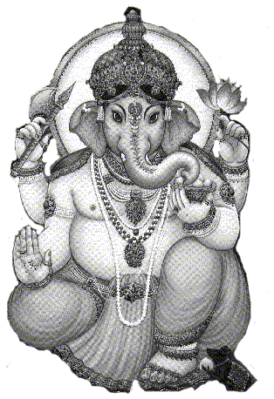 | Shuklaambara Dharam Vishnum  Shashi varnam Chatur Bhujam  Prasanna Vadanam Dhyaayet  Sarva Vighnopa Shantaye | Lord Vigneshwara, who wears a white garment, who is all pervading, who has a bright complexion (like a full moon), who has four hands (representing all power), who has an ever-smiling face, upon that deity I meditate, for the removal of all obstacles.

Saraswati Shloka
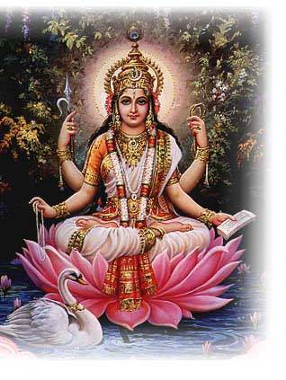 | Saraswati Namastubhyam  Varade Kaama rupini  Vidyaa rambham Karishyaami  Siddhir Bhavatu Me Sadaa | O Goddess Saraswathi; salutations to you, the giver of boons, the one who fulfills desires. I shall begin my studies. May there always be accomplishment for me.

Krishna Shloka
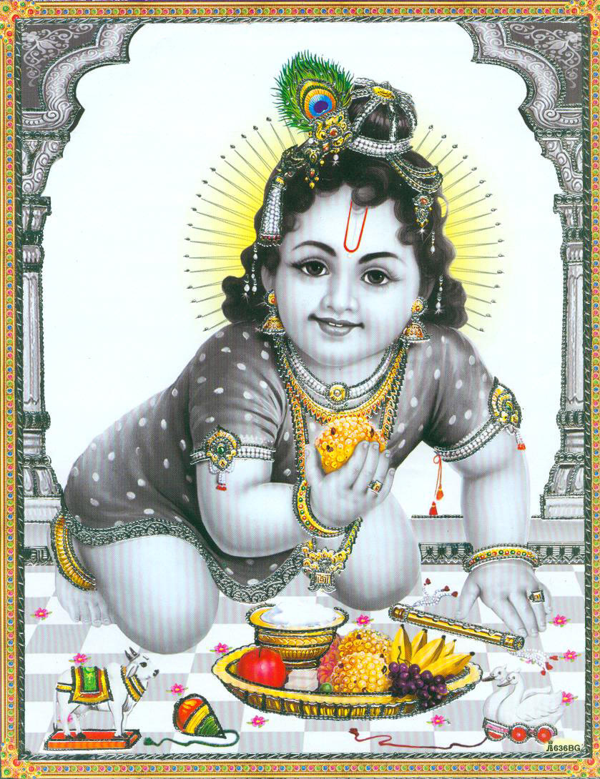 | Vasudeva sutam devam  Kamsa-Chaanoora mardanam  Devaki paramaa nandam  Krishnam vande Jagat gurum | I do vandana (glorification) of Lord Krishna, the resplendent son of Vasudev, who killed the great tormentors like Kamsa and Chanoora, who is a source of greatest joy to Devaki, and who is indeed a world teacher.

Rama Shloka
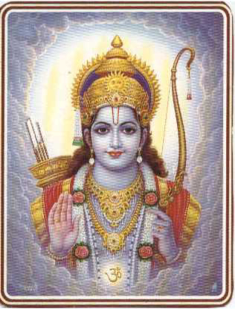 | Raamaya Raama Bhadraaya  Raama chandraaya Vedhase  Raghu Naathaya Naathaya  Sitaayah Pataye Namaha | To Rama, Ramabhadra, Raghunatha(These are different names of Lord Rama), the Lord, the Consort of Seetha, our salutations to him.

Shiva Shloka
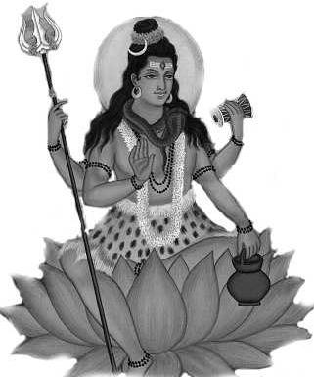 | Karpoora-gauram karuna-avataram  Samsaara saaram Bhujagendra haaram  Sadaa vasantam  Hridaya-aravinde  Bhavam Bhavaanee  sahitam Namaami | I salute to that Ishwara along with Bhavani (Shiva and parvati) who is as white as Karpur(camphor), an incarnation of compassion, the essence of this world, who wears a bhujagendra(snake or serpent) around his neck and is ever present in the lotus abode of our hearts.

Guru Shloka
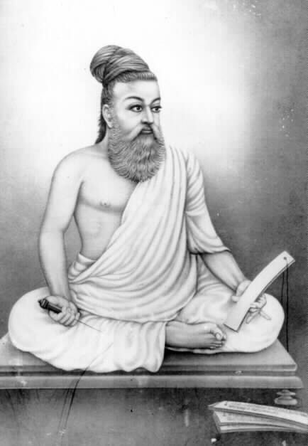 | Gurur Brahma Gurur Vishnu  Gurur Devo Maheshvarah  Guru Saakshaat Param Brahma  Tasmai Sri Gurave Namah | Know The Guru To Be Brahma Himself. He Is Vishnu. He Is Also Shiva. Know Him To Be The Supreme Brahman, And Offer Thy Adoration Unto That Peerless Guru.

Gayatri Mantra

Maha-Mrityumjaya Shloka
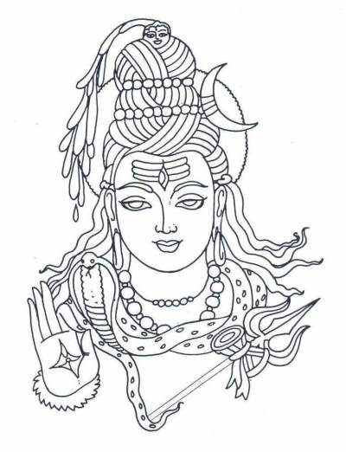 | Om Trayambakam Yajaamahe  Sugandhim Pushti vardhanam  Urva rukamiva Bhandhanaat  Mrityor mukshiya ma-amritat  Om Shanthi Shanthi Shanthihi | We worship the three-eyed One (Lord Shiva), Who is fragrant and Who nourishes all beings; may He liberate me from death, for the sake of Immortality, even as the cucumber is severed from its bondage of the vine.  Om Peace, Peace, Peace

Deep Shlokam (This shloka is to be recited while lighting a lamp)
Shubham Karoti Kalyaanam  Aarogyam Dhana Sampadah  Shatru Buddhi Vinaashaaya  Deepa Jyotir Namostute | I salute the One who is the lamplight that brings auspiciousness; prosperity, good health, abundance of wealth, and the destruction of the intellect’s enemy.

Brief explanation:
This prayer is chanted before lighting the lamplight. Light is considered a symbol of auspiciousness, prosperity, and abundance in many cultures. Light brings with it brightness, but how does it destroy the intellect’s enemy? The intellect’s enemy is ignorance, which is likened to darkness. Light removes the darkness and makes it possible to see things clearly.

Prabhaata shloka (Morning Prayer)
Karaagre Vasate Lakshmi  Kara Madhye Saraswathi  Kara Mule Tu Govindah  Prabhaate Kara Darshanam | On the tip of our fingers is Goddess Lakshmi; on the middle of our hands is Goddess Sarasvati; on the base of our hands is Lord Govinda. In this manner, we look at our hands every morning.

Brief Explanation:
This is a Morning Prayer called “karadarshana”. One begins the day with this prayer. ‘kara” means the palm of the hand and it stands for the five karmendriyas, or the organs of action. While looking at the palm, one invokes the Lord in the form of various deities, thus sanctifying all the actions that will be done during the day. By acknowledging the Lord as the giver of the capacity to perform actions and as the giver of the fruits of those actions, one sanctifies the actions. Thus, one prays in the morning to reinforce the attitude that all actions are performed as a service to the Lord.

Shanti Mantras

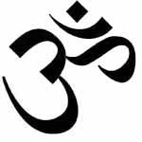 | Om Sahanaa Vavatu Sahanau Bhunaktu  Sahaveeryam Karavaa vahai  Tejas Vinaavati Tamastu maa vidhwisha vahai  Om Shanti Shanti Shantihi | May He protect both of us. May He nourish both of us. May we both acquire the capacity (to study and understand the scriptures). May our study be brilliant. May we not argue with each other. Om peace, peace, peace.

Om Asato Maa Sadgamaya  Tamaso Maa Jyotir gamaya  Mrityormaa Amritam gamayaa  Om Shanti Shanti Shantihi | Lead me (by giving knowledge) from the unreal to the real; from darkness (of ignorance) to the light (of knowledge); from death (sense of limitation) to immortality (limitless liberation)

Sarve Bhavantu Sukhinaha  Sarve Santu Niraamayah  Sarve Bhadraani Pashyantu  Maa Kaschid Dhuka Bhaag Bhavet | May all be happy. May all enjoy health and freedom from disease. May all enjoy prosperity. May none suffer.

Brief explanation:
These are prayers for the prosperity and welfare of humanity. To achieve anything in life, one has to make an effort and await the results. In addition, many unknown factors and laws influence the outcome of that effort. By praying to the Lord, one acknowledges these laws as the natural order inseparable from the Lord, and one acknowledges the Lord as the giver of all results of actions.
Ekata mantra (Unity Hymn)

Our Hindu Dharma consists of several branches. Though different Hindu branches focus on different principles, our ancient scriptures, the Vedas and Upanishadas, are the basis for all of them. This shloka was introduced to strengthen the essential bond thread of unity and harmony among our various faiths and branches.
Meaning of the Mantra
(The One God was addressed by sages with different names. This mantra conveys the message that God is one, but the names and forms are many.)

To whom the Vaidikas and the ancient seers call Indra, Yama and Matarishwaa, and the Vedantins indicate that inexplicable one by the word Brahma.

To which almighty the Shaivaites call Shiva and the Vaishnavaites praise as Vishnu. To Whom, the Bauddhas call Buddha, The Jainas call Arhan, and the Sikhs call Sat-Shri-Akal.

Some call that almighty as Shaasta, some others as Kumaar or Swaami, Maata or Pitaa through devotion and prayer. That Lord of the Universe is only one absolute without a second.
Bhajans

Come Here My Dear

Come here my dear Krishna kanhayee
Maine tere liye hriday andar mandir banayee
(repeat)

For you my dear Krishna kanhayee
Maine tere liye hriday andar mandir banayee
(come here)

For you my dear khaana banaaya (X2)
Maakhan misri dood dhai khoob milaayi
(Come here)

Too much delay too much delay tum ne lagayee(X2)
Maine tere liye hriday andar mandir banayee

Come here my dear Krishna kanhayee
Maine tere liye hriday andar mandir banayee

Rama Ho Rama

Rama ho Rama re, bhul mat jaana
Ye tere Ayodhya chhoda ke,

Dudh laaya dhai laaya tere liye (x2)
Tuj ko khilaaunga vaapas na jaaunga
Ye tere Ayodhya chhoda ke-e-e-e---Rama ho

Phul laaya phal laaya tere liye (x2)
Tuj ko chadhhaunga vaapas na jaaunga
Ye tere Ayodhya chhoda ke-e-e-e---Rama ho

Eeth laaya pathar laaya tere liye (x2)
Mandir banaaunga vaapas na jaaunga
Ye tere Ayodhya chhoda ke-e-e-e---Rama ho
 Geet: song
Baal Hai Gopal Hai

http://www.hssus.org/content/view/125/104/

Baal Hai Gopal Hai Hum Bharat Maa Ke Laal ||

Poorshottam Maryaadaa Dhaaree Dwaapar-men Hum Krishan Muraaree
Har Yuga Men Kar Dharma Dhwajaa Le Vaijayntee Gal Maal Hai Hum Bharat Maa Ke Laal
Baal HaiGopall Hai Hum...(1)

Veer Shivaa Ranaa Abhimaanee Guru Govind Singh Theg Balidaanee
Bandaa Vairaagee Jaisn Ke Tejasvee Hum Laal Hai Hum Bharat Maa Ke Laal

Baal Hai Gopal Hai Hum...(2)

Naana Taatyaa Raanee Jhansi Pralayankar Ban Chumee Phaansee
Pandey Mangal Kukaa Phadake Dhadhak Uthay Ve Jwaal Hai Hum Bharat Maa Ke Laal
Baal Hai Gopal Hai Hum...(3)

Dayanand Aravind Vivekaa Eka Tatvake Roop Anekaa
Divya Jyoti Keshava Maadhava Ki Sampaadita Har Praana Hai Hum Bharat Maa Ke Laal
Baal Hai Gopal Hai Hum...(4)

Meaning

Our baal are the Gopal and the armory of Dharma (Duty to uphold righteousness).

In Treta-yuga the magnificent complete being was baal Raam and in Dwaaparyuga was baal Krishna. In every yuga, the establishing of the victory flag of dharma is the precious wealth we give.

The brave Shivaji and Rana are our pride and Guru Govind singh was a great martyr. Like Banda Vairagee, our bravery shines magnificiently.

Naana, Taatyaa and Queen of Jansi met death in the flames of fire. Our rage cannot be controlled as the flames rise high.

Dayaanand, Aravindo and Vivekanand all had the same vision but with variation only in approach. The bright light given by Keshav (Doctorji) and Madhav (Guruji) is present in every one of us.


Sangh Prarthana and Translation

Sarva Mangala Maangalyaam  Deveem Sarvaartha Saadhikaam  Sharanyaam Sarva Bhootanaam  Namaamo Bhoomi Mataram  Sachchidaanada Roopaaya  Vishwa Mangala Hetave  Vishwa Dharmaika Moolaaya  Namostu Paramaatmane  Vishwa Dharma Vikaasartham  Prabho Sanghatitaa Vayam  Shubhaam Aashisham Asmabhayam  Dehi Tat Paripoortaye  Ajayyam Aatma Saamarthyam  Susheelam Loka Poojitam  Gyanam Cha Dehi Vishwesha  Dhyeya Maarga Prakaashakam  Samut Karshostuno Nityam  Nishreyasa Samanvitah  Tatsaadhakam Sphuratwantah  Suveera Vratamujwalam  Vishwa Dharma Prakaashena  Vishwa Shaanti Pravartake  Hindu Sanghatanaa Kaarye  Dhyeya Nishthaa Sthiraastunah  Sangha Shaktir Vijetreeyam  Krutvaasmad Dharma Rakshanam  Paramam Vaibhavam Praaptum  Samarthaastu Tavaashisha  Tvadiiye Punya Kaaryesmin  Vishwa KalyaaNa Saadhake  Tyaaga Seva Vratasyaayam  Kaayome Patatu Prabho  || Vishwa Dharma Ki Jay || | The most sacred of all that is auspicious  The means to achieve all that one aspires  The safe refuge of all living beings  O Goodness Mother Earth, We salute thee.  You are the cause for the Universe good,  The embodiment of the Truth Wisdom, and Bliss  The Unique origin of Universal Righteousness,  Our Salutations to You, O God, Supreme.  Together we have come organized, O Lord,  The purpose being flourishing of Universal Dharma,  We seek Your blessings, the divine grace,  Bestow on us to accomplish the aim.  Possession of valor, unconquerable ever  Conduct, character renowned world over  Bestow the wisdom that brightens, O God  Paving the way to realize the goal.  Endowed with prosperity, exaltation, perpetual,  May there be affluence bestowed on us;  inspired are we to practice,  the radiant, worthy, valiant, and vow.  With enlightenment from the Universal Dharma,  in propagating peace through out the world  in the task of achieving Hindu unity worldwide,  May our aim and deep faith remain resolute.  With the triumphant power of the organization,  by safeguarding our own Dharma, the righteousness,  May we be blessed to be competent  To attain the glory supreme, sublime.  In pursuit of the welfare of the mankind,  which indeed is thy holy cause and  inspired by the noble virtues of service and sacrifice,  let my being, O Bhagawan!, be offered at your feet.  || Victory to Universal Dharma ||

Soorya Namaskar

For thousands of years, human beings have been worshipping the Sun. For the rishis of the Vedic era in Bharat, the sun was worshipped in all its splendor as Soorya. Soorya Namaskar, which literally means salutations to the earth, is a combination of few Yogasana postures and pranayam (breathing techniques). This is a well balanced set of movements that will stretch all the muscles in the body and keep the body and mind healthy. There are 13 mantras which are different names of the Sun God. We should chant one mantra before each Soorya Namaskar.

The Mantra Offering Salutations to:
AUM Mitraaya Namah The friend of all
AUM Ravaye Namah The shining one
AUM Sooryaaya Namah The one who induces activity
AUM Bhaanave Namah The one who illuminates
AUM Khagaaya Namah The one who moves quickly in the sky
AUM Pooshne Namah The giver of strength
AUM Hiranyagarbhaaya Namah The bright center of all energy
AUM Mareechaye Namah The lord of the dawn
AUM Aadityaaya Namah The son of Aditi
AUM Savitre Namah The benevolent mother
AUM Arkaaya Namah The one who is fit to be praised
AUM Bhaaskaraaya Namah The one who leads to enlightenment
AUM Shrisavitrusooryanaaraayanaaya Namah The Soorya (Sun)

Positions:

Start 1 2 3 4 5


6 7 8 9 10

What is Hindu Dharma?

As Hindu children growing up in America, we all experience now and then that our parents ask us to do certain things and avoid other things. Daddy says, “Beta, Raju is your friend. You should not be rude to him!” Mom says, “Dear, they are older than you; you should respect them!” Sometimes we feel, “Oh! My mom and dad are just crazy!” But actually, they are only trying to teach us what is right and what is wrong. They want us to do the right thing, in thought, words and deed so that we will become good and strong as we grow. As parents, they are doing their duty by teaching us good values and behaviors
In other words, our parents teach us a code of conduct that is acceptable to everyone and will help keep our society strong. This code of conduct is Hindu Dharma. Now, you may wrongly think, “Ok! That’s all Hindu Dharma is about…a code of conduct!” But actually, this is just one of the many aspects of Hindu Dharma. Hindu Dharma is so huge and ancient with many thoughts and aspects. Let us try to explore some of these thoughts.

Hindu Dharma is a Sanatana Dharma or Vedic Dharma.
The foundation of the Hindu Dharma is based on the ancient scriptures, the Vedas. The Vedas describe the basic principles of the life, such as ‘nonviolence’, ‘truth’, ‘non-stealing’, ‘cleanliness’ and ‘control of the senses’. These beliefs are relevant for everyone, everywhere. Thus as long as life exists, Hindu Dharma will exist. That is why it is a Sanatana (eternal) or Vedic Dharma.

Hindu Dharma is a compilation of various thoughts.
Unlike other religions, Hindu Dharma did not originate from a single person, a single book or at a single point in time. However, it is evolved by various sages (scholars) who added more value in it from time to time. Consider Hindu Dharma as a huge tree, with its roots representing the Vedas and the Upanishads, the thick trunk symbolizing the spiritual experiences of numerous scholars, and its branches representing various traditions.

Hindu Dharma is righteousness or duty.
It says to do your duty without getting caught up in your emotions and without expecting anything in return. Our scripture, the Bhagavad Geeta, says - Do your duty and expect nothing in return.

Hindu Dharma is something that holds together.
‘Dharma’ is a Samskrit word. It means “to hold together”. Anything that keeps the society or entire human being together is a Dharma. Good qualities do not make conflict. One should acquire good qualities so that he/she will be likeable to everyone.

Hindu Dharma is a Vishwa (universal) Dharma.
Our Dharma is truly universal because it is based on basic principles which are applicable not only to Hindus but to the whole world. When a Hindu prays, he does not pray for himself, his family, his community or Hindu society. Instead he prays for the welfare of everyone. Hindu Dharma is not a closed book. Keeping the basic principles intact, it accepts new changes according to the need of the time. Hindu Dharma gives freedom of thoughts. Anybody can practice anything as long as it is not harmful. Our dharma has the power to assimilate all faiths and beliefs that exist in the world, and thus end religious intolerance and violence.
As we learn more about Hindu Dharma, we will feel confident and proud that we follow this great way of life. Since ages, our forefathers have retained this treasure. Now it is our turn to do this job.

Pearls of wisdom from Hindu scriptures

Maatru Devo Bhava, Pitru Devo Bhava, Aachaarya Devo Bhava, Atithi Devo Bhava
We should treat Mother as God, Father as god, Teacher as God, and Guest as God

Udaara charitanaam tu, Vasudhaiva kutumbakam
For noble-minded ones, the entire universe is family.

Dharmao Rakshati Rakshitaha
Dharma will protect those who protect Dharma.

Ekam Sat Vipraah Bahudhaa Vadanti
Truth is one, and the Sages call it by many different names.

Paritraanaaya sadhunaam, Vinaashaaya cha dushkrutaam
Dharma samsthapa naarthaaya Sambhavaami yuge yuge
To protect the noble, to destroy the evil, and to establish Dharma, I come to this world time to time. (Stated by Shri Krishna in Bhagavad Gita)

Jeevane yaavadaadaanma, syaat pradaanam tatodhikam
In life, what we give must be more than what we take.

Sanghe Shaktih Kalau Yuge
Strength is in Unity in Kali Yug, i.e. present age.

Swayameva mrigendratha
We achieve through our own efforts.

Karmanyeva adhikaraste maa phaleshu kadaachana
Our responsibility is to perform the actions, not to worry about their results.

Udhyamena hisidhyanti karyaani na manorathaihi
Effort alone creates results, not day-dreaming.

Na jaatu kaamaha kaamaanaam upabhogena shaamyati
Fulfilling our desires does not make those desires go away.

Uthishta jagratha praapyavaraan nibodhata
Arise! Awake! Stop not till the goal is reached!
Ekalavya

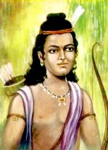
Eklavya was a young tribal boy. He loved to accompany his father who was a tribal chief, on hunting expeditions. One day he came across the gurukula (school) of Dronacharya. Drona was teaching the Pandavas and Kauravas the art of warfare. Eklavya stood transfixed as he saw the wonders that a bow could do.
Eklavya asked his father about this grand looking man who was teaching the young boys. His father explained that the man he was seeing was the great Dronacharya, who was famous for his skills in warfare.
"I wish I could learn from him," said Eklavya. "Son, he has been engaged by Bhishma to teach the princes of the Kuru dynasty," replied his father. "I shall still try to become his student," replied a stubborn Eklavya.
He went to Dronacharya, and asked him to accept him as a student. Drona refused, telling him that he taught only princes. A dejected Eklavya then took a decision. He would become the best archer, and his teacher would be Dronacharya. He went deep into the forest, which was his home and created a statue of Drona out of clay. He worshipped this clay image and took it to be his Guru (teacher). He practiced with bow and arrows relentlessly and gradually became very good in the art of archery. All this time he never forgot to tend to his clay Guru.
One day, Eklavya heard a dog barking loudly. Since the dog was distracting him, he took up his bow and shot five arrows into its mouth. He shot the arrows in such a way that the dog, though unhurt, could no longer close its mouth. It ran whimpering to Dronacharya's gurukula.
The princes and Drona saw the dog and wondered who had shot the arrows so skillfully. After finding out that it was Eklavya, who said that he was Dronacharya's student, Arjun was upset. He reminded Dronacharya of his promise that he would be the world's best archer. How could Dronacharya have taken up a tribal boy as his student and make him a better archer?
Drona went to Eklavya with all his students, where he saw the boy practicing in front of his clay image, which had fresh flowers around it. Eklavya ran to him and fell at his feet saying, "Guruji, thanks for coming here, after so many years of learning from your image, I have the good fortune of seeing you."
With his heart full of admiration for the young boy, Dronacharya said, "My boy, you have successfully completed your education. Now it is time for my Guru Dakshina. Will you give me whatever I ask of you?" Eklavya happily replied in the affirmative. Drona then said, "Eklavya, you made me your Guru even though I rejected you. For my Dakshina, give me your right thumb."
Eklavya looked at him amidst stunned silence, and then slowly but surely walked up in front of his guru's clay imaged, and taking out his knife, he cut off his right thumb. He knew he would never be the best archer now, as without the right thumb it is not possible to shoot arrows.
Today, Ekalavya is known all over the world as one of the greatest, most devoted students. His dedication to his guru is unmatched. Even thousands of years after his death, people continue to admire and learn from Ekalavya.

This story is a very important part of the Mahabharatha. It depicts the eagerness of a student to learn from his chosen Guru, without caring what the consequences may be. It shows the students loyalty to his chosen Guru, who had refused to accept him. This story also shows how a person, however poor he may be by birth can aspire for things seemingly beyond his reach.
What is Balagokulam?

We, as Hindu kids in America, grow up in two different cultures: one at home and a totally different culture outside of home. And as we grow, we have to balance the two cultures, which is a challenging task. While we have to assimilate ourselves in American culture, we also have to follow our (Hindu) culture at home. Several questions arise in our mind about our culture – “Why do we have so many Gods? Why does Ganesha have a head of an elephant? What is reincarnation? And so on ….” Due to a lack of knowledge about our rich culture, we sometime feel inferior and hide our identity. All of this culminates in the final question “Can I be a Hindu and yet be an American?”

Balagokulam is a place where you can get answers to these questions. Balagokulam is a forum started by Hindu Swayamsevak Sangh (HSS) for Hindu kids. HSS is a socio-cultural organization of Hindu volunteers who work towards organizing the Hindu society in America.

In simple words, Balagokulam is a weekly gathering of Hindu kids that enables them to appreciate their cultural roots and learn Hindu values (samskaras) in an enjoyable manner. One might ask, “We are already going to school for an education. Why do we need Balagokulam?” We live in a great country that has a lot to offer in education, careers, and recreation. However, it does not give the spiritual and cultural education and guidance that Hindu Dharma encompasses. That is why it is necessary for all Hindu kids to participate in Balagokulam or other cultural activities.

Then, you might ask, “Our parents are here to teach our culture. Why should we go to Balagokulam?” It is true that parents are the first ones who give us first lesson of the life. It is also true that parents give us valuable information about our culture. But there are certain things for which even parents also can not give convincing answers. Everyone has limitations and one has to look out to others for further learning. For example, your history teacher can not teach science. You need to go to the science teacher. In Balagokulam, we get a suitable atmosphere and friends of the same age, which make learning easy and enjoyable. And while we see ourselves a part of a big group with the same cultural background, we naturally develop confidence. Moreover, we also get a chance to make friends and exchange our views and doubts with them. By coming together, we can learn from each other and preserve our Hindu culture.

Wouldn’t you like to attend Balagokulam? ☺ We meet every week in your area. Please see the details below:
When: _____insert day of week__________
Time: _______insert time________________
Place: ______________address____________
__________________________________
_________________________________
Cost: Free of charge!
For more information, please contact: __________________________________

