Hindu Heritage Camp 2007

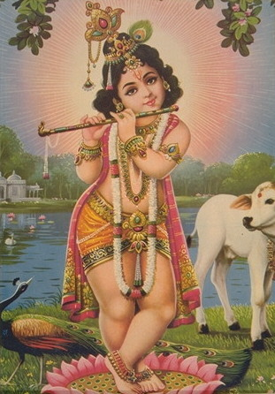
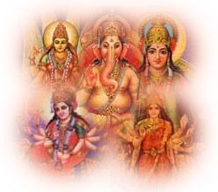


_________________________
Name
Table of Contents

Shlokas, Mantras 4
Ganesha Shlokam 4
Saraswathi Shlokam 4
Krishna Shlokam 4
Shiva Shlokam 5
Guru Shlokam 5
Shanti Mantras 5
Bhajans 6
Mukund Madhav 6
Jai Devi Durga 6
Shiv Har Shankar... 7
Jai Ganesh Jai Ganesh... 7
Om Jai Jagdish Hare 7
Word Search…………………………………………………………………..………….8
Geet 9
Bal Hai Gopal Hai 9
Eesh Hame Detaa Hai 9
Prarthana……………………………………………………………………………10
Subhaashitam 11
Ekaatmata Stotra………………………………………………….…………………………………..12
Yoga 14
Soorya Namaskar 14
Hinduism, that is Sanathan Dharma 15

Introduction and welcome message of HHC

Dear Campers and Parents,

Welcome to Hindu Heritage Camp! During this unique camp, you will be introduced to a whole new world—a world where Hinduism is not a religion, but more of a way of life; where learning is not on command, but an experience; where fun is not an option, but will become a necessity; and where a smile upon your faces is not a sign to us, but a satisfaction.

So what exactly is Hindu Heritage Camp? Hinduism, as you might know, is our religion. But here, at shakha (balagokulam), we want to teach you how it’s also a way of life. Hinduism is just how we do things, not what we are controlled by. Hinduism tells us what’s right and what’s wrong and gives us a path to base our lives upon. In other words, don’t think of Hinduism as a religion, but more of an idea that we all share. The next word, Heritage, basically means tradition. Here, you will learn about the traditions and culture of Bharat, and why they’re important to know. The last word, camp, means only one thing to us, shikshaks, fun! Our job during your camp is not only to make sure you learn something about Hinduism, but also to make sure you have fun! Those three words put together form the name of this place: Hindu Heritage Camp. Don’t set your boundaries here, Hindu Heritage Camp is not only about these three words—it’s about everything you want to make it about, revolving again on that way of life, Hinduism.

You might have noticed the two italicized words above, but do not know the meaning to. The first one is shakha, which is a place we gather every Sunday for an hour or two to play games, say slokas, hold discussions, tell stories, do arts and crafts and much more! The other word is shikshaks. We are the Shikshaks, a camp counselor, a teacher, and of course, a friend! We’re here for you, and to make sure that you get the most out of this camp.

Each and every camp is planned differently, with many various activities. However, we won’t reveal those to you just yet, as they’ll remain a surprise. So, from us here, we would just like to wish all of the campers a happy camp experience, and to the parents, we hope your child enjoys this camp just as much as we do conducting it.

Shlokas, Mantras

Ganesha Shlokam

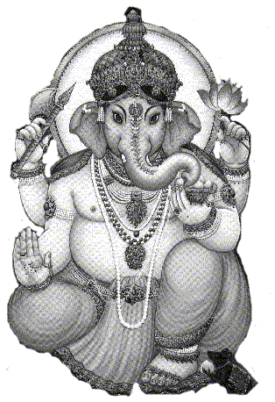 | Shuklambara Dharam Vishnum  Shashivarnam Chatur Bhujam  Prasanna Vadanam Dhyayet  Sarva Vignopa Santaye | Lord Vigneshwara, who wears a white garment, who is all pervading, who has a bright complexion (like a full moon), who has four hands (representing all power), who has an ever-smiling face, upon that deity I meditate, for the removal of all obstacles.

Saraswathi Shlokam

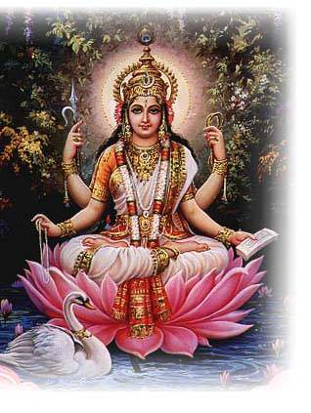 | Saraswathi Namastubhyam  Varade Kamarupini  Vidyarambam Karishyami  Siddhir Bhavatu Me Sada | O Goddess Saraswathi; salutations to you, the giver of boons, the one who fulfills desires. I shall begin my studies. May there always be accomplishment for me.

Krishna Shlokam

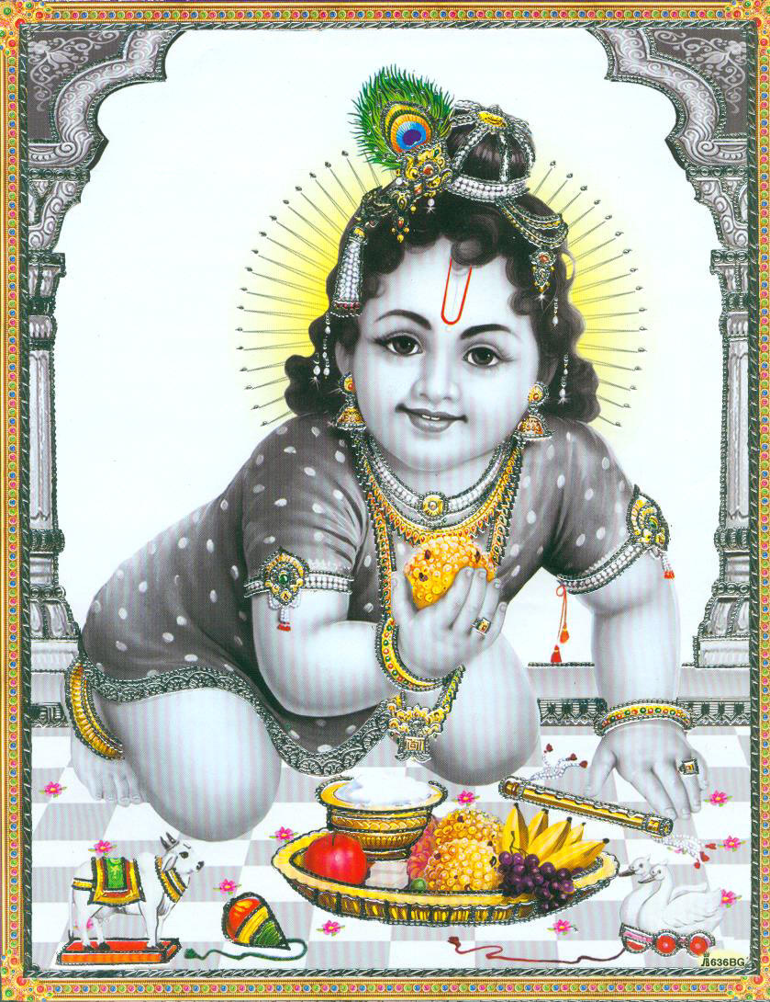 | Vasudeva sutam devam  Kamsa-Chanoora mardanam  Devaki parama-anandam  Krishnam vande Jagatgurum | I do vandana (glorification) of Lord Krishna, the resplendent son of Vasudev, who killed the great tormentors like Kamsa and Chanoora, who is a source of greatest joy to Devaki, and who is indeed a world teacher.

Shiva Shlokam

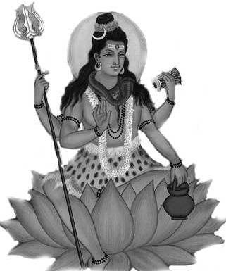 | Karpoora-gauram karuna-avataram  Samsara-saaram Bhujagendra-haaram  Sadaa-vasantam Hridaya-aravinde  Bhavam Bhavanee-sahitam Namami | I salute to that Ishwara along with Bhavani (Shiva and parvati) who is as white as Karpur(camphor), an incarnation of compassion, the essence of this world, who wears a bhujagendra(snake or serpent) around his neck and is ever present in the lotus abode of our hearts.

Guru Shlokam
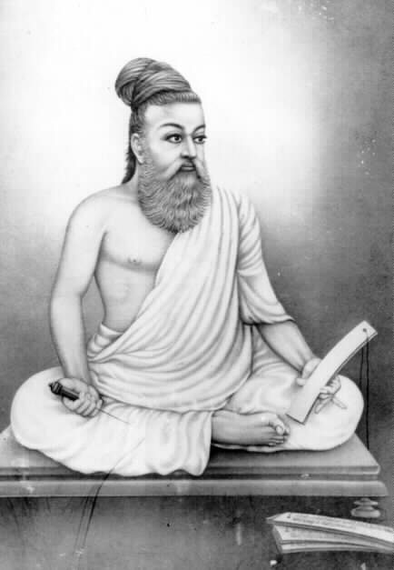 | Gurur Brahma Gurur Vishnu  Gurur Devo Maheshvarah  Guru Shakshat Param Brahma  Tasmai Sri Gurave Namah | Know The Guru To Be Brahma Himself. He Is Vishnu. He Is Also Shiva. Know Him To Be The Supreme Brahman, And Offer Thy Adoration Unto That Peerless Guru.

Shanti Mantras

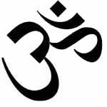 | Om Sahana Vavatu Sahanau Bhunaktu  Sahaveeryam Karavavahai  Tejas Vinavati Tamastuma vidhwishavahai  Om Shanti Shanti Shantihi | May He protect both of us. May He nourish both of us. May we both acquire the capacity (to study and understand the scriptures). May our study be brilliant. May we not argue with each other. Om peace, peace, peace.

Asato Ma Sadgamaya  Tamaso Ma Jyotir gamaya  Mrityorma Amritam gamaya  Om Shanti Shanti Shantihi | Lead me (by giving knowledge) from the unreal to the real; from darkness (of ignorance) to the light (of knowledge); from death (sense of limitation) to immortality (limitless liberation)

Sarve Bhavantu Sukhinaha  Sarve Santu Niramayah  Sarve Bhadrani Pashyantu  Maa Kaschid Dhuka Bhag Bhavet | May all be happy. May all enjoy health and freedom from disease. May all enjoy prosperity. May none suffer.

Brief explanation
These are prayers for the prosperity and welfare of humanity. To achieve anything in life, one has to make an effort and await the results. In addition, many unknown factors and laws influence the outcome of that effort. By praying to the Lord, one acknowledges these laws as the natural order inseparable from the Lord, and one acknowledges the Lord as the giver of all results of actions.

Bhajans

Mukund Madhav  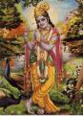  Mukund madhav govind bol  Keshav madhav hari hari bol......  Ram ram bol...... Ram ram bol.....  Krishna krishna bol.... Krishna krishna bol....  Shiv shiv bol..... Shiv shiv bol.....  Mukund madhav govind bol | Jai Devi Durga  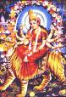  Jai devi durga gauri shankri parvati  Bhuvan mohini lalit kalavati  Jai devi…………  Kamal kamini harinarayani bhagavati  Vedmata vidyadayani bharti  Hanswahini veenapani saraswati  Jai devi………….
Shiv Har Shankar...  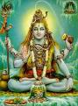  Shiv har shankar gourishaa  Om shiv har shankar gourishaa  Vande gangaa dharanesha  Gouri pate jaya har, har, har har...2  Chandramouli jaya har, har, har har...2  Shiv har sharkar gourishaa  Om shiv har shankar gourishaa  Vande gangaa dharanesha | Jai Ganesh Jai Ganesh...  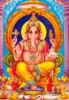  Jai ganesh jai ganesh jai ganesh deva  Matha jaki parvati, pitha maha deva  Jai ganesh jai ganesh jai ganesh pahimam  Jai ganesh jai ganesh jai ganesh rakshamam  Jai ganesh jai ganesh jai ganesh pahimam  Jai ganesh jai ganesh jai ganesh rakshamam  Jai ganesh pahimam, jai ganesh rakshamam

Aarati

Om Jai Jagdish Hare

OM JAI JAGDISH HARE, PRABHU JAI JAGDISH HARE
BHAKT JANO KE SANKAT KSHAN MEN DOOR KARE
OM JAI JAGDISH HARE….

JO DHAVE PHAL PAVE, DUKH BINSE MAN KA
SUKH SAMPATI GHAR AAVE, KASHT MITE TAN KA
OM JAI JAGDISH HARE….
MAT PITA TUM MERE,SHARAN GAHU MAIN KISKI
TUM BIN AUR NA DOOJA,AAS KARUN MAIN JISKI
OM JAI JAGDISH HARE........
TUM PURAN PARMATAM,TUM ANTARYAMI
PAAR BRAHM PARMESHWAR,TUM SABKE SWAMI
OM JAI JAGDISH HARE.........
TUM HO EK AGOCHAR,SAB KE PRANPATI
KIS BIDHI MILUOO DYAAMAY,MAI TUM KO MAIN KUMTI
OM JAI JAGDISH HARE..........

DEENBANDU DUKHHARTA TUM THAKUR MERE
APNE HAATH UTHAO, DWAAR PADA TERE
OM JAI JAGDISH HARE..............

VISHAY VIKAAR MITAO, PAAP HRAO DEVA
SHRADHA BHAKTEE BADHAO, SANTAN KEE SEVA
OM JAI JAGDISH HARE………….

Word Search: Hindu Goddesses

Words:
Annapurna Bharatmata Bhuvaneshwari Devi Dhanwantari Dhumavati Durga Ganga
Gauri Gayatri Kali Lakshmi
Matangi Maya Meenakshi Parvati
Radha Saraswati Shakti Sita

Puzzle:



Geet
Baal Hai Gopal  Baal Hai Gopal Hai, Hum Dharma Ke Bhaal Hai ||  Hum Dharma Ke Bhaal Hai  Poorshottam Maryaadaa Dhaaree, Dwaapar-men Hum Krushana Muraaree ||  Har Yuga Men Kar Dharma Dhwajaa Le, Vaijayntee Gal Maal Hai…  Bal Hai Gopall Hai…(1) ||  Veer Shivaa Ranaa Abhimaanee, Guru Govind Sinha Theh Balidaanee  Bandaa Vairaagee Jaisn Ke, Tejasvee Hum Laal Hai…  Bal Hai Gopal Hai…(2) ||  Naana Taatyaa Raanee Jansi, Pralayankar Ban Chumee Phaansee  Pandey Mangal Kukaa Phadake, Dhadhak Uthay Ve Jwaal Hai…  Bal Hai Gopal Hai…(3) ||  Dayanand Aravind Vivekaa, Eka Tatvake Roop Aneko  Divya Jyoti Keshava Maadhava Ki, Sampaadita Har Praana Hai…  Bal Hai Gopal Hai…(4) || | Eesh Hame Detaa  eesh hame detaa hai sab kuCh,  ham bhee to kuCh denaa seekhe ||0||  sooraj hame roshanee detaa,  hawaa nayaa jeevan detee hai ||  bhookh miTaane ko ham sab kee,  dharatee par hotee khetee hai ||  auroM kaa bhee hit ho jis me,  ham aisaa kuCh karanaa seekhe ||1||  garamee kee tapatee dupahar me,  peD sadaa dete hai Chaayaa ||  suman sugandh sadaa dete hai,  ham sab ko phooloM kee maalaa ||  tyaagee taruoM ke jeevan se,  ham parahit kuCh karanaa seekhe ||2||  jo anapaDh hai unhe paDhaaye,  jo chup hai unako waaNee de ||  piChaDh gaye jo unhe baDhaaye,  samarasataa ka bhaav jagaa de ||  ham mehanat ke deep jalaa kar,  nayaa ujaalaa karanaa seekhe ||3||

 Sangh Prarthana and Translation

Sarva Mangala Maangalyaam  Deveem Sarvaartha Saadhikaam  Sharanyaam Sarva Bhootanaam  Namaamo Bhoomi Mataram  Sachchidaanada Roopaaya  Vishwa Mangala Hetave  Vishwa Dharmaika Moolaaya  Namostu Paramaatmane  Vishwa Dharma Vikaasartham  Prabho Sanghatitaa Vayam  Shubhaam Aashisham Asmabhayam  Dehi Tat Paripoortaye  Ajayyam Aatma Saamarthyam  Susheelam Loka Poojitam  Gyanam Cha Dehi Vishwesha  Dhyeya Maarga Prakaashakam  Samut Karshostuno Nityam  Nishreyasa Samanvitah  Tatsaadhakam Sphuratwantah  Suveera Vratamujwalam  Vishwa Dharma Prakaashena  Vishwa Shaanti Pravartake  Hindu Sanghatanaa Kaarye  Dhyeya Nishthaa Sthiraastunah  Sangha Shaktir Vijetreeyam  Krutvaasmad Dharma Rakshanam  Paramam Vaibhavam Praaptum  Samarthaastu Tavaashisha  Tvadiiye Punya Kaaryesmin  Vishwa KalyaaNa Saadhake  Tyaaga Seva Vratasyaayam  Kaayome Patatu Prabho  || Vishwa Dharma Ki Jay || | The most sacred of all that is auspicious  The means to achieve all that one aspires  The safe refuge of all living beings  O Goodness Mother Earth, We salute thee.  You are the cause for the Universe good,  The embodiment of the Truth Wisdom, and Bliss  The Unique origin of Universal Righteousness,  Our Salutations to You, O God, Supreme.  Together we have come organized, O Lord,  The purpose being flourishing of Universal Dharma,  We seek Your blessings, the divine grace,  Bestow on us to accomplish the aim.  Possession of valor, unconquerable ever  Conduct, character renowned world over  Bestow the wisdom that brightens, O God  Paving the way to realize the goal.  Endowed with prosperity, exaltation, perpetual,  May there be affluence bestowed on us;  inspired are we to practice,  the radiant, worthy, valiant, and vow.  With enlightenment from the Universal Dharma,  in propagating peace through out the world  in the task of achieving Hindu unity worldwide,  May our aim and deep faith remain resolute.  With the triumphant power of the organization,  by safeguarding our own Dharma, the righteousness,  May we be blessed to be competent  To attain the glory supreme, sublime.  In pursuit of the welfare of the mankind,  which indeed is thy holy cause and  inspired by the noble virtues of service and sacrifice,  let my being, O Bhagawan!, be offered at your feet.  || Victory to Universal Dharma ||

Subhaashitam

Quotes from Hindu texts…

“Maatru Devo Bhava, Pitru Devo Bhava, Aachaarya Devo Bhava, Atithi Devo Bhava”
(Be the one to treat Mother as your God, Father as your god, Teacher as your God, and Guest as your God)

“udaara charitanaam tu, Vasudhaiva kutumbakam”
(For noble-minded ones, entire universe is family)

“Dharmao Rakshati Rakshitah”
(Dharma will protect those who protect Dharma)

“Ekam Sat Vipraah Bahudhaa Vadanti”
(Truth is one and the Sages call it by different names)

“Paritraanaaya sadhunaam, Vinaashaaya cha dushkrutaam
Dharma samsthapanaarthaaya Sambhavaami yuge yuge”
(to protect the noble, to destroy the evil, and to establish Dharma, I come to this world time to time—shri Krishna in Bhagavad Gita)

Jeevane yaavadaadaanma, syaat pradaanam tatodhikam”
(In life, what we give must be more than what we take)

“Sanghe Shaktih Kalau Yuge”
(Strength is in Unity in Kali Yug, i.e. present age)

“Swayameva mrigendratha”
(We achieve through our own efforts)

“Karmanyeva adhikaraste maa phaleshu kadaachana”
(Our responsibility is in our actions, not to worry about their results.)

“Udhyamenahisidhyanti karyaani na manorathaihi”
(Effort alone creates results, not day-dreaming.)

“Na jaatu kaamaha kaamaanaam upabhogena shaamyati”
(By fulfilling those desires in us, those desires don't go away)

“Uthishta jagratha praapyavaraan nibodhata”
(Arise! Awake! Stop not till the goal is reached!)

Ekaatmata Stotra

Om Namah Sacchidaananda,
roopaaya paramaatmane |
Jyotirmaya Swaroopaaya,
Vishwa Maangalya Moortaye || 1 ||

Prakritih Pancha Bhootaani,
Grahaa Lookaa Swaraastathaa |
Dishah Kaalashcha Sarveshaam,
Sadaa Kurvantu Mangalam || 2 ||

Ratnaakaraadhau Tapadhaam,
Himaalaya Kireetineem |
BrahmaRaajarshi Ratnaadyaam,
Vande Bhaarata Maataram || 3 ||

Mahendro Malayah Sahyo
Devataatmaa Himaalayah |
Dhyeyo Raivatako Vindhyo
Girishchaaravalistathaa || 4 ||

Gangaa Saraswatee Sindhur
Brahma Putrashcha Gandakee |
Kaaveree Yamunaa Revaa
Krishnaa Godaa Mahaanadee || 5 ||

Ayodhyaa Mathuraa Maayaa
Kaashee Kaanchee Avantika |
Vaishaalee Dwaarikaadhyeya
Puree Takshashilaa Gayaa || 6 ||

Prayaagah Paataleeputram
Vijayaanagaram Mahat |
Indraprastham Somanaathah
Tathaa Amrutasara Priyam || 7 ||

Chaturvedaah Puraanaani
Sarvopanishadas Tathaa |
Raamaayanam Bhaaratam Cha
Geetaa Saddarshanaanicha || 8 ||

Jainaagamaas Tripitakaa
Gurugranthah Sataam Girah |
Eshah Jnaana Nidhih Shreshtah
Shraddheyo Hridi Sarvadaa || 9 ||

Arundhatyanasooyaa Cha
Saavitree Jaanakee Sati |
Draupadee Kannagee Gaargee
Meeraa Durgaavatee Tathaa || 10 ||

Lakshmeerahalyaa Channamma
Rudramaambaa Suvikramaa |
Niveditaa Saaradaa Cha
Pranamyaa Matru Devataah || 11 ||

Shree Raamo Bharatah Krishno
Bhishmo Dharmas Tathaarjunah |
Maarkandeyo Harishchandrah
Prahlaado Naarado Dhruvah || 12 ||

Hanumaan Janako Vyaaso
Vasishtashcha Shuko Balih |
Dadheechi Vishwa Karmaanau
Pruthu Vaalmeeki Bhaargavaah || 13 ||

Bhageerathash chaikalavyo
Manur Dhanvantaristathaa |
Shibishcha Rantidevashcha
Puraanod Geeta Keertayah || 14 ||

Buddhaa Jinendraa Gorakshah
Paaninishcha Patanjalih |
Shankaro Madhva Nimbaarkau
Shree Raamanuja Vallabhau || 15 ||

Jhoolelaalotha Chaitanyah
Tiruvalluvarastathaa |
Naayanmaaraalavaarashcha
Kambashcha Basaveshvarah || 16 ||

Devalo Ravidaasashcha
Kabeero Guru Naanakah |
Narasis Tulaseedaaso
Dashamesho Drudavratah || 17 ||

Shreemat Shankara Devashcha
Bandhoo Saayana Maadhavau |
Jnaaneshwaras Tukaaraamo
Raamadaasah Purandarah || 18 ||

Birasaa Sahajaanando
Raamaanandas Tathaa Mahaan |
Vitarantu Sadaivete
Daiveem Sadguna Sampadam || 19 ||

Bharatarshih Kaalidaasah
Shree Bhojo Jakanastathaa |
Sooradaasas Tyaagaraajo
Rasakhaanashcha Satkavih || 20 ||

Ravivarmaa Bhaatakhande
Bhaagya Chandrah Sabhoopatih |
Kalaavantashcha Vikhyaataah
Smaraneeyaah Nirantaram || 21 ||

Agastyah Kambu Kaundinyau
Raajendrashchola Vamshajah |
Ashokah Pushyamitrashcha
Khaaravelah Suneetimaan || 22 ||

Chaanakya Chandraguptau Cha
Vikramah Shaalivaahanah |
Samudraguptah Shreeharshah
Shailendro Bapparaavalah || 23 ||

Laachid Bhaaskara Varmaacha
Yashodharmaa Cha Hoonajit |
Shree Krishnadevaraayashcha
Lalitaaditya Udbalah || 24 ||

Musunoori Naayakau Tau
Prataapah Shiva Bhoopatih |
Ranajit Simha Ityete
Veeraa Vikhyaata Vikramaah || 25 ||

Vaijnaanikaashcha Kapilah
Kanaadah Sushrutastathaa |
Charako Bhaaskaraachaaryo
Varaaha Mihirah Sudheeh || 26 ||

Naagaarjuno Bharadwaajo
Aaryabhatto Basurbudhah |
Dhyeyo Venkataraamashcha
Vijnaa Raamaanujaadayah || 27 ||

Raamakrishno Dayaanando
Ravindro Raama Mohanah |
Raamateerthoravindashcha
Vivekaananda Udyashaah || 28 ||

Daadaabhaai Gopabandhuh
Tilako Gaandhiraadrutaah |
Ramano Maalaveeyashcha
Shree Subrahmanya Bhaaratee || 29 ||

Subaashah Pranavaanandah
Kraantiveero Vinaayakah |
Takkaro Bheema Raavashcha
Phule Naaraayano Guruh || 30 ||

Sangha Shaktih Pranetaarau
Keshavo Maadhavstathaa |
Smaraneeyaah Sadaivete
Nava Chaitanya Daayakaah || 31 ||

Anuktaa Ye Bhaktaah
Prabhu Charana Samsakta Hridayaah
Avignaata Veera
Adhisamaramudhwasta Ripavah |
Samaajoddharthaarah
Suhitakara Vijnaana Nipunaah
Namastebhyo Bhooyaat
Sakala Sujanebhyah Pratidinam || 32

Idamekaatmataa Stotram
Shraddhayaa Yah Sadaa Patet 34
Sa Raashtra Dharma Nishtaavaan
Akhandam Bhaaratam Smaret || 33 ||

||Vishwa Dharma Ki Jay ||

Yoga

Soorya Namaskar

For thousands of years, human beings have been worshipping the Sun. For the rishis of the Vedic era in Bharat, the sun was worshipped in all its splendor as Soorya. Soorya Namaskar, which literally means salutations to the earth, is a combination of few Yogasana postures. This is a well balanced set of movements that will stretch all the muscles in the body and keep the body and mind healthy. There are 13 mantras which are different names of the Sun God. We should chant a mantra before each Soorya Namaskar.

The Mantra Offering Salutations to:
AUM Mitraaya Namah The friend of all
AUM Ravaye Namah The shining one
AUM Sooryaaya Namah The one who induces activity
AUM Bhaanave Namah The one who illuminates
AUM Khagaaya Namah The one who moves quickly in the sky
AUM Pooshne Namah The giver of strength
AUM Hiranyagarbhaaya Namah The bright center of all energy
AUM Mareechaye Namah The lord of the dawn
AUM Aadityaaya Namah The son of Aditi
AUM Savitre Namah The benevolent mother
AUM Arkaaya Namah The one who is fit to be praised
AUM Bhaaskaraaya Namah The one who leads to enlightenment
AUM Shrisavitrusooryanaaraayanaaya Namah The Soorya (Sun)

Positions



Hinduism, that is Sanathan Dharma

Introduction

Hinduism is the oldest religion of the world with a history of at least six thousand years. Unlike some of the well-known religions of the world, it does not have a single founder, a single Book, a single Church or even a single way of life. It is based on the spiritual realizations of a galaxy of saints and seers and this tradition flows continuously like a river; hence its name Sanathana Dharma.

Hinduism is like a noble mother who lovingly cares for all of her children, including those who may deny her. An atheist, an agnostic, even a blasphemer, has a place in it as much as a staunch believer. In case they, in course of time, repent and relent they are accepted back as the prodigal sons.

Strangely enough, 'Hinduism' is not its original name! In fact its adherents never gave it any particular name and simply called it Sanathana Dharma which means 'The eternal law that supports and sustains those who practice it'. Actually, the origin of the words 'Hindu' and 'Hinduism' is geographical. The land of the river Sindhu (Indus) and the people inhabiting it came to be known as 'Hindu' among the ancient Persians, in whose language, the 'S' of Sanskrit became 'H'. And this name has somehow stuck.

The number of scriptures in Hinduism are numerous. These are the Vedas, Ithihasas, Puranas, Smrithis, Darshanas and Agamas.

The most important scripture is the Veda with its fourfold division, viz., Rig-Veda, Yajurveda, Samaveda and Atharvaveda.The Rig-Veda is primarily a book of prayers. The Yajurveda is a work of liturgical practices. The Samaveda comprises hymns, taken mostly from the Rig-Veda and set to music, to be sung at appropriate places in a Vedic sacrifice. The Atharvaveda is like an appendix supplying additional information on all aspects of the Veda. Each Veda is again divided into four sections: Samhita (collection of mantras), Brahmana (liturgical instructions, generally in prose), Aranyaka (symbolical contemplation of Vedic rituals, to be practiced in forests by the forest-recluses) and Upanishad (metaphysical reflections).

Among the Itihasas Ramayana and Mahabharata are most important. The puranas are popular works with a mixture of ancient fables and didactic material aimed at educating the masses in our religion and culture.

Among the Smrtis or secondary scriptures, special mention must be made of the Bhagavad-Gita, popularly known as the Gita. It is a part of the great epic, the Mahabharata, and is in the form of a dialogue between Arjuna, the pandava hero and Krishna, considered as an incarnation of God. The Gita contains wonderful ideas of ethics, religion and philosophy rolled into one integrated unit and can easily be declared as the Book for all the Hindus of the modern age.

The dharmasastra literature which is voluminous, deals with many aspects of the personal, the social and the legal life of the Hindus. Some of the books of this category are considered as an authority even today by the law-courts while deciding certain types of cases concerning the Hindus.

The Darshanas are six in number: Nyaya, Vaisheshika, Sankhya, Yoga, Poorva Mimamsa and Vedanta. Vedanta has three important divisions and these are: Adwaita of Shankara, Vishishtadwaita of Ramanuja and Dwaita of Madhwacharya.

The Agamas, a special class of literature, highly technical in nature, are the guiding lights for the construction and consecration of temples and images, as also the various ritualistic practices connected with them.

Concept of God and the Mode of Hindu Worship:

God is the only one without a second; his nature is satchitananda that is existence-consciousness-bliss. The creation is his vestibule. He is both with attributes and without.

The Hindus worship many Gods because the human nature is varied and each one approaches god in his unique way; these gods are like our pass words to the same supreme god who is one and the same. Some of these are Siva, Vishnu, Shakti, Ganapathi and Surya.

The deighty worship has its origin in the following way: Since man can not jump into a milk ocean and drink he uses a ladle for this purpose and similarly an idol provides the portal to god. These idols are made of stone, wood, clay and metal. Kissing a stone or hanging a golden cross around the neck can also be construed as idol worship.

Temple worship has its origin in the following way: God is omnipresent, omnipotent and omniscient and when man propitiates him in a collective worship it is a temple. This provides group awareness. The temple structure, idols and the rituals are organized according to agamas.

Some times He incarnates himself as an Avatar in this world to redeem it from wickedness. Rama and Krishna are two of these Avatars.

Two more aspects of Hindu religious practices need mention here: celebration of festivals and visiting the places of pilgrimage.

Festivals are occasions for exercising greater self-control through fasting, keeping vigil and special worship of God. They are also occasions of joy- once the religious vows are over-feasting and family/social reunions take place.

Visiting places of pilgrimage--especially the places surcharged with the spiritual power by the association of great saints-will help in the recharging as it were, of one's spiritual aspirations.

It should be noted that visiting places of worship, observing religious festivals and going on a pilgrimage are common to almost all the religions of the world.

It will not be out of place to mention here that the Hindu religious works which advocate rituals or pilgrimage are also bold enough to declare that the best worship is the worship of the Supreme Self within and the best pilgrimage is resorting to the God in one's own heart!

Hindu culture

Hindu society developed a large number of Arts, crafts and sciences the enumeration of which rises sometimes to 64! These arts, crafts and sciences help the human beings not only to beautify or refine their physique but also sharpen their intellects and add to their external comforts. A few of them may be listed here: vocal and instrumental music, dance and drama, making of flower-garlands, coloring of cloth, decorating one's body, decoration of the house, water-sports, hair-dressing, culinary arts, preparation of musical instruments, hand-writing, drawing and painting, wood-work, metal filigree work, making of ornaments of gold and precious stones, gardening, various types of physical exercises and feats and so on.

Apart from these there were several other fields in which great progress had been made by the ancient and medieval Hindus. Some of them were: medicine and surgery, veterinary sciences, military sciences including the building of warships, chemical sciences including alchemy, astronomy and astrology, mining and metallurgy, and many others.

Puzzle Page

Unscramble Names: Hindu Gods and Goddesses

DIRECTIONS: Unscramble the following names of Indian Gods and Goddesses

- MAANHUN: _ _ _ _ _ _ _ 8.) SIVHNU: _ _ _ _ _ _
- RISHANK: _ _ _ _ _ _ _ 9.) STAAARSWI: _ _ _ _ _ _ _ _

- VSIAH: _ _ _ _ _ 10.) GARUD: _ _ _ _ _

- HEAANSG: _ _ _ _ _ _ _ 11.) TASI: _ _ _ _

- MARA: _ _ _ _ 12.) VITAPRA: _ _ _ _ _ _ _

- KHMLASI: _ _ _ _ _ _ _ 13.) LKAI: _ _ _ _

7) HAMRAB: _ _ _ _ _ _ 14.) BAMA: _ _ _ _



Name | Phone Number | Email Address

Hindu Heritage Camp
July 13-22, 2007
Surrey, Canada B.C.

http://www.balagokulam.org
http://www.hssus.org
Email: balagokulam@hssworld.org



